**Program no. 1**

**//Write the program to find the sum of two numbers.**

#include<iostream.h>

#include<conio.h>

void main()

{

clrscr();

int a,b,c;

cout<<"enter the value of a= ";

cin>>a;

cout<<"enter the value of b= ";

cin>>b;

c=a+b;

cout<<"sum of two numbers are "<<c;

}

**OUTPUT**

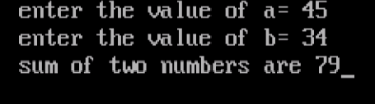

**Program no. 2**

**//** **Write the program to find the sum of n numbers.**

#include<iostream.h>

#include<conio.h>

void main()

{

clrscr();

int n,i,sum=0;

cout<<"enter the nth number ";

cin>>n;

for(i=1;i<=n;i++)

{

sum=sum+i;

}

cout<<"sum of n nunber is "<<sum;

}

**OUTPUT**

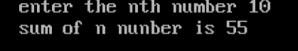

**Program no. 3**

**//Write a program to check whether a number is even or odd.**

#include<iostream.h>

#include<conio.h>

void main()

{

clrscr();

int a;

cout<<"enter the number ";

cin>>a;

if(a%2==0)

{

cout<<"Number is even ";

}

else

{

cout<<"Number is odd ";

}

}

**OUTPUT**

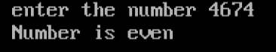

**Program no.** 4

**//Write a program to check whether a number is prime or not.**

#include<iostream.h>

#include<conio.h>

void main()

{

clrscr();

int n,i,c=0;

cout<<"enter the number ";

cin>>n;

for(i=2;i<n;i++)

{

if(n%i==0)

{

c++;

break;

}

}

if (c==0)

{

cout<<"number is prime ";

}

else

{

cout<<"number is not prime ";

}

}

**OUTPUT**

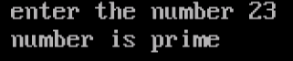

**Program no. 5**

**// Write a program to check whether a character is alphabet or not.**

#include<iostream.h>

#include<conio.h>

void main()

{

clrscr();

char ch;

cout<<"enter the character ";

cin>>ch;

if(ch>='a'&&ch<='z'||ch>='A'&&ch<='Z')

{

cout<<"character is alphabet";

}

else

{

cout<<"character is not alphabet";

}

}

**OUTPUT**

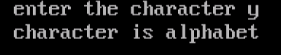

**Program no. 6**

**//Write a program to check whether a character is vowel or not**.

#include<iostream.h>

#include<conio.h>

void main()

{

clrscr();

char ch;

cout<<"enter the character ";

cin>>ch;

if(ch=='a'|| ch=='A'|| ch=='e'|| ch=='E'|| ch=='i'|| ch=='I'|| ch=='o' || ch=='O' || ch=='u' || ch=='U')

{

cout<<"character is vowel ";

}

else

{

cout<<"character is NOT vowel";

}

}

**OUTPUT**

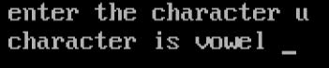

**Program no. 7**

**//Write a program to print the year is leap or not.**

#include<iostream.h>

#include<conio.h>

void main()

{

clrscr();

int year;

cout<<"enter the year=";

cin>>year;

if(year%4==0||year%400==0||year%100==0)

{

cout<<"the year is leap";

}

else

{

cout<<"the year is not leap";

}

}

**OUTPUT**

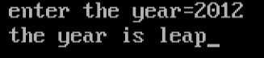

**Program no. 8**

**//Write a program to perform addition, subtraction, multiplication and division**.

#include<iostream.h>

#include<conio.h>

void main()

{

clrscr();

int a,b;

cout<<"entre the value of 'a' ";

cin>>a;

cout<<"enter the value of 'b' ";

cin>>b;

cout<<"Addition i.e. "<<a<<"+"<<b<<"="<<a+b<<endl;

cout<<"Subtraction i.e. "<<a<<"-"<<b<<"="<<a-b<<endl;

cout<<"Multiplication i.e. "<<a<<"*"<<b<<"="<<a*b<<endl;

cout<<"Division i.e. "<<a<<"/"<<b<<"="<<a/b<<endl;

}

**OUTPUT**

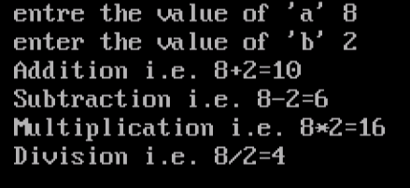

**Program no. 9**

**//write a Program to print A to Z.**

#include<iostream.h>

#include<conio.h>

void main()

{

clrscr();

char ch;

int i,g;

cout<<"print A-Z "<<endl;

for(i=97;i<=122;i++)

{

ch=(char)i;

g=(int)ch-32;

cout<<" "<<(char)g;

}

}

**OUTPUT**



**Program no. 10**

**//** **Write a program to swap the two numbers with help of 3rd variable.**

#include<iostream.h>

#include<conio.h>

void main()

{

clrscr();

int a,b,c;

cout<<"entre the value of a ";

cin>>a;

cout<<"entre the value of b ";

cin>>b;

c=a;

a=b;

b=c;

cout<<"after swapping"<<"\n";

cout<<"a= "<<a<<"\t"<<"b= "<<b;

}

**OUTPUT**

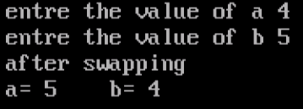

**Program no. 11**

**//Write a program to swap the two numbers without the help of 3rd variable.**

#include<iostream.h>

#include<conio.h>

void main()

{

clrscr();

int a,b;

cout<<"entre the value of a ";

cin>>a;

cout<<"entre the value of b ";

cin>>b;

a=a+b;

b=a-b;

a=a-b;

cout<<"after swapping without using 3rd variable"<<"\n";

cout<<"a= "<<a<<"\t"<<"b= "<<b;

}

**OUTPUT**

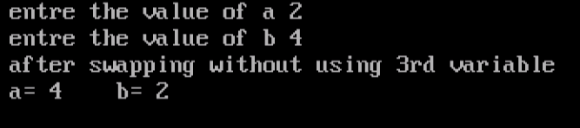

**Program no. 12**

**//** **Write a program to check whether a number is prime or not in a given range**.

#include<iostream.h>

#include<conio.h>

void main()

{

clrscr();

int a,b,i,j,c;

cout<<"enter the starting value ";

cin>>a;

cout<<"enter the last value ";

cin>>b;

for(i=a;i<b;i++)

{ c=0;

for(j=2;j<i;j++)

{

if(i%j==0)

{

c++;

break;

}

}

if (c==0)

{

cout<<i<<" ";}

}

getch();

}

**OUTPUT**

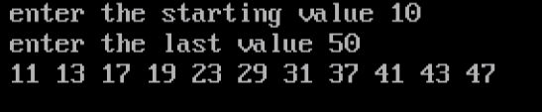

**Program no. 13**

**//Write a program to find the grade of a student.**

#include<iostream.h>

#include<conio.h>

void main()

{

clrscr();

int m,e,c,h,p,sum;

float avg;

cout<<"enter the marks of respective subjects: "<<endl;

cout<<"maths= ";

cin>>m;

cout<<"english= ";

cin>>e;

cout<<"computer= ";

cin>>c;

cout<<"hindi= ";

cin>>h;

cout<<"punjabi= ";

cin>>p;

sum=m+e+c+h+p;

avg=sum/5;

cout<<"\t avrage marks "<<avg <<" %"<<endl;

if(avg>95)

{

cout<<"grade of a student is A+ ";

}

else if(avg<=95 && avg>85)

{

cout<<"grade of a student is A ";

}

else if(avg<=85 && avg>75)

{

cout<<"grade of a student is B+ ";

}

else if(avg<=75 && avg>65)

{

cout<<"grade of a student is B ";

}

else if(avg<=65 && avg>50)

{

cout<<"grade of a student is C ";

}

else if(avg<=50 && avg>=33)

{

cout<<"grade of a student is D ";

}

else

{

cout<<"student is FAIL ";

}

}

**OUTPUT**

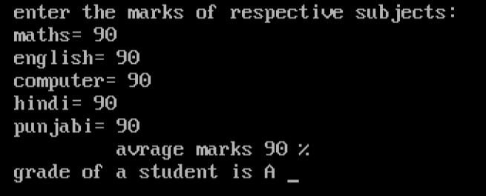

**Program no. 14**

**//Write the program to Print Table of Number.**

#include<iostream.h>

#include<conio.h>

void main()

{

clrscr();

int a,i;

cout<<"Enter the number ";

cin>>a;

cout<<"the multiplication table of "<<a<<" is "<<endl;

for(i=0;i<=10;i++)

{

cout<<a<<"*"<<i<<"=";

cout<<a*i;

cout<<endl;

}

}

**OUTPUT**

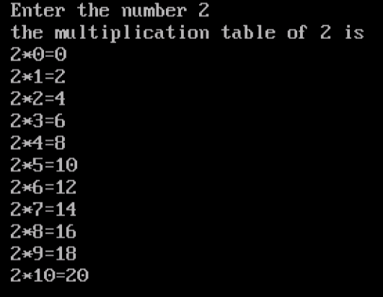

**Program no. 15**

**//Write a program to reverse the any number.**

#include<iostream.h>

#include<conio.h>

void main()

{

clrscr();

int no,rev=0,r;

cout<<"enter the number ";

cin>>no;

while(no>0)

{

r=no%10;

rev=rev*10+r;

no=no/10;

}

cout<<"reverse number "<<rev;

}

**OUTPUT**

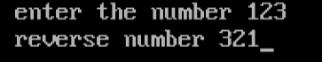

**Program no. 16**

**//Write a program to find greatest among three numbers.**

#include<iostream.h>

#include<conio.h>

void main()

{

clrscr();

int a,b,c;

cout<<"enter the value of 'a' ";

cin>>a;

cout<<"enter the value of 'b' ";

cin>>b;

cout<<"enter the value of 'c' ";

cin>>c;

if(a>b||a>c)

{

cout<<"greatest among three numbers is 'a' i.e. "<<a;

}

else if(b>c)

{

cout<<"greatest among three numbers is 'b' i.e. "<<b;

}

else

{

cout<<"greatest among three numbers is 'c' i.e. "<<c;

}

}

**OUTPUT**

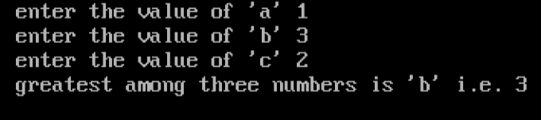

**Program no. 17**

**//write the Program to print the pattern (left reverse of right angle triangle).**

#include<iostream.h>

#include<conio.h>

void main()

{

clrscr();

int i,j,n;

cout<<"enter the number ";

cin>>n;

for(i=1;i<=n;i++)

{

for(j=1;j<=i;j++)

{

cout<<"*";

}

cout<<endl;

}

}

**OUTPUT**

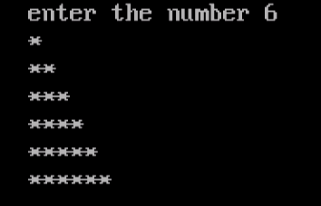

**Program no. 18**

**//write the Program to print the pattern(bottom reverse of right angle triangle).**

#include<iostream.h>

#include<conio.h>

void main()

{

clrscr();

int i,j,n;

cout<<"enter the number ";

cin>>n;

for(i=n;i>=1;i--)

{

for(j=1;j<=i;j++)

{

cout<<"* ";

}

cout<<endl;

}

}

**OUTPUT**

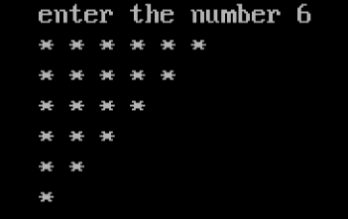

**Program no. 19**

**//Write a program to find the factorial of any number.**

#include<iostream.h>

#include<conio.h>

void main()

{

clrscr();

long int i,n,f=1;

cout<<"enter the value of n ";

cin>>n;

for(i=1;i<=n;i++)

{

f=f*i;

}

cout<<"factorial of "<<n<<" is "<<f;

}

**OUTPUT**

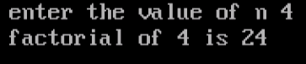

**Program no. 20**

**//write the Program to Calculate Area and Perimeter of Rectangle.**

#include<iostream.h>

#include<conio.h>

void main()

{

clrscr();

int l,b,a,p;

cout<<"enter the length of the rectangle ";

cin>>l;

cout<<"enter the breadth of the rectangle ";

cin>>b;

a=l*b;

p=2*(l+b);

cout<<"Area of the rectangle is "<<a<<endl;

cout<<"perimeter of the rectangle "<<p;

}

**OUTPUT**

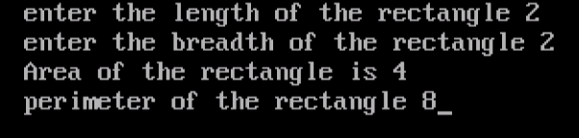

**Program no. 21**

**//Write a program to convert Fahrenheit into centigrade.**

#include<iostream.h>

#include<conio.h>

void main()

{

clrscr();

float f,c;

cout<<"enter the temprature in fahrenheit ";

cin>>f;

c=(((f+32)/9)*5);

cout<<"temprature in centigrade is "<<c;

}

**OUTPUT**

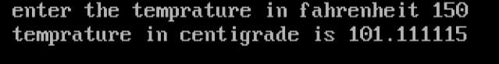

**Program no. 22**

**//Write a program to convert centigrade into Fahrenheit.**

#include<iostream.h>

#include<conio.h>

void main()

{

clrscr();

float f,c;

cout<<"enter the temprature in centigrade ";

cin>>c;

f=((1.8)*c-32);

cout<<"temprature in fahrenheit is "<<f;

}

**OUTPUT**

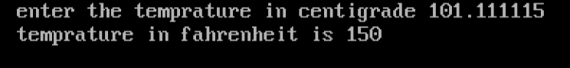

**Program no. 23**

**//Write a program to print ASCII value of character.**

#include<iostream.h>

#include<conio.h>

void main()

{

clrscr();

char ch;

cout<<"enter any character=";

cin>>ch;

cout<<"ASCII value of character '"<<ch<<"' is "<<(int)ch;

}

**OUTPUT**

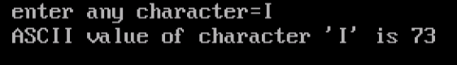

**Program no. 24**

**//Write a program to print the Fibonacci series.**

#include<iostream.h>

#include<conio.h>

void main()

{

clrscr();

int a=0,b=1,c=0,n;

cout<<"Enter the how many digits you want in the series ";

cin>>n;

cout<<"The Fibonacci series is "<<endl;

cout<<" "<<a;

for (int i=0;i<=n;i++)

{

a=b;

b=c;

c=a+b;

cout<<" "<<c;

}

}

**OUTPUT**

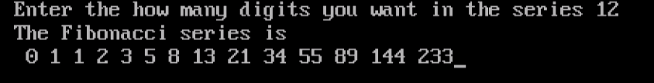

**Program no. 25**

**//Write the program to find the addition of 1D array.**

#include<iostream.h>

#include<conio.h>

void main()

{

clrscr();

int i,a[2],sum=0;

cout<<"ARRAY"<<"\n";

cout<<"INPUT THE VALUES"<<endl;

for(i=0;i<=1;i++)

{

cout<<"a["<<i<<"]=";

cin>>a[i];

}

cout<<"output of array"<<endl;

for(i=0;i<=1;i++)

{

cout<<"a["<<i<<"]=";

cout<<a[i]<<endl;

sum=sum+a[i];

}

cout<<"sum= "<<sum<<endl;

}

**OUTPUT**

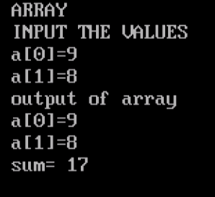

**Program no. 26**

**//Write the program to input and display the elements of 2D array.**

#include<iostream.h>

#include<conio.h>

void main()

{

clrscr();

int i,j,a[20][20],n,m;

cout<<"ARRAY"<<"\n";

cout<<"enter the size of the array(less then 20): ROWS= ";

cin>>n;

cout<<"COLUMNS: ";

cin>>m;

cout<<endl;

cout<<"INPUT THE VALUES"<<endl;

for(i=0;i<n;i++)

{

for(j=0;j<m;j++)

{

cout<<"a["<<i<<"]["<<j<<"]=";

cin>>a[i][j];

}

}

cout<<endl;

cout<<"OUTPUT OF ARRAY"<<endl;

for(i=0;i<n;i++)

{

for(j=0;j<m;j++)

{

cout<<"a["<<i<<"]["<<j<<"]=";

cout<<a[i][j]<<endl;

}

}

}

**OUTPUT**

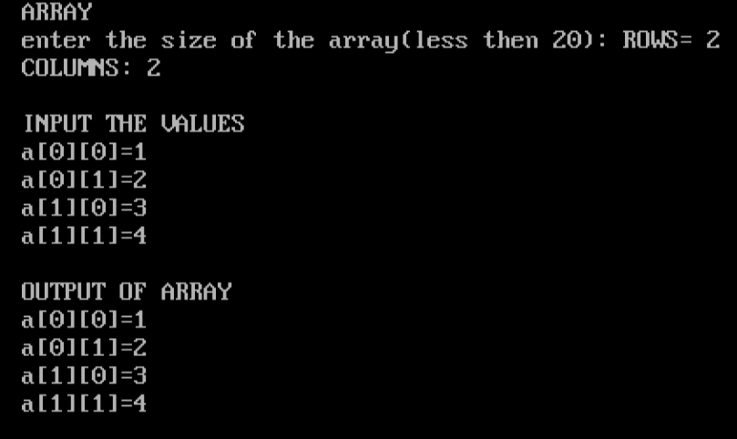

**Program no. 27**

**//Write the Program to Add Two Matrixes.**

#include<iostream.h>

#include<conio.h>

void main()

{

clrscr();

int i,j,a[20][20],b[20][20],c[20][20],n,m;

cout<<"ARRAY"<<"\n";

cout<<"enter the size of the array(less then 20): ROWS= ";

cin>>n;

cout<<"COLUMNS: ";

cin>>m;

cout<<endl;

if(m==n)

{

cout<<"INPUT THE VALUES OF MATRIX A "<<endl;

for(i=0;i<n;i++)

{

for(j=0;j<m;j++)

{

cout<<"a["<<i<<"]["<<j<<"]=";

cin>>a[i][j];

}

}

cout<<endl;

cout<<"INPUT THE VALUES OF MATRIX B "<<endl;

for(i=0;i<n;i++)

{

for(j=0;j<m;j++)

{

cout<<"b["<<i<<"]["<<j<<"]=";

cin>>b[i][j];

}

}

cout<<endl;

for(i=0;i<n;i++)

{

for(j=0;j<m;j++)

{

c[i][j]=a[i][j]+b[i][j];

}

}

cout<<"SUM OF TWO MATRIXES IS "<<endl;

for(i=0;i<n;i++)

{

for(j=0;j<m;j++)

{

cout<<c[i][j]<<"\t";

}

cout<<endl;

}

}

else

{

cout<<"SUM NOT POSSIBLE ";

}

}

**OUTPUT**

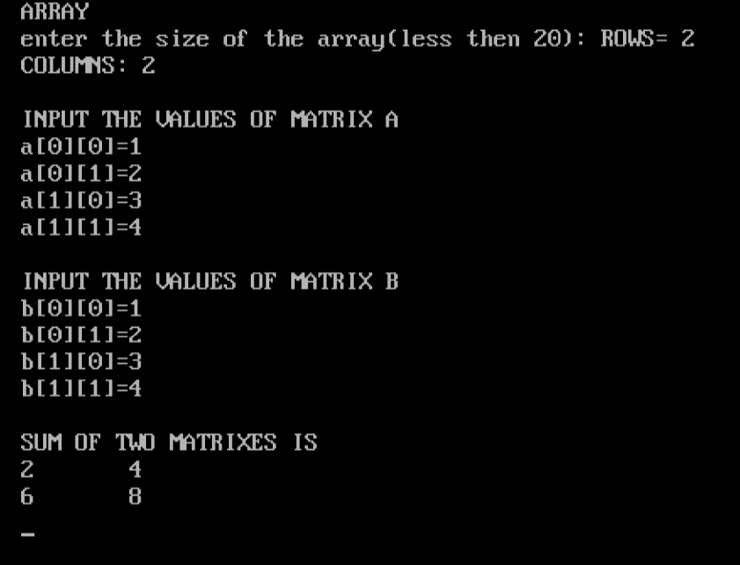

**Program no. 28**

**//Write the program to Transpose Matrix.**

#include<iostream.h>

#include<conio.h>

void main()

{

clrscr();

int i,j,a[20][20],b[20][20],n,m;

cout<<"ARRAY"<<"\n";

cout<<"enter the size of the array(less then 20): ROWS= ";

cin>>n;

cout<<"COLUMNS: ";

cin>>m;

cout<<endl;

if(m==n)

{

cout<<"INPUT THE VALUES "<<endl;

for(i=0;i<n;i++)

{

for(j=0;j<m;j++)

{

cout<<"a["<<i<<"]["<<j<<"]=";

cin>>a[i][j];

}

}

cout<<endl;

cout<<"OUTPUT OF MATRIX "<<endl;

for(i=0;i<n;i++)

{

for(j=0;j<m;j++)

{

cout<<a[i][j]<<"\t";

}

cout<<endl;

}

cout<<endl;

for(i=0;i<n;i++)

{

for(j=0;j<m;j++)

{

b[i][j]=a[j][i];

}

}

cout<<"TRANSPOSE MATRIX IS "<<endl;

for(i=0;i<n;i++)

{

for(j=0;j<m;j++)

{

cout<<b[i][j]<<"\t";

}

cout<<endl;

}

}

else

{

cout<<"SUM NOT POSSIBLE ";

}

}

**OUTPUT**

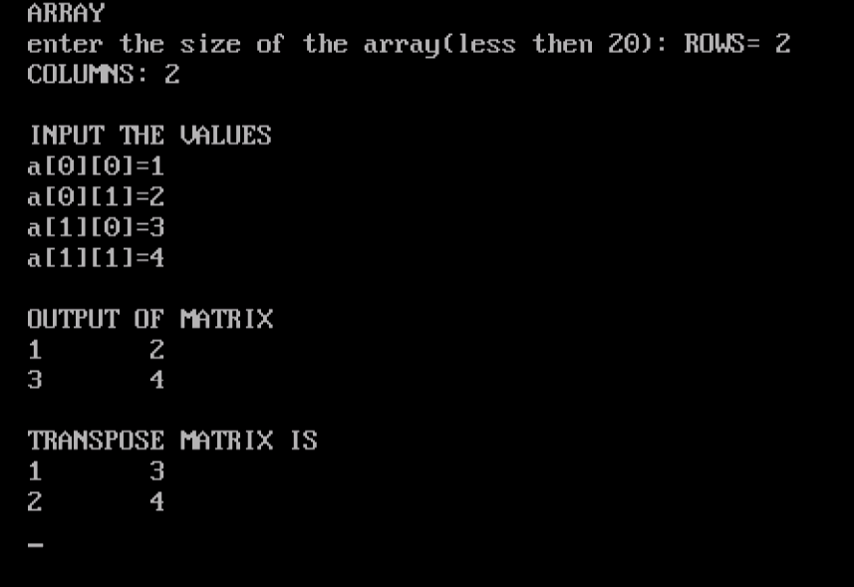

**Program no. 29**

**//Write the** [**Program to Check Whether a Number is Palindrome or Not**](https://www.programiz.com/cpp-programming/examples/palindrome-number)**.**

#include<iostream.h>

#include<conio.h>

void main()

{

clrscr();

int num,no,rev=0,r;

cout<<"enter the number ";

cin>>no;

num=no;

while(no>0)

{

r=no%10;

rev=rev*10+r;

no=no/10;

}

if(rev==num)

{

cout<<"number is PALINDROME ";

}

else

{

cout<<"number is NOT palindrome ";

}

}

**OUTPUT**

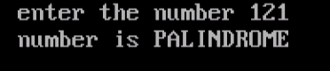

**Program no.30**

**//Write the Program using struct (Name/rollno/branch/semester).**

#include<iostream.h>

#include<conio.h>

struct student

{

char name[20],branch[10];

int rollno,sem;

};

void main()

{

clrscr();

student s;

cout<<"ENTER THE INFORMATION RESPECTIVELY "<<endl;

cout<<"NAME ";

cin>>s.name;

cout<<"ROLL NO. ";

cin>>s.rollno;

cout<<"BRANCH ";

cin>>s.branch;

cout<<"SEMESTER ";

cin>>s.sem;

cout<<endl<<"DISPLAY THE INFORMATION "<<endl;

cout<<"STUDENT NAME= "<<s.name<<endl ;

cout<<"ROLL NO. = "<<s.rollno<<endl;

cout<<"BRANCH= "<<s.branch<<endl;

cout<<"SEMSETER= "<<s.sem<<endl ;

}

**OUTPUT**

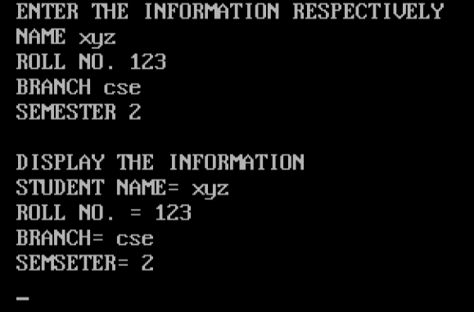

**Program no. 31**

**//Write the Program to find Armstrong number.**

#include<iostream.h>

#include<conio.h>

void main()

{

clrscr();

int n,no,num=0,r;

cout<<"enter the number ";

cin>>n;

no=n;

while(no!=0)

{

r=no%10;

num=num+r*r*r;

no=no/10;

}

if(num==n)

{

cout<<"no. is ARMSTONG NO.";

}

else

{

cout<<"no. is NOT armstrong no. ";

}

}

**OUTPUT**

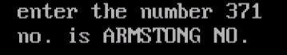

**Program no. 32(i)**

**//Example for no argument and no return type.**

#include<iostream.h>

#include<conio.h>

void sum();

void main()

{

sum();

}

void sum()

{

clrscr();

int a,b,c;

cout<<"Enter two numbers :\n";

cout<<"a= ";

cin>>a;

cout<<"b= ";

cin>>b;

c=a+b;

cout<<"Sum is "<<c;

getch();

}

**OUTPUT**

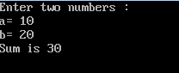

**Program no. 32(ii)**

**//Example for no argument but with return type.**

#include<iostream.h>

#include<conio.h>

int sum();

void main()

{

int s;

s=sum();

cout<<"Sum is "<<s;

}

int sum()

{

clrscr();

int a,b,c;

cout<<"Enter two numbers : ";

cout<<"\nEnter the value of a = ";

cin>>a;

cout<<"Enter the value of b = ";

cin>>b;

c=a+b;

return c;

getch();

}

**OUTPUT**

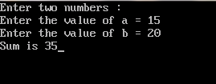

**Program no. 32(iii)**

**//Example for program with argument and no return type.**

#include<iostream.h>

#include<conio.h>

void sum(int,int);

void main()

{

clrscr();

int a,b;

cout<<"Enter two numbers : ";

cout<<"\nValue of a = ";

cin>>a;

cout<<"Value of b = ";

cin>>b;

sum(a,b);

}

void sum(int x,int y)

{

int c;

c=x+y;

cout<<"Sum is = "<<c;

getch();

}

**OUTPUT**

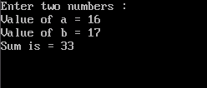

**Program no. 32(iv)**

**//Example for program with an arument and a return type.**

#include<iostream.h>

#include<conio.h>

int sum(int,int);

void main()

{

clrscr();

int a,b;

cout<<"Enter two numbers : ";

cout<<"\nValue of a = ";

cin>>a;

cout<<"Value of b = ";

cin>>b;

cout<<sum(a,b);

}

int sum(int x,int y)

{

int c;

c=x+y;

cout<<"Sum is : ";

return c;

}

**OUTPUT**

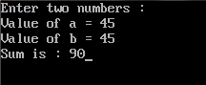

**Program no. 33**

**//Write the Program to find an element in one dimensional array.**

#include<iostream.h>

#include<conio.h>

void main()

{

clrscr();

int i,a[20],n,m;;

cout<<"enter the size of array ";

cin>>n;

cout<<"INPUT THE VALUES"<<endl;

for(i=0;i<n;i++)

{

cout<<"a["<<i<<"]=";

cin>>a[i];

}

cout<<"enter the element which you want to find in the array ";

cin>>m;

for(i=0;i<n;i++)

{

if(a[i]==m)

{

cout<<"ELEMENT IS FOUND AT: a["<<i<<"]";

}

}

}

**OUTPUT**

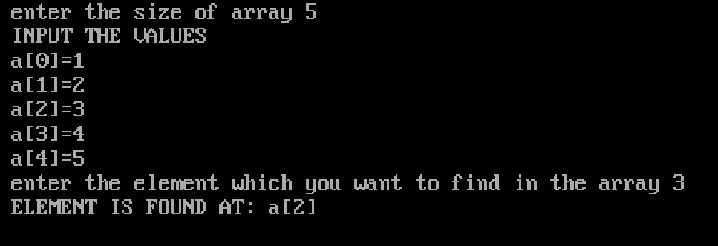

**Program no. 34**

**//Write the Program to find square root of a number.**

#include<iostream.h>

#include<conio.h>

#include<math.h>

void main()

{

clrscr();

float a,n;

cout<<"entre the number ";

cin>>n;

a=pow(n,0.5);

cout<<"squre root of "<<n<<" is: "<<a;

}

**OUTPUT**

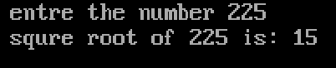

**Program no. 35**

**//Program to find whether an entered Character is a Number, Alphapet Or a Special Character.**

#include<iostream.h>

#include<conio.h>

void main()

{

clrscr();

char ch;

cout<<"Enter any Character : ";

cin>>ch;

if(ch>='0' && ch<='9')

{

cout<<"The character is a NUMBER i.e., "<<ch<<" ";

}

else if((ch>='a' && ch<='z') || (ch>='A' && ch<='Z'))

{

cout<<"The Characer is an ALPHABET i.e., "<<ch<<" ";

}

else

{

cout<<"The character is a SPECIAL CHARACTER i.e., "<<ch<<" ";

}

getch();

}

**OUTPUT :**

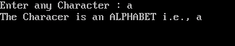



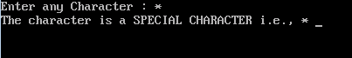

**Practical No. 1**

**INTRODUCTION TO HTML**

**What is HTML ?**

HTML (in long, Hypertext Markup Language) is a markup language used to create Web pages. With HTML, you can make your own Website.

**A Brief History of HTML**

HTML is developed and maintained by World Wide Web (W3C) consortium.

**What is hyper in HTML ?**

In Hypertext Markup Language (HTML), the term hyper signifies the navigation from one location to another in a non-linear fashion. That is, clicking a hypertext on a Web page takes you to the relevant page on Internet or Web site, which is not necessarily the next page on the Web site.

**What HTML defines ?**

HTML defines the content, i.e., the [structure](https://codescracker.com/html/html-structure.htm) and layout of a Web page with the help of [tags](https://codescracker.com/html/html-elements.htm) and [attributes](https://codescracker.com/html/html-attributes.htm). An element includes start and end tags, with some content inside/within them, and attributes provide additional information (such as alignment of element on a Web page) about the elements.

Hypertext Markup Language (HTML) is one of the most commonly used language to design and develop web pages. To create a web page using HTML, you must have to be familiar with the HTML basics.

So learn HTML basics such as tags and the content embedded within the HTML tags, attributes and the data types.

HTML tags instruct the web browser about how it should interpret the document. The attributes of the tag provide the additional information such as its behaviour and properties. The content is displayed on the browser according to the properties and behaviours defined by the tag and the attributes.

**A Simple HTML Document**

**Example**

<! DOCTYPE html>  
<html>  
<head>  
<title>Page Title</title>  
</head>  
<body>  
<h1>My First Heading</h1>  
<p>My first paragraph.</p></body>  
</html>

**Example Explained**

* The <!DOCTYPE html> declaration defines this document to be HTML5
* The <html> element is the root element of an HTML page
* The <head> element contains meta information about the document
* The <title> element specifies a title for the document
* The <body> element contains the visible page content
* The <h1> element defines a large heading
* The <p> element defines a paragraph

**HTML TAGS**

HTML tags are element names surrounded by angle brackets:

<tagname>content goes here...</tagname>

* HTML tags normally come **in pairs** like <p> and </p>
* The first tag in a pair is the **start tag,** the second tag is the **end tag**

**HTML PAGE STRUCTURE**

Below is a visualization of an HTML page structure:

<html>

<head>

<title>Page title</title>

</head>

<body>

<h1>This is a heading</h1>

<p>This is a paragraph.</p>

<p>This is another paragraph.</p>

</body>

</html>

**Practical No.2**

**LIST OF TOOLS USED TO DESIGN WEB PAGES WITH BRIEF INTRODUCTION.**

Most of the tools you need to build a website are already on your computer. The three things you must have are:

* [**Text editor**](https://www.thoughtco.com/web-design-4133459)  
  Windows: [Microsoft Notepad](https://www.thoughtco.com/web-design-4133459) - [Find Notepad on Your Windows Machine](https://www.thoughtco.com/find-notepad-on-your-computer-3469134)  
  Macintosh: [Macintosh TextEdit](https://www.thoughtco.com/web-design-4133459) - [Find TextEdit on Your Macintosh](https://www.thoughtco.com/find-textedit-on-your-mac-3469899)  
  Linux: [vi](https://www.thoughtco.com/web-design-4133459) or [Emacs](https://www.thoughtco.com/web-design-4133459)
* [**Web browser**](https://www.thoughtco.com/web-design-4133459)  
  Windows: [Internet Explorer](https://www.thoughtco.com/web-design-4133459)  
  Macintosh: [Safari](https://www.thoughtco.com/web-design-4133459)  
  Linux: [Firefox](https://www.thoughtco.com/web-design-4133459)
* [**FTP client**](https://www.thoughtco.com/web-design-4133459)While FTP is available via command line in Windows, Macintosh, and Linux, it's a lot easier to use a [client](https://www.thoughtco.com/web-design-4133459). There are several good free ones available

These tools are free and available right in your OS, but they don't have a lot of features. If you want to get more advanced features, there are lots of HTML editors available for free and low cost. [Find the Perfect Web Page Editor](https://www.thoughtco.com/html-and-web-page-editors-3468123).

You should also consider installing other browsers like Firefox, [Opera](https://www.thoughtco.com/web-design-4133459), and Safari so that you can test your pages.

Some of the other tools for web designing:

**Usersnap**

This is one of the best website development tools that make work very easy for both the beginners and the developers. It helps them in improving their websites, receiving feedbacks from their users and that too in the form of screenshots, communicating with the visitors and also solving web related issues faster. This is not just enough, this website development tool has a lot more to offer. Its amazing features allow you to communicate more easily with the users, get feedback from them in the form of screenshots to know what they find inconvenient, install a feedback system that runs on almost every browser and also choose a theme that best matches your identity. This web design and development tool helps you make your website more appealing and convenient for your users.

**Powermockup**

Making an effective and interesting presentation is not a piece of cake. Know that good presentation depends on a number of things, including the content, design, style, etc. This website tool helps in making presentation slides more interactive and interesting by providing mock-ups and wire-frames for PowerPoint.

**Hotjar**

This is one of the best tools that help you deal with your website analytics. It makes it easy for you to solve issues related to your website more effectively and quickly. It also helps you record the activity of users more easily.

**Goodbarber**

Creativity is not limited to specific people. There are many people who get creative thoughts and ideas, but because of not having the required skills, they fail to give shape to their ideas. This Goodbarber.com is an effective tool that helps individual who have ideas of their own personalized mobile applications, but they fail to give shape to these ideas due to their lack of skills. This tool provides the best and cheaper alternative to the complicated web design and development projects. It provides a very simple interface with the help of which you can easily make a mobile application.

**ThemifyFlow**

It is very difficult to edit PHP template to even make a simple change or to create Word Press themes, but with the help of this tool, it can be done easily. This tool lets you create your own theme with templates, headers, footers, sidebar and stylish. Now you don’t need CSS or PHP coding anymore to edit your theme. The interface concept provided by ThemifyFlow is very simple and easy to learn and use. It is a perfect tool for people who don’t have the required skills but want to do their work on their own.

**Frontify**

This web application is more like a sharing platform that allows creative people to share their ideas, designs and concepts with others regarding their web projects. It helps in building and improving the community of website developers where they can share, discuss their designs and get feedback from each other.

**TeamDesk**

Creating a database for your company or business is not an easy thing and requires special kinds of skills to do it, but now with the help of this development tool, you can easily create a database for your company just by simply showing your business’s information and structure. The TeamDesk.net provides you an accurate and centralized source of data that you can easily manage. It also gives you a chance to give your team access to the company’s information through an online database system. It also helps you in improving the performance of your business.

**uCoz**

It is an effective and complex website tool that is rated as the best website builder for advance users. It offers a variety of amazing features such as unlimited disk space, data backup and complete website control, etc. This tool allows you to personalize your website and make changes according to your needs.  
Website designing and development tools for the Professionals:

**Komodo Edit**

The Komodo Edit, as the name suggests, is an editing tool that helps developers in writing and editing their codes. It is a multi-language text editor that works on almost all the operating systems,including Windows, LINUX, UNIX, Mac, etc. It also has an amazing feature of auto-code completion that works for different web languages such as HTML, PHP, Java, Ruby, CSS, JavaScript and Perl etc.

**Fontello**

This development tool is one of the best icon font generators. It allows you to choose your favorite from thousands of icon fonts, change or edit them according your needs or requirements. You can also convert the icon fonts into a single font file with the help of this web tool.

**CSS 3.0 Maker**

No matter how much developers love the amazing features of CSS3 but they definitely hate to write syntax because it is a difficult and complicated thing to do and requires a developer to remember almost 100 properties along with their respective prefixes. This tool saves you from all this trouble and makes syntax writing easy for you. This is an online tool that helps you copy and paste the difficult and tricky codes into your styling sheet. It generates code that you can use for styling details including box radii, text and box shadows, transitions, gradients, transforms and rotations, etc. It also shows which mobile and desktop browsers can adopt or support these styling details.

**Dirty Markup**

Coding is a very difficult thing to do and the developers sometimes find it very exhausting because of its complicated nature. It is an effective website application that allows you to clean and format your CSS, HTML and JavaScript easily and fast. It also has combined capabilities of other single-syntax web coding cleaning tools. It makes coding and encoding simple and easy. Just learn the basics of this tool and then you can use it to ease your work.

**BugHerd**

Website bugs are quite common in website designing and development. They make things difficult and complicated and sometimes even disturb the performance of the website. This web tool helps developers in dealing with the bug issues. It automatically resolves minor bug issues, get clients’ feedback and also in tracking the existing and the potential bugs. So, if you ever encounter the bug problems in your website system, then you can easily solve those issues with this effective BugHerd tool.

**Typetester**

This web development tool is very simple and easy to use. It allows you to enter and test different types of font and compare them. You can also change their size and color etc. This amazing web development tool allows you to compare about 36 different types of fonts at one time.

**PageSpeed Insights**

Google has brought remarkable changes in the technology. It has made things easy and simple. Just like its other applications and tools, this web development tool is also very useful and effective. As the name suggests, this tool provides developers information about the front end performance of their Page. It uses the network independent aspect to check and calculate the performance of the page. You can use this PageSpeed Insight to know and improve the performance of your Web Page.

**Amazium**

It is a difficult task to create an attractive and appealing website design, but this tool makes it easy for you. It helps you create a colorful and amazing web design. It allows you to easily and quickly create a website that can be viewed on almost all kinds of devices.

**Webflo**

This amazing web designing tool provides you a wide range of web templates along with UI designs. It makes designing easy. All you need to do is to take care of your design and this tool will automatically generate codes for your design.

**Bootstrap**

This amazing web designing tool makes front end web development easy, simple and fast for you. It is designed for both developers and beginners and can be used for all kinds of web projects or devices. It uses a single code base to scale websites and applications.

**BrowserStack**

There are a variety of different browsers available. The developers are required to make sure that the website they have designed and developed must be compatible with all of these browsers for a smoother and better performance. This web-browser testing tool allows developers to test their designed websites. It has access to almost all the mobile and desktop browsers and makes it easy for developers to test if their designed website is compatible with these browsers or not.

**CrossBrowser Testing**

This web-browser tool also helps developers to test their websites on different web browsers. It is an advanced testing tool that provides access to more than 130 web and mobile browsers and 25 different operating systems. Developers can easily use this tool to ensure that their designed website is compatible with all of the browsers and operating systems. It also allows them to compare their website with other browsers and know the differences.

**Summary**

These website designing and development tools offers a variety of different functions that can be used for simplifying and understanding the coding, encoding, designing and developing process of the website. You do not need to develop any kind of special skills for using these website development tools. All you need to do is to check out the tools, tutorials, read out the instructions carefully and understand the basic features before using it because only then you will be able to use these website tools.

**Practical No.3**

**CODE TO IMPLEMENT CONCEPT OF LINKS.**

**HTML LINKS**

Links are found in nearly all web pages. Links allow users to click their way from page to page.

HTML Links – Hyperlinks

HTML links are hyperlinks. You can click on a link and jump to another document .When you move the mouse over a link, the mouse arrow will turn into a little hand.

**HTML LINKS – SYNTAX**

In HTML, links are defined with the **<a>** tag:

<a href="*url*">*link text*</a>

***EXAMPLE***

<a href="https://www.w3schools.com/html/">Visit our HTML tutorial</a>

The **href** attribute specifies the destination address of the link. The **link text** is the visible part .Clicking on the link text will send you to the specified address.

**Note:** Without a forward slash on subfolder addresses, you might generate two requests to the server. Many servers will automatically add a forward slash to the address, and then create a new request.

**Local Links**

The example above used an absolute URL (A full web address).A local link (link to the same web site) is specified with a relative URL (without http://www....).

***Example***

<a href="html_images.asp">HTML Images</a>

**HTML LINK COLORS**

By default, a link will appear like this (in all browsers):

* An unvisited link is underlined and blue
* A visited link is underlined and purple
* An active link is underlined and red

***Example***

<style>  
a:link {  
    color: green;   
    background-color: transparent;   
    text-decoration: none;  
}  
  
a:visited {  
    color: pink;  
    background-color:transparent;  
    text-decoration: none;  
}  
  
a:hover {  
    color: red;  
    background-color:transparent;  
    text-decoration:underline;  
}  
  
a:active {  
    color: yellow;  
    background-color:transparent;  
    text-decoration:underline;  
}  
</style>

**HTML LINKS - THE TARGET ATTRIBUTE**

The **target** attribute specifies where to open the linked document.

The target attribute can have one of the following values:

* _blank - Opens the linked document in a new window or tab
* _self - Opens the linked document in the same window/tab as it was clicked (this is default)
* _parent - Opens the linked document in the parent frame
* _top - Opens the linked document in the full body of the window
* Frame name - Opens the linked document in a named frame

This example will open the linked document in a new browser window/tab:

***Example***

<a href="https://www.w3schools.com/"target="_blank">Visit W3Schools!</a>

***Example***

<a href="https://www.w3schools.com/html/"target="_top">HTML5 tutorial!</a>

**HTML LINKS - IMAGE AS LINK**

It is common to use images as links:

***Example***

<a href="default.asp">  
  <img src="smiley.gif"alt="HTML tutorial"style="width:42 px;height:42 px;border:0;">  
</a>

**Note:** border: 0; is added to prevent IE9 (and earlier) from displaying a border around the image (when the image is a link).

**HTML LINKS - CREATE A BOOKMARK**

HTML bookmarks are used to allow readers to jump to specific parts of a Web page. Bookmarks can be useful if your webpage is very long. To make a bookmark, you must first create the bookmark, and then add a link to it. When the link is clicked, the page will scroll to the location with the bookmark.

***Example***

First, create a bookmark with the id attribute:

<h2 id="C4">Chapter 4</h2>

Then, add a link to the bookmark ("Jump to Chapter 4"), from within the same page:

<a href="#C4">Jump to Chapter 4</a>

Or, add a link to the bookmark ("Jump to Chapter 4"), from another page:

***Example***

<a href="html_demo.html#C4">Jump to Chapter 4</a>

**EXTERNAL PATHS**

External pages can be referenced with a full URL or with a path relative to the current web page. This example uses a full URL to link to a web page:

***Example***

<a href="https://www.w3schools.com/html/default.asp">HTML tutorial</a>

This example links to a page located in the html folder on the current web site:

***Example***

<a href="/html/default.asp">HTML tutorial</a>

This example links to a page located in the same folder as the current page:

***Example***

<a href="default.asp">HTML tutorial</

**HTML LINKS COLORS**

When you place your mouse cursor over a link, then you will watch the following two things will happen normally:

the arrow of the mouse will turn into a little hand

the color of the link element will change

By default, the link will appear as in all browsers:

|  |  |
| --- | --- |
| Link | Appearance |
| unvisited link | underline and blue |
| visited link | underline and purple |
| active link | underline and red |

**Practical No.4**

**CODE TO IMPLEMENT CONCEPT OF TABLES.**

**Defining an HTML Table**

An HTML table is defined with the **<table>** tag.

Each table row is defined with the **<tr>** tag. A table header is defined with the **<th>** tag. By default, table headings are bold and centered. A table data/cell is defined with the **<td>** tag.

***Example***

<table style="width:100%">  
  <tr>  
    <th>Firstname</th>  
    <th>Lastname</th>   
    <th>Age</th>  
  </tr>  
  <tr>  
    <td>Jill</td>  
    <td>Smith</td>   
    <td>50</td>  
  </tr>  
  <tr>  
    <td>Eve</td>  
    <td>Jackson</td>   
    <td>94</td>  
  </tr>  
</table>

**Note:** The <td> elements are the data containers of the table.  
They can contain all sorts of HTML elements; text, images, lists, other tables, etc.

**HTML Table Example**

|  |  |  |
| --- | --- | --- |
| Company | Contact | Country |
| Alfreds Futterkiste | Maria Anders | Germany |
| Centro comercial Moctezuma | Francisco Chang | Mexico |
| Ernst Handel | Roland Mendel | Austria |
| Island Trading | Helen Bennett | UK |
| Laughing Bacchus Winecellars | Yoshi Tannamuri | Canada |
| Magazzini Alimentari Riuniti | Giovanni Rovelli | Italy |

**HTML TABLE - ADDING A BORDER**

If you do not specify a border for the table, it will be displayed without borders.

A border is set using the CSS **border** property:

***Example***

table, th, td {  
    border: 1px solid black;  
}

Remember to define borders for both the table and the table cells.

**HTML TABLE - COLLAPSED BORDERS**

If you want the borders to collapse into one border, add the CSS **border-collapse** property:

***Example***

table, th, td {  
    border: 1px solid black;  
    border-collapse: collapse;  
}

**HTML TABLE - ADDING CELL PADDING**

Cell padding specifies the space between the cell content and its borders.

If you do not specify a padding, the table cells will be displayed without padding.

To set the padding, use the CSS **padding** property:

***Example***

th, td {  
    padding: 15px;  
}

**HTML TABLE - LEFT-ALIGN HEADINGS**

By default, table headings are bold and centered.

To left-align the table headings, use the CSS **text-align** property:

***Example***

th {  
    text-align: left;  
}

**HTML TABLE - ADDING BORDER SPACING**

Border spacing specifies the space between the cells.

To set the border spacing for a table, use the CSS **border-spacing** property:

***Example***

table {  
    border-spacing: 5px;  
}

**Note:** If the table has collapsed borders, border-spacing has no effect.

**HTML TABLE - CELLS THAT SPAN MANY COLUMNS**

To make a cell span more than one column, use the **colspan** attribute:

***Example***

<table style="width:100%">  
  <tr>  
    <th>Name</th>  
    <th colspan="2">Telephone</th>  
  </tr>  
  <tr>  
    <td>Bill Gates</td>  
    <td>55577854</td>  
    <td>55577855</td>  
  </tr>  
</table>

**HTML TABLE - CELLS THAT SPAN MANY ROWS**

To make a cell span more than one row, use the **rowspan** attribute:

***Example***

<table style="width:100%">  
  <tr>  
    <th>Name:</th>  
    <td>Bill Gates</td>  
  </tr>  
  <tr>  
    <th rowspan="2">Telephone:</th>  
    <td>55577854</td>  
  </tr>  
  <tr>  
    <td>55577855</td>  
  </tr>  
</table>

**HTML TABLE - ADDING A CAPTION**

To add a caption to a table, use the **<caption>** tag:

***Example***

<table style="width:100%">  
  <caption>Monthly savings</caption>  
  <tr>  
    <th>Month</th>  
    <th>Savings</th>  
  </tr>  
  <tr>  
    <td>January</td>  
    <td>$100</td>  
  </tr>  
  <tr>  
    <td>February</td>  
    <td>$50</td>  
  </tr>  
</table>

**Note:** The <caption> tag must be inserted immediately after the <table> tag.

**A SPECIAL STYLE FOR ONE TABLE**

To define a special style for a special table, add an **id** attribute to the table:

***Example***

<table id="t01">  
  <tr>  
    <th>Firstname</th>  
    <th>Lastname</th>   
    <th>Age</th>  
  </tr>  
  <tr>  
    <td>Eve</td>  
    <td>Jackson</td>   
    <td>94</td>  
  </tr>  
</table>

Now you can define a special style for this table:

table#t01 {  
    width: 100%;   
    background-color: #f1f1c1;  
}

And add more styles:

table#t01 tr:nth-child(even) {  
    background-color: #eee;  
}  
table#t01 tr:nth-child(odd) {  
    background-color: #fff;  
}  
table#t01 th {  
    color: white;  
    background-color: black;  
}

**SUMMARY OF POINTS:**

1. Use the HTML **<table>** element to define a table
2. Use the HTML **<tr>** element to define a table row
3. Use the HTML **<td>** element to define a table data
4. Use the HTML **<th>** element to define a table heading
5. Use the HTML **<caption>** element to define a table caption
6. Use the CSS **border** property to define a border
7. Use the CSS **border-collapse** property to collapse cell borders
8. Use the CSS **padding** property to add padding to cells
9. Use the CSS **text-align** property to align cell text
10. Use the CSS **border-spacing** property to set the spacing between cells
11. Use the **colspan** attribute to make a cell span many columns
12. Use the **rowspan** attribute to make a cell span many rows
13. Use the **id** attribute to uniquely define one table

**Practical No.5**

**CODE TO IMPLEMENT CONCEPT OF LISTS**

HTML allows you to display the information in the form of lists. These information in these lists may be presented in an ordered and sequential manner or in an unordered and random manner. Here are the list of tags used in displaying the list in an HTML document:

|  |  |
| --- | --- |
| Tag | Description |
| OL | used to display the list of information in an ordered of sequence |
| UL | used to display the information in an unordered list |
| LI | defines a list item |
| DL | allows you to include the description of the items in the UL or OL lists |
| DT | defines the term in a description list |
| DD | defines the description in a description list |

**HTML List Example**

* An Unordered List:

Item

Item

Item

Item

* An Ordered List:

First item

Second item

Third item

Fourth item

**UNORDERED HTML LIST**

An unordered list starts with the **<ul>** tag. Each list item starts with the **<li>** tag.

The list items will be marked with bullets (small black circles) by default:

**Example**

<ul>  
  <li>Coffee</li>  
  <li>Tea</li>  
  <li>Milk</li>  
</ul>

**UNORDERED HTML LIST**

Choose List Item Marker

The CSS **list-style-type** property is used to define the style of the list item marker:

|  |  |
| --- | --- |
| Value | Description |
| Disc | Sets the list item marker to a bullet (default) |
| Circle | Sets the list item marker to a circle |
| Square | Sets the list item marker to a square |
| None | The list items will not be marked |

***Example*** - Disc

<ul style="list-style-type:disc">  
  <li>Coffee</li>  
  <li>Tea</li>  
  <li>Milk</li>  
</ul>

***Example*** - Circle

<ul style="list-style-type:circle">  
  <li>Coffee</li>  
  <li>Tea</li>  
  <li>Milk</li>  
</ul>

***Example*** - Square

<ul style="list-style-type:square">  
  <li>Coffee</li>  
  <li>Tea</li>  
  <li>Milk</li>  
</ul>

***Example*** - None

<ul style="list-style-type:none">  
  <li>Coffee</li>  
  <li>Tea</li>  
  <li>Milk</li>  
</ul>

**ORDERED HTML LIST**

An ordered list starts with the **<ol>** tag. Each list item starts with the **<li>** tag.

The list items will be marked with numbers by default:

***Example***

<ol>  
  <li>Coffee</li>  
  <li>Tea</li>  
  <li>Milk</li>  
</ol>

**ORDERED HTML LIST - THE TYPE ATTRIBUTE**

The **type** attribute of the <ol> tag, defines the type of the list item marker:

|  |  |
| --- | --- |
| Type | Description |
| type="1" | The list items will be numbered with numbers (default) |
| type="A" | The list items will be numbered with uppercase letters |
| type="a" | The list items will be numbered with lowercase letters |
| type="I" | The list items will be numbered with uppercase roman numbers |
| type="i" | The list items will be numbered with lowercase roman numbers |

Numbers:

<ol type="1">  
  <li>Coffee</li>  
  <li>Tea</li>  
  <li>Milk</li>  
</ol>

Uppercase Letters:

<ol type="A">  
  <li>Coffee</li>  
  <li>Tea</li>  
  <li>Milk</li>  
</ol>

Lowercase Letters:

<ol type="a">  
  <li>Coffee</li>  
  <li>Tea</li>  
  <li>Milk</li>  
</ol>

Uppercase Roman Numbers:

<ol type="I">  
  <li>Coffee</li>  
  <li>Tea</li>  
  <li>Milk</li>  
</ol>

Lowercase Roman Numbers:

<ol type="i">  
  <li>Coffee</li>  
  <li>Tea</li>  
  <li>Milk</li>  
</ol>

**HTML DESCRIPTION LISTS**

HTML also supports description lists.

A description list is a list of terms, with a description of each term.

The **<dl>** tag defines the description list, the **<dt>** tag defines the term (name), and the **<dd>** tag describes each term:

***Example***

<dl>  
  <dt>Coffee</dt>  
  <dd>- black hot drink</dd>  
  <dt>Milk</dt>  
  <dd>- white cold drink</dd>  
</dl>

**NESTED HTML LISTS**

List can be nested (lists inside lists):

***Example***

<ul>  
  <li>Coffee</li>  
  <li>Tea  
    <ul>  
      <li>Black tea</li>  
      <li>Green tea</li>  
    </ul>  
  </li>  
  <li>Milk</li>  
</ul>

**Note:** List items can contain new list, and other HTML elements, like images and links, etc.

**HORIZONTAL LISTS**

HTML lists can be styled in many different ways with CSS.

One popular way is to style a list horizontally, to create a menu:

**Example**

<!DOCTYPE html>  
<html>  
<head>  
<style>  
ul {  
    list-style-type: none;  
    margin: 0;  
    padding: 0;  
    overflow: hidden;  
    background-color: #333333;  
}  
  
li {  
    float: left;  
}  
  
li a {  
    display: block;  
    color: white;  
    text-align: center;  
    padding: 16px;  
    text-decoration: none;  
}  
  
li a:hover {  
    background-color: #111111;  
}  
</style>  
</head>  
<body>  
  
<ul>  
  <li><a href="#home">Home</a></li>  
  <li><a href="#news">News</a></li>  
  <li><a href="#contact">Contact</a></li>  
  <li><a href="#about">About</a></li>  
</ul>  
  
</body>  
</html>

## SUMMARY WITH POINTS:

* Use the HTML **<ul>** element to define an unordered list
* Use the CSS**list-style-type** property to define the list item marker
* Use the HTML **<ol>** element to define an ordered list
* Use the HTML **type** attribute to define the numbering type
* Use the HTML **<li>** element to define a list item
* Use the HTML **<dl>** element to define a description list
* Use the HTML **<dt>** element to define the description term
* Use the HTML **<dd>** element to describe the term in a description list
* Lists can be nested inside lists
* List items can contain other HTML elements
* Use the CSS property **float:left** or **display:inline**to display a list horizontally

**Practical No.6**

**CODE TO IMPLEMENT CONCEPT OF VIDEO AND AUDIO.**

**HTML VIDEO**

A video file is a collection of images that is displayed in a sequence representing scenes in motion.

Similar to the audio file system, video files are also encoded or decoded using the various video codecs, such as DivX and QuickTime.

**List of Commonly Used Video File Formats**

The table given below lists commonly used video file formats.

|  |  |  |
| --- | --- | --- |
| **Format** | **File** | **Description** |
| MPEG | .mpg .mpeg | MPEG. Developed by the Moving Pictures Expert Group. The first popular video format on the web. Used to be supported by all browsers, but it is not supported in HTML5 (See MP4) |
| MPEG-4 or MP4 | .mp4 | MP4. Developed by the Moving Pictures Expert Group. Based on QuickTime. Commonly used in newer video cameras and TV hardware. Supported by all HTML5 browsers. Recommended by YouTube |
| AVI | .avi | AVI (Audio Video Interleave). Developed by Microsoft. Commonly used in video cameras and TV hardware. Plays well on Windows computers, but not in web browsers |
| QuickTime | .mov | QuickTime. Developed by Apple. Commonly used in video cameras and TV hardware. Plays well on Apple computers, but not in web browsers. (See MP4) |
| Flash | .swf .flv | Flash. Developed by Macromedia. Often requires an extra component (plug-in) to play in web browsers |
| RealVideo | .rm .ram | RealVideo. Developed by Real Media to allow video streaming with low bandwidths. It is still used for online video and Internet TV, but does not play in web browsers |
| WMV | .wmv | WMV (Windows Media Video). Developed by Microsoft. Commonly used in video cameras and TV hardware. Plays well on Windows computers, but not in web browsers |
| WebM | .webm | WebM. Developed by the web giants, Mozilla, Opera, Adobe, and Google. Supported by HTML5 |
| Ogg | .ogg | Theora Ogg. Developed by the Xiph.Org Foundation. Supported by HTML5 |

**HTML <video> tag**

To show a video in HTML, use the <video> tag. Let's look at the following example, to know how to embed video into your webpage.

<video width="320" height="240" controls>

<source src="song.mp4" type="video/mp4">

<source src="song.ogg" type="video/ogg">

Your browser does not support the video tag.

</video>

**HTML Video Working**

The controls attribute adds video controls, like play, pause, and volume.

It is a good idea to always include width and height attributes. If height and width are not set, the browser does not know the size of the video. The effect will be that the page will change (or flicker) while the video loads.

Text between the <video> and </video> tags will only display in browsers that do not support the <video> tag.

Multiple <source> tags can link to different video files. The browser will use the first recognized format.

**HTML <video> Autoplay**

To start a video automatically use the autoplay attribute.

Let's look at the following example, to know hot to embed video and set to autoplay when web page loads.

<video width="320" height="240" autoplay>

<source src="songs.mp4" type="video/mp4">

<source src="songs.ogg" type="video/ogg">

Your browser does not support the video tag.

</video>

**HTML AUDIO**

An audio file is used to store audio data on various data, such as a computer system, mp3 players, and mobile phones.

To store an audio data, you need to convert it into a digital format. The process of converting audio data into a digital file is called encoding of the raw audio data. It involves taking samples of audio data and storing them in a compressed format to reduce the file size.

An audio player decodes these compressed sample files to make the audio waves audible. The process of converting a digital file into the audio data is known as decoding. A codec is performs the encoding and decoding of the raw audio data.

**List of Commonly Used Audio File Formats**

The table given below lists commonly used audio file formats:

|  |  |  |
| --- | --- | --- |
| **Format** | **File Extension** | **Description** |
| MIDI | .mid .midi | MIDI (Musical Instrument Digital Interface). Main format for all electronic music devices like synthesizers and PC sound cards. MIDI files do not contain sound, but digital notes that can be played by electronics. Plays well on all computers and music hardware, but not in web browsers |
| WMA | .wma | WMA (Windows Media Audio). Developed by Microsoft. Commonly used in music players. Plays well on Windows computers, but not in web browsers |
| RealAudio | .rm .ram | RealAudio. Developed by Real Media to allow streaming of audio with low bandwidths. Does not play in web browsers |
| WAV | .wav | WAV. Developed by IBM and Microsoft. Plays well on Windows, Macintosh, and Linux operating systems. Supported by HTML5 |
| AAC | .aac | AAC (Advanced Audio Coding). Developed by Apple as the default format for iTunes. Plays well on Apple computers, but not in web browsers |
| MP3 | .mp3 | MP3 files are actually the sound part of MPEG files. MP3 is the most popular format for music players. Combines good compression (small files) with high quality. Supported by all browsers |
| Ogg | .ogg | Ogg. Developed by the Xiph.Org Foundation. Supported by HTML5 |
| MP4 | .mp4 | MP4 is a video format, but can also be used for audio. MP4 video is the upcoming video format on the internet. This leads to automatic support for MP4 audio by all browsers |

**HTML <audio> tag**

To play an [audio file in HTML](https://codescracker.com/html/html-audio-video.htm), use the <audio> tag.

Let's look at the following example, to know how to embed audio files into your web page.

<audio controls>

<source src="songs.ogg" type="audio/ogg">

<source src="songs.mp3" type="audio/mpeg">

Your browser does not support the audio tag.

</audio>

**HTML Audio Working**

The controls attribute adds audio controls, like play, pause, and volume.

Text between the <audio> and </audio> tags will display in browsers that do not support the <audio> tag.

Multiple <source> tags can link to different audio files. The browser will use the first recognized format

**Practical No.7**

**CODE TO IMPLEMENT CONCEPT OF FORMS.**

A **FORM** is an area of a Web page that allows the users to provide their information in a variety of ways, such as by entering the text field or by selecting one or more available options from the provided list.

HTML enables you to add a form in a Web page by using the FORM tag. After adding the form on the Web page, you can add various controls, such as buttons and text fields, on the form by using a variety of tags. Some examples of these elements are INPUT, BUTTON,TEXTAREA, and DATALIST.

**The <form> Element**

The HTML **<form>** element defines a form that is used to collect user input:

<form>  
*form elements*  
</form>

An HTML form contains **form elements**.

Form elements are different types of input elements, like text fields, checkboxes, radio buttons, submit buttons, and more.

**The <input> Element**

The **<input>** element is the most important form element.

The <input> element can be displayed in several ways, depending on the **type** attribute.

Here are some examples:

|  |  |
| --- | --- |
| **Type** | **Description** |
| <input type="text"> | Defines a one-line text input field |
| <input type="radio"> | Defines a radio button (for selecting one of many choices) |
| <input type="submit"> | Defines a submit button (for submitting the form) |

You will learn a lot more about input types later in this tutorial.

**Text Input**

**<input type="text">** defines a one-line input field for **text input**:

***Example***

<form>  
  First name:<br>  
  <input type="text" name="firstname"><br>  
  Last name:<br>  
  <input type="text" name="lastname">  
</form>

This is how it will look like in a browser:

First name:  
  
Last name:  


**RADIO BUTTON INPUT**

**<input type="radio">** defines a **radio button**.

Radio buttons let a user select ONE of a limited number of choices:

**Example**

<form>  
  <input type="radio" name="gender" value="male" checked> Male<br>  
  <input type="radio" name="gender" value="female"> Female<br>  
  <input type="radio" name="gender" value="other"> Other  
</form>

This is how the HTML code above will be displayed in a browser:

 Male  
 Female  
 Other

**The Submit Button**

**<input type="submit">** defines a button for **submitting** the form data to a **form-handler**.

The form-handler is typically a server page with a script for processing input data.

The form-handler is specified in the form's **action** attribute:

**Example**

<form action="/action_page.php">  
  First name:<br>  
  <input type="text" name="firstname" value="Mickey"><br>  
  Last name:<br>  
  <input type="text" name="lastname" value="Mouse"><br><br>  
  <input type="submit" value="Submit">  
</form>

**This is how the HTML code above will be displayed in a browser**:

Top of Form

First name:  
   
Last name:  
   
  


Bottom of Form

**THE ACTION ATTRIBUTE**

The **action** attribute defines the action to be performed when the form is submitted.

Normally, the form data is sent to a web page on the server when the user clicks on the submit button.

In the example above, the form data is sent to a page on the server called "/action_page.php". This page contains a server-side script that handles the form data:

<form **action="/action_page.php**">

If the action attribute is omitted, the action is set to the current page.

**THE METHOD ATTRIBUTE**

The **method** attribute specifies the HTTP method (**GET**or **POST**) to be used when submitting the form data:

<form action="/action_page.php" **method="get"**>

or:

<form action="/action_page.php" **method="post"**>

**WHEN TO USE GET?**

The default method when submitting form data is GET.

However, when GET is used, the submitted form data will be **visible in the page address field**:

/action_page.php?firstname=Mickey&lastname=Mouse

**Note:** GET must NOT be used when sending sensitive information! GET is best suited for short, non-sensitive, amounts of data, because it has size limitations too.

**WHEN TO USE POST?**

Always use POST if the form data contains sensitive or personal information. The POST method does not display the submitted form data in the page address field.

POST has no size limitations, and can be used to send large amounts of data.

**THE NAME ATTRIBUTE**

Each input field must have a **name** attribute to be submitted.

If the name attribute is omitted, the data of that input field will not be sent at all.

This example will only submit the "Last name" input field:

***Example***

<form action="/action_page.php">  
  First name:<br>  
  <input type="text" value="Mickey"><br>  
  Last name:<br>  
  <input type="text" name="lastname" value="Mouse"><br><br>  
  <input type="submit" value="Submit">  
</form>

Grouping Form Data with <fieldset>

The **<fieldset>** element is used to group related data in a form.

The **<legend>** element defines a caption for the <fieldset> element.

Example

<form action="/action_page.php">  
  <fieldset>  
    <legend>Personal information:</legend>  
    First name:<br>  
    <input type="text" name="firstname" value="Mickey"><br>  
    Last name:<br>  
    <input type="text" name="lastname" value="Mouse"><br><br>  
    <input type="submit" value="Submit">  
  </fieldset>  
</form>

**This is how the HTML code above will be displayed in a browser:**

Top of Form

Personal information:First name:  
   
Last name:  
   
  


Bottom of Form

**Practical No.8**

**CODE TO IMPLEMENT CONCEPT OF FRAMES.**

**IFRAME SYNTAX**

An HTML iframe is defined with the **<iframe>** tag:

<iframe src="URL"></iframe>

The **src** attribute specifies the URL (web address) of the inline frame page.

**IFRAME - SET HEIGHT AND WIDTH**

Use the **height** and **width** attributes to specify the size of the iframe.

The attribute values are specified in pixels by default, but they can also be in percent (like "80%").

***Example***

<iframe src="demo_iframe.htm" height="200" width="300"></iframe>

**IFRAME - REMOVE THE BORDER**

By default, an iframe has a border around it.

To remove the border, add the **style** attribute and use the CSS **border** property:

***Example***

<iframe src="demo_iframe.htm" style="border:none;"></iframe>

**IFRAME - TARGET FOR A LINK**

An iframe can be used as the target frame for a link.

The **target** attribute of the link must refer to the **name** attribute of the iframe:

***Example***

<iframe src="demo_iframe.htm" name="iframe_a"></iframe>  
  
<p><a href="https://www.w3schools.com" target="iframe_a">W3Schools.com</a></p>

**HTML IFRAME TAG**

|  |  |
| --- | --- |
| Tag | Description |
| [<iframe>](https://www.w3schools.com/tags/tag_iframe.asp) | Defines an inline frame |

**Practical No.9**

**CODE TO IMPLEMENT CONCEPT OF META TAG.**

**Definition and Usage**

Metadata is data (information) about data.

The <meta> tag provides metadata about the HTML document. Metadata will not be displayed on the page, but will be machine parsable.

Meta elements are typically used to specify page description, keywords, author of the document, last modified, and other metadata.

The metadata can be used by browsers (how to display content or reload page), search engines (keywords), or other web services.

HTML5 introduced a method to let web designers take control over the viewport (the user's visible area of a web page), through the <meta> tag (See "Setting The Viewport" example below).

***Example***

Describe metadata within an HTML document:

<head>  
  <meta charset="UTF-8">  
  <meta name="description" content="Free Web tutorials">  
  <meta name="keywords" content="HTML,CSS,XML,JavaScript">  
  <meta name="author" content="John Doe">  
  <meta name="viewport" content="width=device-width, initial-scale=1.0">  
</head>

***TIPS AND NOTES***

Note: <Meta> tags always go inside the <head> element.

Note: Metadata is always passed as name/value pairs.

Note: The content attribute MUST be defined if the name or the http-equiv attribute is defined. If none of these are defined, the content attribute CANNOT be defined.

**Setting The Viewport**

HTML5 introduced a method to let web designers take control over the viewport, through the <meta> tag.

The viewport is the user's visible area of a web page. It varies with the device, and will be smaller on a mobile phone than on a computer screen.

You should include the following <meta> viewport element in all your web pages:

<meta name="viewport" content="width=device-width, initial-scale=1.0">

A <Meta> viewport element gives the browser instructions on how to control the page's dimensions and scaling.

The width=device-width part sets the width of the page to follow the screen-width of the device (which will vary depending on the device).

The initial-scale=1.0 part sets the initial zoom level when the page is first loaded by the browser.

Here is an example of a web page without the viewport meta tag, and the same web page with the viewport meta tag:

**Tip:** If you are browsing this page with a phone or a tablet, you can click on the two links below to see the difference.

[](https://www.w3schools.com/html/example_withoutviewport.htm) [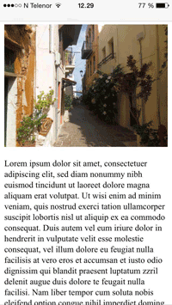](https://www.w3schools.com/html/example_withviewport.htm)

**Without the viewport meta tag**  **With the viewport meta tag**

**Practical No.10**

**INTRODUCTION TO CSS**

**WHAT IS CSS?**

* **CSS** stands for **C**ascading **S**tyle **S**heets
* CSS describes **how HTML elements are to be displayed on screen, paper, or in other media**
* CSS **saves a lot of work**. It can control the layout of multiple web pages all at once
* External stylesheets are stored in **CSS files**

HTML with CSS is used to design web page more interactive.

For now, let's take a quick look at HTML with CSS to create some interactive web pages. You can style your HTML elements in one of the following three ways:

* internal CSS
* external CSS
* inline CSS

**WHY USE CSS?**

CSS is used to define styles for your web pages, including the design, layout and variations in display for different devices and screen sizes.

**CSS SOLVED A BIG PROBLEM**

HTML was NEVER intended to contain tags for formatting a web page!

HTML was created to **describe the content** of a web page, like:

<h1>This is a heading</h1>

<p>This is a paragraph.</p>

When tags like <font>, and color attributes were added to the HTML 3.2 specification, it started a nightmare for web developers. Development of large websites, where fonts and color information were added to every single page, became a long and expensive process.

To solve this problem, the World Wide Web Consortium (W3C) created CSS.

CSS removed the style formatting from the HTML page!

**CSS SAVES A LOT OF WORK!**

The style definitions are normally saved in external .css files.

With an external stylesheet file, you can change the look of an entire website by changing just one file!

**HTML CSS SYNTAX**

You can use the following general form to use HTML with CSS:

element{property1:value1;property2:value2;}

Here, the element is an HTML element name.

The property is a CSS property.

The value is a CSS value.

Multiple styles are separated with semicolon.

**CODE OF THE WEBPAGE PREPAIRED DURING TERAINING**

<html>

<head>

<title>Registration form</title>

<b><center><font size="10">REGISTRATION/ENQUIRY</font></center></b></br>

</head>

<body>

<img src="http://www.rayatbahrauniversity.edu.in/wp-content/uploads/2017/05/logo-11.png" width="200" height="72">

<span style="margin-left:40em">

<img src="http://www.rayatbahra.com/rayat_bahra_pictures/logo_trans.png" align="right" width="200" height="72">

</span>

<img src="http://www.siliconindia.com/images/education/18619.jpeg" width="350" height="72">

<pre > </pre>

<form name="tick"

action=" "

method="post">

Campus preference:

Ropar<input type="radio"

name="campus"

value=" ">

RBU<input type="radio"

name="campus"

value=" ">

Hoshiarpur<input type="radio"

name="campus"

value=" ">

Patiala<input type="radio"

name="campus"

value=" ">

Sonepat<input type="radio"

name="campus"

value=" ">

BU Shimla<input type="radio"

name="campus"

value=" ">

Panipat<input type="radio"

name="campus"

value=" "></br>

<pre > </pre>

Official use: College:<input type="text"

name="College"

value=" "

size= "40"

maxlength="50">

Branch\Course:<input type="text"

name="Branch\Course"

value=" "

size= "5"

maxlength="10">

Date:<input type="date"

name="date"

value=" "

size= " 10"

maxlength="10"></br>

Name of Institute\School\College <input type="line "

name="name"

value=" "

size= "40"

maxlength="50"> </br>

Board\University<input type="line "

name="name"

value=" "

size= "30"

maxlength="50">

<pre > </pre>

<fieldset>

1.Name of Applicant <font size="1">(in capital letters )</font> </br>

<input type="textbox"

name="name"

value=" "

size="50"

maxlength="50"> </br>

2.Date of Birth</br>

<input type="date"

name="date">

<span style="margin-left:4em">

3.Gender <select name="dropdown">

<option value="Male" selected>Male</option>

<option value="Female">Female</option>

<option value="Other ">Other </option>

</select>

</span>

<span style="margin-left:4em">

4.Category

<select name="dropdown">

<option value="general" selected>general</option>

<option value="SC">SC</option>

<option value="ST">ST</option>

<option value="BC">BC</option>

<option value="OBC">OBC</option>

</span>

</select></br>

5.Father's Name:</br>

<input type="text"

name="father's name "

value=" "

size="50"

maxlength="50"></br>

<pre ></pre>

6.Address for Corrspondance</br><textarea name="address"

rows="5"

cols="50">

</textarea></br>

<pre ></pre>

<font size="2">City\Town\Village:<input type="text"

name="City\town\village"

value=" "

size="10"

maxlength="20">

<span style="margin-left:5em">

district<input type="text"

name="district"

value=" "

size="10"

maxlength="20">

</span>

<span style="margin-left:5em">

state<input type="text"

name="state"

value=" "

size="10"

maxlength="20">

</span>

<span style="margin-left:5em">

Pincode <input type="number"

name="pincode "

size="10"

maxlength="6">

</span>

</font></br>

<pre ></pre>

7.Mobile no.<input type="number"

name="mobile no."

value=" "

size="20"

maxlength="10"></br>

<pre ></pre>

8.Email ID<input type="email"

name="email"

size="50"

maxlength="50" >

<pre ></pre>

<style>

table, th, td {

border: 1px solid black;

}

</style>

<table style="width:1%">

<tr>

<th>examination</th>

<th>name of the course</th>

<th>school&place </th>

<th>board/univerty</th>

<th>marks obtained/total</th>

<th>%</th>

</tr>

<tr>

<td>class 10th</td>

<td> </td>

<td><input type="textbox"></td>

<td><input type="textbox"></td>

<td><input type="textbox"></td>

<td><input type="textbox"></td>

</tr>

<tr>

<td>class

10+2/diploma</td>

<td><input type="textbox"></td>

<td><input type="textbox"></td>

<td><input type="textbox"></td>

<td><input type="textbox"></td>

<td><input type="textbox"></td>

</tr>

<tr>

<td>Graduation</td>

<td><input type="textbox"></td>

<td><input type="textbox"></td>

<td><input type="textbox"></td>

<td><input type="textbox"></td>

<td><input type="textbox"></td>

</tr>

</table></br></br>

9.Name of the entrance exam given if through counselling:.....................Rank................</br>

<hr>

<pre> </Pre>

Signature of Student\Parents

<span style="margin-left:56em">Official's Signature</span>

</fieldset>

</body>

</html>

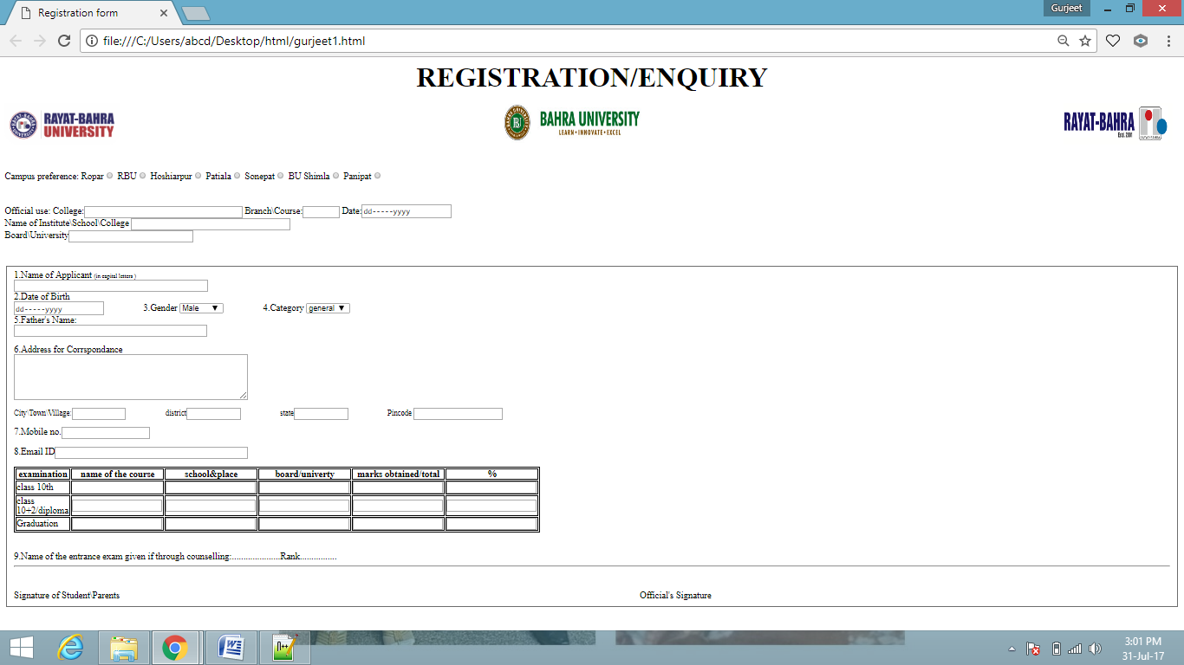

**Practical No.1**

# Computer Hardware Peripherals

## Introduction

A peripheral is a piece of computer hardware that is added to a computer in order to expand its abilities. The term peripheral is used to describe those devices that are optional in nature, as opposed to hardware that is either demanded or always required in principle. There are all different kinds of peripherals you can add your computer. The main disctinction among peripherals is the way they are connected to your computer. They can be connected internally or externally.

## Buses

A bus is a subsystem that transfers data between computer components inside a computer or between computers. Unlike a point-to-point connection, a bus can logically connect several peripherals over the same set of wires. Each bus defines its set of connectors to physically plug devices, cards or cables together. There are two types of buses: internal and external. Internal buses are connections to various internal components. External buses are connections to various external components. There are different kinds of slots that internal and external devices can connect to.

## Internal

### Types of Slots

There are many different kinds of internal buses, but only a handful of popular ones. Different computers come with different kinds and number of slots. It is important to know what kind and number of slots you have on your computer before you go out and by a card that matches up to a slot you don’t have.

#### PCI

PCI (Peripheral Component Interconnect) is common in modern PCs. This kind of bus is being succeeded by PCI Express. Typical PCI cards used in PCs include: network cards, sound cards, modems, extra ports such as USB or serial, TV tuner cards and disk controllers. Video cards have outgrown the capabilities of PCI because of their higher bandwidth requirements.

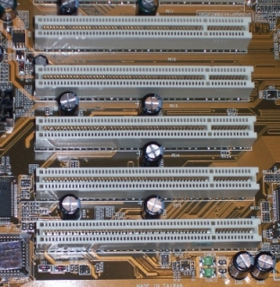

PCI Slots

#### PCI Express

PCI Express was introduced by Intel in 2004. It was designed to replace the general-purpose PCI expansion bus and the AGP graphics card interface. PCI express is not a bus but instead a point-to-point conection of serial links called lanes. PCI Express cards have faster bandwidth then PCI cards which make them more ideal for high-end video cards.

#### PCMCIA

PCMCIA (also referred to as PC Card) is the type of bus used for laptop computers. The name PCMCIA comes from the group who developed the standard: Personal Computer Memory Card International Association. PCMCIA was originally designed for computer memory expansion, but the existence of a usable general standard for notbeook peripherals led to many kinds of devices being made available in this form. Typical devices include network cards, modems, and hard disks.

#### AGP

AGP (Accelerated Graphics Port) is a high-speed point-to-point channel for attaching a graphics card to a computer’s motherboard, primarily to assist in the acceleration of 3D computer graphics. AGP has been replaced over the past couple years by PCI Express. AGP cards and motherboards are still available to buy, but they are becoming less common.

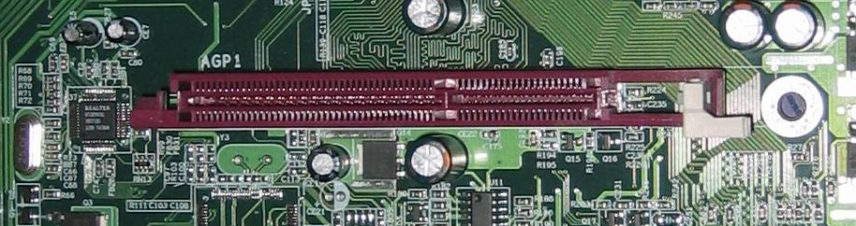

AGP Slot

### Types Of Cards

#### Video Card

A video card (also known as graphics card) is an expansion card whose function is to generate and output images to a display. Some video cards offer added functions, such as video capture, TV tuner adapter, ability to connect multiple monitors, and others. Most video cards all share similar components. They include a graphics processing unit (GPU) which is a dedicated microprocessor optimized for 3D graphics rendering. It also includes a video BIOS that contains the basic program that governs the video card’s operations and provides the instructions that allow the computer and software to interface with the card. If the video card is integrated in the motherboard, it may use the computer RAM memory. If it is not it will have its own video memory called Video RAM. This kind of memory can range from 128MB to 2GB. A video card also has a RAMDAC (Random Access Memory Digital-to-Analog Converter) which takes responsibility for turning the digital signals produced by the computer processor into an analog signal which can be understood by the computer display. Lastly, they all have outputs such as an HD-15 connector (standard monitor cable), DVI connector, S-Video, composite video or component video.

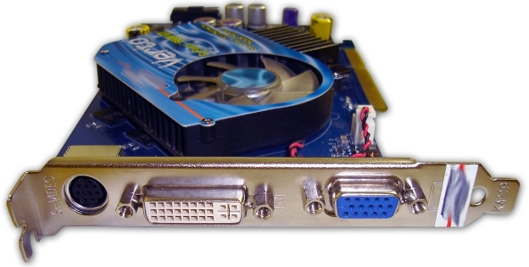

Graphics Card

#### Sound Card

A sound card is an expansion card that facilitates the input and output of audio signals to/from a computer under control of computer programs. Typical uses for sound cards include providing the audio component for multimedia applications such as music composition, editing video or audio, presentation/education, and entertainment. Many computers have sound capabilities built in,, while others require additional expansion cards to provide for audio capability.

#### Network Card

A network card is an expansion card that allows computers to communicate over a computer network. It allows users to connect to each other either by using cables or wirelessly. Although other network technologies exist, Ethernet has achieved near-ubiquity for a while now. Every Ethernet network card has a unique 48-bit serial number called a MAC address, which is stored in ROM carried on the card. You can learn more about networking in the introduction to networking lesson.

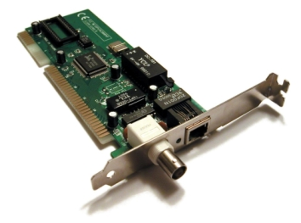

Network Card

## External

### Types of Connections

#### USB

USB (Universal Serial Bus) is a serial bus standard to interface devices. USB was designed to allow many peripherals to be connected using a single standardized interface socket and to improve the plug-and-play capabilities by allowing devices to be connected and disconnected without rebooting the computer. Other convient features include providing power to low-consumption devices without the need for an external power supply and allowing many devices to be used without requiring manufacturer specific, individual device drivers to be installed. USB is by far the dominating bus for connecting external devices to your computer.

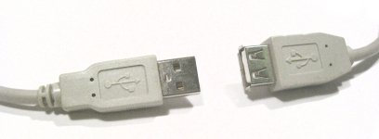

USB Connectors

#### Firewire

Firewire (technically known as IEEE 1394 and also known as i.LINK for Sony) is a serial bus interface standard for high-speed communications and isochronous real-time data transfer, frequently used in a personal computer. Firewire has replaced Parallel ports in many applications. It has been adopted as the High Definition Audio-Video Network Alliance (HANA) standard connection interface for A/V (audio/visual) component communication and control. Almost all modern digital camcorders have included this connection.

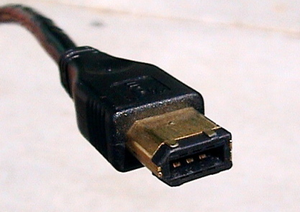

Firewire Cable

#### PS/2

The PS/2 connector is used for connecting some keyboards and mice to a PC compatible computer system. The keyboard and mouse interfaces are electrically similar with the main difference being that open collector outputs are required on both ends of the keyboard interface to allow bidirectional communication. If a PS/2 mouse is connected to a PS/2 keyboard port, the mouse may not be recognized by the computer depending on configuration.

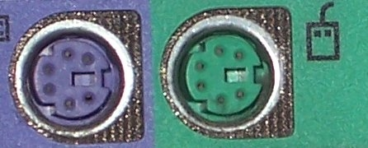

PS/2 Ports

### Devices

#### Removable Storage

The same kinds of CD and DVD drives that could come built-in on your computer can also be attached externally. You might only have a CD-ROM drive built-in to your computer but you need a CD writer to burn CDs. You can buy an external CD writer that connects to your USB port and acts the same way as if it was built-in to your computer. The same is true for DVD writers, Blu-ray drives, and floppy drives. Flash drives have become very popular forms of removable storage especially as the price of flash drives decreases and the possible size for them increases. Flash drives are usually USB ones either in the form USB sticks or very small, portable devices. USB flash drives are small, fast, removable, rewritable, and long-lasting. Storage capacities range from 64MB to 32GB or more. A flash drive does not have any mechanically driven parts so as opposed to a hard drive which makes it more durable and smaller usually.

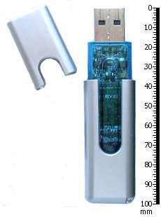

USB Flash Drive

#### Non-removable Storage

Non-removable storage can be a hard drive that is connected externally. External hard drives have become very popular for backups, shared drives among many computers, and simply expaning the amount of hard drive space you have from your internal hard drive. External hard drives come in many shapes and sizes like flash drives do. An external hard drive is usually connected by USB but you can also have a networked hardrive which will connect to your network which allows all computers on that network to access that hard drive.

#### Input

Input devices are absolutely crucial to computers. The most common input devices are mice and keyboards which barely every computer has. A new popular pointing device that may eventually replace the mouse is touch screen which you can get on some tablet notebooks. Other popular input devices include microphones, webcams, and fingerprint readers which can also be built in to modern laptops and desktops. A scanner is another popular input device that might be built-in to your printer.

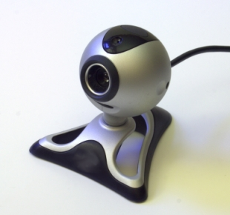

Webcam

#### Output

There are lots of different kinds of output devices that you can get for your computer. The absolute most common external output device is a monitor. Other very popular output devices are printers and speakers. There are lots of different kinds of printers and different sizes of speakers for your computer. Monitors are connected usually through the HD-15 connector on your video card. Printers are usually connected through a USB port. Speakers have their own audio out port built-in to the sound card.

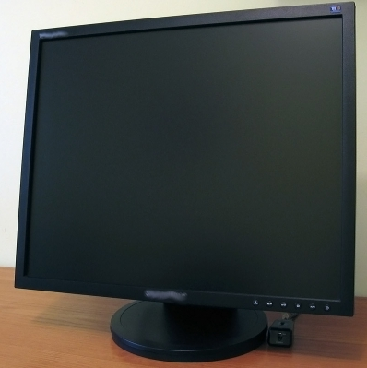

Monitor

**Practical No.2**

**TROUBLESHOOTING OF VARIOUS SOFTWARE AND HARDWARE PROBLEMS.**

**1. Free up RAM by closing other open programs**.

Every piece of software uses Random Access Memory (RAM). The more software that's running on your computer, the more RAM it uses. This can be especially problematic if you're using older machines that don't have a lot of RAM. So if a software program refuses to load or is running slowly, the first thing to do is to close all other open applications.

If you want to find out which open applications might be hogging your RAM, both Windows and Macintosh operating systems (OS) have tools that display this information:

In Windows, hit Ctrl+Alt+Delete, then choose the Start Task Manager option. From the window that appears, click the Processes tab, then click the Memory menu item. This sorts all open processes based on the amount of RAM they're using. You can shut down a runaway process by clicking the End Process button. Before you do that, you may want to do a bit of research on the process to ensure that you don't accidentally stop a critical process or program.

In Mac OS X, use the Activity Monitor (called the Process Viewer in older versions of OS X). Access the Activity Monitor by going to Applications > Utilities. Once you've called up the Activity Monitor, sort programs based on RAM usage by clicking the column labeled "Real Memory."

**2. Restart the software.**

Software problems can stem from a conflict with other programs or simply from difficulties the software encountered when starting up. Shutting the program down and restarting it can sometimes resolve these issues.

**3. Shut down and restart your computer.**

If restarting the problematic program doesn't resolve the issue, try rebooting your computer. Once the computer has fully restarted, re-launch the application in question and see if the problem has been resolved.

**4. Use the Internet to find help.**

No matter what software problems you encounter, chances are it's happened to someone else. So there's a good chance you can find help on the Internet. Here are a few places to get started:

Search for answers: In your search engine query, include the software program name and version, the problem you encountered, and the circumstances under which the problem occurred. If you received a specific error message, enter the exact error message text, along with the name of the application.

**5. Undo any recent hardware or software changes**.

Changes to software and hardware can sometimes cause software problems, such as:

Conflicts with other software: Newly installed software may conflict with other software. For example, Symantec Norton Antivirus can conflict with competing antivirus products. So, if you recently installed another antivirus program and Norton Antivirus no longer works correctly, uninstalling the other antivirus product could solve your problem.

Changes to computer settings: Undo any recent changes to your computer's settings, and try launching the software again. For example, the Windows Control Panel includes an option to "Set Program Access and Defaults," which allows you to disable access to certain applications. If you accidentally disable access to a program here, the program may not run.

Conflicts with new or improperly configured hardware, such as scanners and printers. If you've recently connected new hardware to one of your computers, try disconnecting the hardware and see if that corrects the software issue.

**6. Uninstall the software, then reinstall it.**

Sometimes, software problems occur because critical application files have been removed, updated, or deleted. For example, many Windows applications use Dynamic Link Library (DLL) files to perform basic tasks. Often, several applications will use the same DLL file. If you've recently removed one program from your computer, it's possible you removed DLL files that another program relied on. Similarly, adding a program could add or update DLL files. Applications that were dependent on those DLL files may become unstable or stop working entirely.

To ensure that all the necessary files are intact, you can completely uninstall the problematic software, then reinstall it. Even if you remove a program using its built-in uninstall wizard (if it includes one), it's still a good idea to check your hard drive's Program Files folder — usually located on the C drive — for any remnants of the program, and delete any files or folders you find.

Before reinstalling, check to see if there's a new version of the program available. The vendor or developer might have introduced bug fixes that address the issue you're having.

**7. Look for software patches.**

Software vendors may also fix bugs by issuing patches — small software updates that address known problems. Even if you're using the most current version of the software, there may be a more recent patch available for that version.

**8. Scan for viruses and malware.**

Viruses, spyware, and other forms of malicious software (or "malware") can cause software to freeze, crash, or quit working entirely.

If tips 1 through 8 haven't helped solve your software problem, you may also want to scan the computer using both antivirus and anti-malware tools to find and remove viruses and malware. Use the most thorough scan mode available, and remember to restart your machine if the antivirus or anti-malware programs found any threats.

**9. Check for a firewall conflict.**

Some organizations may choose to install personal firewall software on each computer, rather than a centralized hardware or software-based firewall. Personal firewalls can be an important line of defense against hackers and other security threats, but they can also cause software conflicts.

Firewalls frequently display messages asking whether it should allow a program to run or block it. Therefore, it's possible to accidentally tell the personal firewall to block a program from running. Check the firewall's settings to see if the problematic software was added to the firewall's list of programs to block. If so, change the firewall's settings to allow the software to run, then check to see if you're still having issues with your software.

**10. Boot up in Safe Mode.**

Some software malfunctions can be caused by OS settings or other system problems. Windows and Mac operating systems both offer a troubleshooting environment known as Safe Mode. Safe Mode disables non-critical applications and processes, which theoretically makes it easier to isolate problems.

Most Windows computers allow you to enter Safe Mode by pressing the F8 key as your computer is booting up. On a Mac, enter Safe Mode by pressing the Shift key while your computer boots up (or immediately after it boots up).

Once your computer is in Safe Mode, launch the problematic software and try to replicate the problem you had while your computer was in normal mode. If you don't have the same problem in safe mode, there's a good chance that the issue was caused by your OS or another program, not by the application you are troubleshooting.

**11. Defragment your hard drive.**

As a final troubleshooting step, you might defragment your computer's hard drive. Defragmenting rearranges your hard drive's file structure so that the system runs more efficiently. Defragmenting will probably be most useful if you're experiencing overall sluggishness on your computer, because defragmenting is meant to make your entire system run faster. Note that defragmenting a hard drive applies primarily to Windows-based computers.

Most recent Windows editions — including XP, Vista, and Windows 7 — include a built-in disk-defragmentation tool. To launch it, go to Start > All Programs > Accessories > System Tools > Disk Defragmenter. Be aware that defragmenting a hard drive can be time-consuming, so make sure to perform this task when you will be away from your computer for a few hours.

**TROUBLESHOOTING HARDWARE PROBLEMS**

* Monitor
* Printer
* CD
* Keyboard
* Mouse
* Networking
* Video/Screen
* Sound
* Startup
* Hard Drive

**Troubleshooting Questions**

When your computer is not running properly the first course of action is to do a proper shut down, and restart. Click on the Start button, select "shut down". Leave the PC off for 1 to 2 minutes. Turn the PC back on again. If the PC is frozen and you cannot shut it down, hold the power button on the CPU for 30-40 seconds until it shuts down.

* When did your computer last work properly?
* If your computer was working satisfactory yesterday or the last time you were logged on but are now having trouble, try to identify everything that has changed recently.
* Did the trouble begin shortly after you installed:
* New program?
* New piece of hardware or updated a device driver?
* Do you receive a consistent error message?
* If so, write down the exact error message that appears on the screen, either write it down word for word.
* Can you reproduce the trouble with specific steps?
* If you can identify a specific set of actions that consistently cause the trouble to occur, the Technical Support Specialist and outline your steps to determine the problem. Write down the precise sequence of actions.
* Does the problem only occur after you have been using your computer for a while?
* **AN UNRESPONSIVE PC**
* First check the cable. Unplug it from the computer and the outlet. Re-plug in both sides and try booting it again.
* Check the wall outlet. Plug something else into the outlet and see if it works. If you have a surge protector try a different outlet.
* Turn the system off and wait 30 seconds and then try again.
* Reach behind the machine and see if you feel air blowing out of the power supply. If you do, then you know the machine is getting some power.
* Look at the keyboard for the indicator lights being lit up as the machine boots.
* Sometimes the monitor has something to do with the system acting up. Unplug the power cord from the monitor and the wall and re-plug it. Unplug the cable from the computer to the monitor and re-plug it into the monitor. Try rebooting.
* Listen to identify a beeping series if there is one to report it to the technical help.
* If you have a tower computer you should see indicator lights just above the power button on the PC, if you see any numbers lit up report this to the Help Desk.
* Turn in all comments to the Help Desk.
* **MONITOR TROUBLESHOOTING**

**Symptom:** The monitor screen is black

**Diagnosis**

* Check to see if the computer turned on.:-Is the computer turned on? There is a light on the CPU. If the computer is on, it will be lit.
* Check to see if the monitor getting power:-If no lights appear on the front of the monitor at all, it is not getting any power from the power source. Check to see if ALL plugs are secure.
* Power cord from the computer to the power strip.Power strip to the wall socket.Check to see if the Power Strip turned on.There is a light on the strip. If the strip is on, the indictor light will be on.
* Check to see if the monitor getting a signal from the computer:- There is a light on the monitor. If the monitor is on, it will be lit. If it is turned on, check the contrast and brightness buttons to see if they have been tampered with.
* A green light on the front of the monitor would indicate that it is getting a signal from the computer.
* An orange light would indicate there is not signal from the computer. Make sure the computer is on and you see lights on the front of it. Check the cable that runs from the monitor to the computer to see if it has worked loose.
* Check to see if the brightness has been turned entirely down:- Make sure you check the brightness and contrast buttons or settings on the monitor.
* Check to see if the computer in Power Save or Sleep mode:- Move the mouse or press any key on the keyboard to see if the computer will "wake-up."
* Check to see if all peripherals plugged in:- Verify that all cables and cords leading in to and out of your computer to insure they are all in tight and not disconnected.

**Secure the following to the computer:**

* Monitor
* Mouse
* Keyboard
* Printer
* Network cable to computer and wall (Blue)
* Check to see if the monitor goes black just as Windows is loaded:- This could indicate a problem with the video card driver or settings in Windows. Since you can't see to get to the settings, this is difficult to fix without a visit from technical support.

**Symptom:** The screen is not synchronized

**Diagnosis:-**

* Check to make sure the signal cable is firmly connected in the socket.
* Check that the output level matches the input level of your computer.
* Make sure the signal timing of the computer system is within the specification of the monitor.

**Symptom:** The screen is too bright or too dark

**Diagnosis**

* Check if the Brightness or contrast control is at the appropriate position, not at the maximum or minimum.
* Check if the specified voltage is applied
* Check if the signal timing of the computer system is within the specification of the monitor.
* Especially, check the horizontal frequency.

**Symptom:** The screen is shaking

**Diagnosis**

* Move all objects that emit a magnetic field, such as a motor or transformer, away from the monitor.
* Check if the specified voltage is applied.
* Check if the signal timing of the computer system is within the specification of the monitor.
* **PRINTER TROUBLESHOOTING**

**Symptom:** The Printer is not printing

**Diagnosis**

* Check to see if the printer getting power. If there are no lights or no display on the front of the printer, the printer is not getting electricity or power.
* Check to make sure the power cord is plugged in both to the wall or power strip and to the back of the printer. Wiggle the power cord where it plugs into the back of the printer to make sure it is not loose. Some models of desk jets have a two part power cord. In this case, check along the length of the power cord to make sure both parts are plugged in together.
* If the printer is still not getting power, plug the power cord into a different outlet on the power strip. If this does not work, try plugging the printer into a different wall outlet.
* Check to see if you can print a Windows test page. The windows test page is a basic communication test between your computer and the printer.

TO PRINT A WINDOWS TEST PAGE:

**Left mouse-click on the Start button.**

* Go to Settings and then select Printers.
* Inside the printer window, you should see a small printer icon with the name of printer you are trying to print to.
* Place your mouse arrow on the small printer icon and right mouse-click.
* A small gray window should appear and the last choice in the box is Properties.

**Left mouse-click on Properties**.

* A printer window with several tabs should appear.
* On the General tab, there is a Print Test Page button in the lower right corner.

**Left mouse-click on the button.**

* You may click on the "Yes" button on your screen, but the real question is: Did anything print from the printer?
* If you can print a Windows test page, try to print from a different program. If the document does not print from that program, the printing problem has to do with that program.
* Check to see if there is paper in printer. Is their a paper jam? If the printer has paper in the paper tray, the paper may be jammed or not feeding properly. Take the paper out of the paper tray and check to see that the top piece of paper is not crinkled or bent.
* If the printer is a DeskJet, lift open the front cover and look to see if a piece of paper is halfway fed through. If it is, remove paper gently from the top and close.
* If the printer is a LaserJet, open the top of the printer and check for paper underneath the toner cartridge. If there is paper there, gently remove it, and replace the toner cartridge.
* Check to see if the computer getting a signal from the printer.:-The computer and the printer must be communicating before the printer will print. When you send a document to print, does a small printer appear on the Windows taskbar (down by the time)? If this printer appears on the taskbar, the computer thinks the printer is receiving communication. At this point, the printer should blink lights (if a DeskJet) or says "printing" or "receiving" on the display (if a laser printer). If the printer is not receiving the communication from the computer, try restarting the computer. After you have logged in, see if you can print now.
* Check to see if Printer offline or Paused:- If the printer is off-line or paused, the print jobs will just stack up in the print queue but nothing prints.
* Left mouse-click on the Start button
* Go to Settings
* Then choose Printers
* The Printer folder should open and display the printers installed on this PC.
* Place your mouse arrow on the printer you are checking and right mouse click. A dialog box should open.
* If the printer is paused or offline you will see a black check mark next to the words "Pause Printing" or "Printer Offline."
* Left mouse-click on the black check mark and see if you can "uncheck" it.
* If the check mark will not go away, try restarting the PC (Start – Shutdown – Restart).
* Then repeat steps 1 through 7 again.
* Check to see if there multiple jobs in the Print queue:- If the printer is a local printer (i.e., there is a cable running directly from the printer to the computer you are printing from), power off the PC, power off the printer, count to 10, and then turn both the printer and the computer back on again. Sometimes this will allow the printer to start printing again.

**Symptom:-** The printer is printing streaks on the page

**Diagnosis**

* If the printer is a DeskJet, go to the HP DeskJet Utilities menu in the Program menu. Choose the "Clean the Print Cartridges" option. If this does not work, try replacing the ink cartridge. If the new cartridge does not help the streaking, place the cartridge back inside the original packaging and save it until the other cartridge has been used up. This just tests to see if the ink cartridge is defective.
* If the printer is a LaserJet, try changing the toner cartridge. If the new toner cartridge does not improve the streaking problem, return old cartridge to the printer and place the new toner cartridge back in its original packaging for later use.
* If neither option works, please visit the printer maintenance vendor list to schedule printer service.
* The printer in spite of everything is not printing?
* Turn the PC off. If the printer is a local printer, i.e., has a direct cable hookup to the PC, turn the printer off also so both the PC and printer are turned off at the same time. After 30 seconds, turn the PC and the printer back on again. Try to print a Windows test page.
* **CD TROUBLESHOOTING**

**Symptom:-** The computer won't read the CD

**Diagnosis**

* Check to see if the label side of the CD is faced up
* Check to see if the CD be read from the CD Rom drive of another computer
* If the CD can be read from another computer's CD ROM drive, the CD ROM drive may be bad and need to be replaced.
* The CD ROM drive may also have dirt or debris inside. Try cleaning the drive with a standard audio CD player cleaning kit. After cleaning the drive, try to read the CD again. Check to see if the CD scratched or dirty.
* CD, CDR, or CDRW drives read discs by shining a laser onto the CD and then measuring the amount of light that gets reflected back. Most of the time a small scratch won't matter.
* If the CD is dirty, you can clean the CD using a CD Cleaning kit or you can also use a mild detergent, like dish soap, and warm water, wash the CD and dry with a soft cloth. Once the CD is fully dry, insert the CD into the CD ROM drive and try to read it.If the CD is not dirty, you can try to clean the CD Rom drive using a professional CD cleaner kit
* Check to see if the CD is a CD-R or CD-RW that was burned
* A number of older CD drives cannot read some types of CD-R CDs. Try using a different CD-R disk with a different dye under the reflective layer. You will have noticed that some CD-R disks are blue, gold, green, or even silver colored. Some of the colors have a lower light reflectivity value and an older CD Rom drive may have difficulty reading that brand of CD-R media.
* **KEYBOARD TROUBLESHOOTING**

**Symptom:-** Keyboard doesn't respond and gives off a constant beeping noise when booting up

**Diagnosis**

* Check the plug to make sure it's connected securely.
* Try unplugging it and re-plugging it again. If there is no response, check the indicator light on the keyboard. Is it on? Do the lights respond when you press the caps lock or the num lock key? If not, maybe your keyboard is broken.
* Check to see if there a key stuck
* Gently pry off the cover and clean it with alcohol. Make sure it is not connected to your machine when you are cleaning it. The space bar frequently comes off track. Gently pry it off, noting which way the bar lies in your particular keyboard so you can replace it properly.
* **MOUSE TROUBLESHOOTING**

**Symptom:-**The mouse is acting erratic

**Diagnosis**

* Reboot the computer and see if that corrects the problem. If not check to see if there is insufficient memory.

**Symptom:-** The mouse will only move one way, either vertically or horizontally

**Diagnosis**

* Clean the mouse
* Shut down your machine and unplug your mouse from the computer.
* Open the underside of the mouse and remove the ball.
* If the ball is a rubber ball, do not clean it with alcohol. Clean it with a soft cloth. There should be no lubricant placed on a mouse ball.
* Clean the roller in the body of the mouse with a cotton swab that is slightly damp with alcohol. Replace the ball when the rollers are dry and replace the bottom portion.
* **NETWORKING TROUBLESHOOTING**

**Symptom:-** My PC is not working on the Network

**Diagnosis**

* Programs that require network drives to run or operate properly: SIS, HR, FRS, PROD – ALPHA, Network Shares, and some school applications.
* You would also need a network connection to print to the network laser or color laser printers within CCRI.

**Symptom:-** Message "No Domain Server Available" or there are no Network drives (like the S drive).

* **VIDEO/SCREEN TROUBLESHOOTING**

**Symptom:-** The Monitor is Black

**Symptom:-** The desktop Icons are too IMMENSE or too undersized

**Diagnosis**

* Usually this is due to the Display Settings. The standard video setting for most College software is 800x600. To check the video display settings:
* Left mouse-click on the Start button (lower left-hand corner of the screen).
* Go to Settings. Go to Control Panel.
* Once in the Control Panel, look for the Display icon.
* Double left mouse-click on the Display icon.
* In the Display Properties box, left mouse-click on the settings tab.
* screen resolution setting box
* Place your mouse arrow on the slider, hold down the left-mouse button, and move the arrow until the number changes to the desired setting.
* 640x480 screen resolution has fewer pixels so the screen appears larger. 1024x768 screen resolution has more pixels in the same screen area so the appears smaller.

**Symptom:-** The Screen goes black if not used for a few minutes

**Diagnosis**

* The power saver or energy saver features may be turned on. To correct this problem, you can turn off the feature.
* Left mouse-click on the Start button (lower left-hand corner of the screen).
* Go to Settings. Go to Control Panel.
* Once in the Control Panel, look for the Display icon.
* Double left mouse-click on the Display icon.
* Left mouse-click on the Screen Saver tab.
* Left mouse-click on the Power or Settings button (depends on your version of Windows) in the lower left corner.
* On the Power schemes tab, you should see where it says "Turn off monitor:" with an amount of time next to it.
* Left mouse-click on the drop-down arrow.Change the time to "Never."
* Left mouse-click on the Apply button in the lower right-hand corner.
* Left mouse-click on the OK button.
* Left mouse-click on the next OK button.
* **SOUND TROUBLESHOOTING**

**Symptom:-** The computer has no sound

**Symptom:-** No sound is heard from audio (music) CDs

**Diagnosis**

* Look for the Volume icon in the system tray in the lower right-hand corner of the Windows desktop.
* Place the mouse arrow on this icon.
* Double left-mouse click. The Volume Control dialog box should appear on the computer screen .
* Place the mouse arrow on the "slider" button and slide the arrow up to increase or down to decrease the volume.
* If "Mute all" check box is checked, there will be no sound. To enable the sound again, uncheck the box.
* Ensure the speakers are properly connected to the audio card’s output connector and turned on.

**Symptom:-** There is no volume icon in the lower right corner

**Diagnosis**

* To place the volume icon in the system tray in the lower right of the desktop:
* Place the mouse arrow on the Start button in the lower left corner.
* Left mouse-click on Settings.
* Left mouse-click on the Control Panel
* Place the mouse arrow on the Multimedia icon Information Technology.
* (In Windows XP, look for the Sounds and Audio Devices icon .) Information Technology
* Double-left mouse click.
* Left mouse-click on the Audio file tab.
* Towards the bottom look for the check box that reads "Show volume control on taskbar."
* Make sure the box is checked to activate the icon.
* Startup Troubleshooting
* If your computer is making noise or attempting to start up, but there is no video or no display on the monitor.

**Symptom:-** No power lights on the monitor/computer

* **HARD DRIVE TROUBLESHOOTING**

**Symptom:-** The cursor is stuck on the hourglass

**Diagnosis**

* Open Task Manager
* Simultaneously press [Ctrl] [Alt] [Delete]. You will see a list of all tasks (programs) currently running. You may notice one program has "Not Responding" instead of "Running" listed next to it. Select this task and click the End Task button.
* Another dialog box will open stating that the program is not responding. Choose End Now to close the program.
* Reboot your computer (Warm Boot)
* Resetting a computer that is already turned on:
* Press [Ctrl] [Alt] [Delete] once to open the Task Manager.
* Press [Ctrl] [Alt] [Delete] again to restart the computer.
* Shut down your computer (Cold Boot)
* Start-up of a computer from a powered-down state.
* If you restart your computer and the problem isn’t resolved, make an attempt to completely shut down the computer by pressing the power button. Let it set for 15-30 seconds then restart the computer.

**Symptom:-** You have run out of disk space on your computer. Music files, movies, digital pictures, and other big data files can fill up your hard drive.

**Diagnosis**

* To check for disk space:
* Open My Computer. Right click on the C: drive and select Properties from the shortcut menu. A pie chart will appear telling you the used and free space.
* Try running the Disk Cleanup Wizard. This utility can tell you whether you are running out of room and help you clear away some space. Click the Start button and choose Programs | Accessories | System Tools | Disk Cleanup. Choose the disk to clean up (C: ) and let the wizard do the work.

**Practical No.3**

**TROUBLESHOOTING OF NETWORK DEVICES AND NETWORK.**

Network troubleshooting is primarily done by network engineers or administrators to repair or optimize a network. It is generally done to recover and establish network or Internet connections on end nodes/devices.

Some of the processes within network troubleshooting include but are not limited to:

* Finding and resolving problems and establishing Internet/network connection of a computer/device/node
* Configuring a router, switch or any network management device
* Installing cables or Wi-Fi devices
* Updating firmware devices on router switch
* Removing viruses
* Adding, configuring and reinstalling a network printer

Network troubleshooting can be a manual or automated task. When using automated tools, network management can be done using network diagnostic software.

Local area networks (LAN) are integral to the operation of many businesses today. The most common LANs use Ethernet, a data link layer protocol, and Internet Protocol (IP), a network layer protocol.

A LAN is comprised of many elements: printers, monitors, PCs, IP phones, servers, storage hardware, networking equipment, security software, network applications, enterprise applications, office productivity applications, and more. Devices on the network are linked physically by twisted pair copper, fiber or wireless access points.

LAN Network Troubleshooting is typically the job for the frontline network support staff - engineers and technicians. Common Ethernet network troubleshooting problems include user connection issues and slow networks.

Root causes of Ethernet network troubleshooting problems are frequently caused by one of these three sources:

1**. Physical layer**: copper, fiber or wireless

**Possible causes:**

* Damaged or dirty cabling or terminations
* Excessive signal attenuation
* Insufficient cable bandwidth
* Wireless interference

2. **Network Layer**: Ethernet and IP

**Possible causes:**

* Damaged networking devices
* Incorrect or sub-optimal device configurations
* Authentication and association issues
* Insufficient network bandwidth

3. **Switches and VLANs**

**Possible causes:**

* Excessive utilization
* Too many errors
* Incorrectly assigned VLAN membership
* Traffic priority (CoS/QoS) issues

**Best practices for successful network Ethernet troubleshooting include these steps:**

1. **Identify the exact issue or problem:** Have the person who reported the problem explain how normal operation appears, and then demonstrate the perceived problem.

2. **Recreate the problem if possible:** Ask yourself if you understand the symptoms, and verify the reported problem yourself if possible.

3. **Localize and isolate the cause:** Attempt to isolate the problem to a single device, connection, or software application.

4**. Formulate a network troubleshooting plan for solving the problem:** Research and/or consider the possible solutions to the problem. Consider the possibility that some solutions to the problem at hand may introduce other problems.

5. **Implement the network troubleshooting plan:** Your actual solution to the problem may be replacing hardware, implementing a software patch, reinstalling the application or component or cleaning a virus infected file. If the problem is the user account, the user’s security settings or logon scripts may need to be adjusted.

6. **Test to verify that the problem has been resolved:** After you have implemented the solution, ensure that the entire problem has been resolved by having the user test for the problem again.

7**. Document the problem and solution:** Documentation can be used for future reference to help you troubleshoot the same or similar problem. You can also use the documentation to prepare reports on common network problems for management and/or users, or to train new network users, network troubleshooters, or members of the network support team.

8**. Provide feedback to the user:** This encourages users to report similar situations in the future, which will improve the performance of your network. If the user could have done something to correct or avoid the issue, providing feedback may reduce the number of future network problems.

**Importance of LAN troubleshooting tools and training**

Giving frontline network support staff the proper training, the right tools, and a solid network troubleshooting methodology results in faster LAN problem solving - saving staff time, closing trouble tickets quicker, minimizing downtime, and getting network users back to productivity faster.

**INTRODUCTION**

Whether you have a small Windows network in your house with only one PC or a large Windows enterprise network with thousands of PCs and servers, troubleshooting Windows networking can be challenging. You can trust me on this topic as I have performed troubleshooting on LANs & WANs, SMB networks & large datacenters. The complexity of troubleshooting increase with the number of devices and the scope of the Windows infrastructure. However, there is an important set of core troubleshooting steps that you would use to troubleshoot a Windows network, no matter its size and scope. Now, let’s learn the steps you should take to successfully troubleshoot a Windows network – the first time!

**Step 1 – Know Your Infrastructure**

* While you can blindly perform troubleshooting, you will be much more successful by first knowing your infrastructure (what is connected to what and how it is designed). If this is a Windows enterprise network, perhaps you are lucky and you can locate a network diagram. Ideally, you are troubleshooting your own network, that you designed, but we can’t always have that luxury.

**Step 2 – Learn About Your Network**

* If you don’t know your infrastructure design and there’s no documentation to reference, you can start troubleshooting by learning about your network infrastructure from a few common network diagnostic tools. There is actually a lot to be learned by simply running IPCONFIG and/or the LAN details Windows GUI.

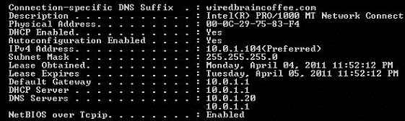  
**Figure 1:** IPCONFIG

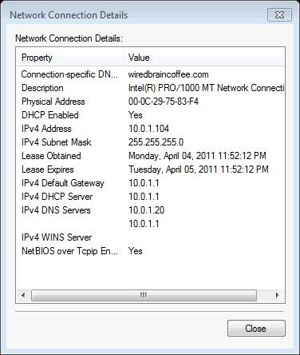  
**Figure 2:** Windows Network Connection Details

* From these two commands, you learn a lot:
* Whether the network interface is up or down (physical network connectivity)
* How you are to obtain an IP address – DHCP or static
* Whether you have an IP address, no IP address, or an automatically obtained IP address (those that start with 169.254.x.x, or APIPA)
* Your default gateway
* Whether you have DNS servers configured and what they are
* All this information is tremendously valuable in solving your Windows network problems.
* In the graphics above, the network is working great and there are no problems. However, what if the IPCONFIG shows a problem? In the following steps, I’ll focus more on the most common Windows networking problems and resolutions.

**Step 3 – Network Connection Is Down**

* If you look at [the OSI model](http://techgenix.com/Networking-Basics-Part17/), the physical layer (layer 1) is at the bottom. If layer 1 doesn’t work then NOTHING else is going to work. It is best to troubleshoot from the “bottom up” (from layer 1 up to the higher layers).

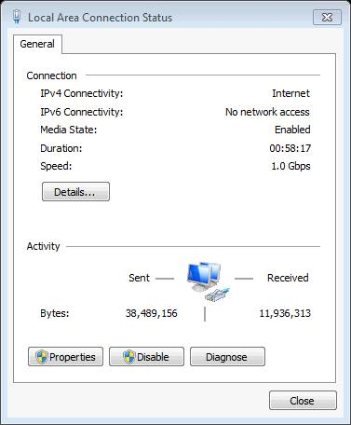  
**Figure 3:** Media State Issue

* In the graphic above, you can see that the **Media State**is **Enabled**. That is the normal, fully-functioning state. However, if the media state is disabled then you need to:
* Check the network cable – is it unplugged? Disconnected? Cut?
* Check the network switch – is the network cable connected there? Is the port enabled?
* You’ve got to get this working first, before anything else will work.

**Step 4 – No IP Address**

* Whether you have no IP address (0.0.0.0) or an automatic private IP address (APIPA, starting with 169.254.x.x), it doesn’t matter. You’ll have to obtain an IP address before you can use the network. If you are set to use DHCP (likely the default) and your DHCP server is down then that is the reason that you don’t have an IP address.
* Options to solve the problem:
* Resolve the issue with the DHCP server
* Statically assign an IP address that isn’t in conflict, is on the right subnet, etc

**Step 5 – No DNS Servers**

* If you don’t have any DNS servers configured then you’ll be able to communicate on the network with IP addresses only. You should be able to ping your default gateway, your DHCP server, and other servers on the network. However, you won’t be able to do any of that by name.
* Options to solve this problem:
* Determine why the DHCP server isn’t providing DNS server IPs
* Manualy configure the DNS server IPs if you know them
* Configure public Internet DNS servers like the Google public DNS servers (like 8.8.4.4)
* On the other hand, if you have DNS servers configured but you can’t ping them then you need to check the DNS servers – perhaps they are hung or packets are being restricted through a firewall.

**Step 6 – No Default Gateway**

* If you have no default gateway IP address configured, this will prevent you from communicating on another IP subnet (like the Internet) but not from communicating on your local LAN. Thus, even with no IP default gateway configured, you should be able to work as normal with local servers. In fact, configuring a default gateway is optional if you don’t need to reach an external network.
* You could manually configure a default gateway or determine why the DHCP server didn’t provide one for you.
* Alternatively, if you have a default gateway defined but you can’t communicate with it (even with a ping) then you need to check your local router.

**Step 7 – Misconfigured Subnet Mask**

* If you have an incorrectly configured IP subnet mask then you’ll get some unpredictable results. You either need to manually configure it (if you are using static IP addresses) or check the DHCP server to see why it gave you the wrong subnet mask.

**Summary**

Troubleshooting a Windows network doesn’t have to be difficult if you understand the various pieces that make it all work. Having a strong understanding of the network design and layout is going to go a long way to solving problems. Even if you don’t have that knowledge to begin with, you can quickly learn about how the network is configured by running a command like IPCONFIG. From there, you can start troubleshooting, first the physical connectivity and then move on to the IP address configuration. By following these steps, you should be able to resolve your network troubles quickly and easily.

**Practical No.4**

**Installation of Linux and windows operating system.**

*Installation of Linux operating system.*

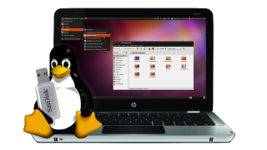

So you've decided to give Linux a shot, and you've found a distribution that suits you. But how do you actually get it installed? Here, we'll show you how to create a live CD or USB drive, boot into Linux, and install it on your system. Whether you've played around with live CDs and drive partitioning before or this is your first time, this guide will get you up and running with Linux in just a little bit of time. It isn't the most straightforward process, but if you're reading this, you're probably experienced enough with a computer to pull this off—it just takes a bit of legwork.

[](http://lifehacker.com/5157811/five-best-live-cds)

Note: If you're installing Linux on a Windows computer, the process shouldn't be too difficult (though you may want to brush up with our previous installation guide while you're here). If you're installing on a Mac or Hackintosh, however, you'll need to perform a few extra steps, so definitely check out our triple booting guide for Macs and [Hackintoshes](http://lifehacker.com/5698205/how-to-triple-boot-your-hackintosh-with-windows-and-linux), even if you aren't triple booting.

## Burning a Live CD or USB Stick

There are a few different methods for installing Linux on your computer, but generally, the most popular way is by downloading and burning a live CD (which has its own uses besides just installing Linux). I'll show you how to do both here. The live CD method is probably easier, so go that route unless you're on a netbook, or otherwise can't burn a CD.

## The Live CD Method

You'll have to get your live CD from the net, so head to your distribution's home page (like [Ubuntu's](http://www.ubuntu.com/))and look for a downloads section. Most will make it pretty easy to find. In addition, many sites will even host BitTorrent downloads of their distribution too, which will be a little faster—so if you see a link for "alternative downloads", check that out. Otherwise you can probably download it directly from the site.

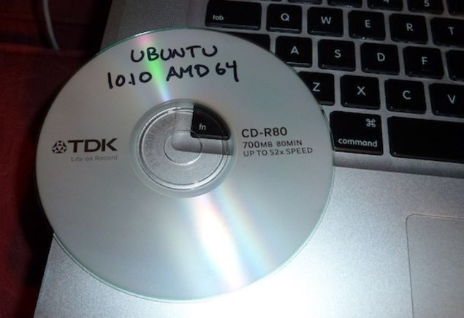

You'll probably have a few different choices when you download. For example, some distributions have netbook-optimized versions, while others (like Ubuntu) will offer different versions based on the desktop environment they come with. And, most will have 32- and 64-bit versions available as well (if you don't know which one's right for you, we've written a handy guide to help you out). Generally, it shouldn't be too hard to figure out which one you want. When in doubt, just go with the 32-bit desktop version (sometimes labeled "i386").

Once your .ISO file is done downloading, open up your favorite burning program and burn that sucker to a blank CD. It's pretty easy to do on Windows 7. Once it's done burning, restart your computer. Wait for the "press any key to boot from CD" prompt, and then press a key. Once the CD boots up, it'll give you the option to try out Linux or install it. Go ahead and click install. If you want to try it out, though, go for it—you'll be able get a pretty good feel for what the desktop is like. When you're ready to install, you can usually launch the installer right from the desktop.

## The Live USB Method

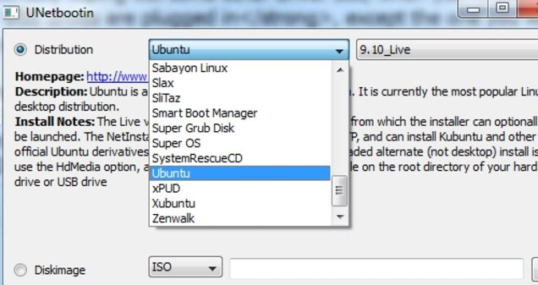

The Live USB method requires previously mentioned [Unetbootin](http://unetbootin.sourceforge.net/) for Windows. All you need to do is download it, start it up, and you can manage everything from right inside the program. Pick your distribution from its list (remember to pick the right version, as described above), pick the drive letter that corresponds to your thumb drive at the bottom, and hit OK. If Unetbootin doesn't list your distribution, you can still download an ISO as described in the live CD method and point Unetbootin to that file instead.

Booting from your USB drive will take a few extra steps over the live CD method. While your computer is probably set to check your CD drive for bootable discs, it probably isn't set to check your USB ports. So, with your newly created live USB stick plugged in, restart your computer and enter your BIOS setup (usually by hitting a key like Delete when you first start up—your computer's splash screen will let you know when you first turn on your computer). Head over to the "Boot" section of your BIOS and find the section for changing your PC's boot order. You'll want to move your USB hard drive to the top of the list. Save your settings and exit the BIOS. When your computer reboots, it should take you to the Unetbootin menu, from which you can boot into your Linux live session (as described in the live CD method).

## The Installation Process

The installation process will be slightly different for every distro, but in general setup should guide you through the necessary steps pretty easily. Assuming you're installing Linux alongside another OS like Windows, though, there are a few things you'll want to pay attention to.

## Partitioning Your Drive

When the installer asks you where you want to install Linux, you'll have to partition your drive. We've [gone through how to do this](http://lifehacker.com/5531037/how-to-triple+boot-your-mac-with-windows-and-linux-no-boot-camp-required) a [few times before](http://lifehacker.com/193474/hack-attack-how-to-triple+boot-windows-xp-vista-and-ubuntu), and it's usually pretty simple to add new partitions from the free space on your drive.

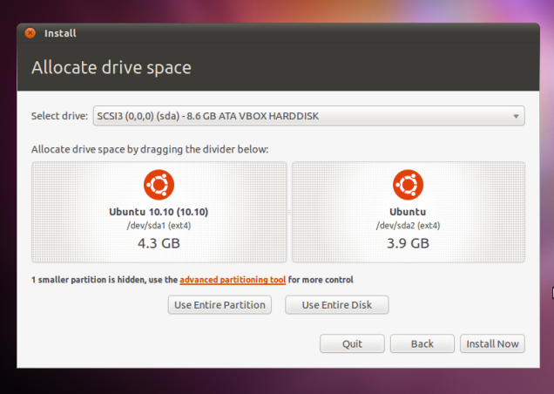

Ubuntu's installation should partition the drive for you automatically, and unless you have any special needs (like if you're on a Mac), you can breeze right through the installation with no problems. If not, you may be given a more advanced partitioning tool, and you'll have to create the partitions yourself. If this is the case, you'll actually want to create two new partitions. One is for the operating system itself, which I'd format as Ext4. Give it at least 10 GB of space, and set the mount point as /. You'll want to create the second partition for what's called swap space. This essentially helps your computer manage memory more effectively and keeps it running fast. If you have a small amount of ram (one or two GB), you'll want your swap partition to be twice as large as the amount of RAM you have. If you have 3 GB or more, you can probably just make a swap partition that's the same size as the amount of RAM you have.

## GRUB and Other Bootloaders

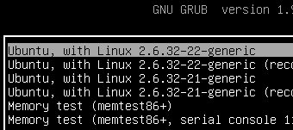

Linux is going to install a new bootloader for you called GRUB. It's going to replace your normal bootloader and give you the option to choose between Windows and Linux at startup. In general, you shouldn't have to do anything here—most distros will install GRUB by default, and it should work correctly out of the box. Just note that Mac users will want to install GRUB on the Linux partition itself, and Windows users will need to be careful since if you reinstall Windows, you'll lose GRUB and have to reinstall it yourself. Of course, if you prefer something a little prettier, you can mess around with previously mentioned [Burg](http://code.google.com/p/burg/), but we'd recommend doing that after you get your Linux installation up and running. That's it! To boot into your newly installed Linux partition, you just need to restart your computer. When you do, it'll take you to the GRUB menu, which will let you choose whether to boot into Linux or Windows. From there, you can play around with your new Linux installation. It'll probably come with quite a few apps installed, some you'll recognize and some you won't, and you can poke around in the settings and see what's available to you. If you're lucky, most of your hardware will work. If you're unlucky, you'll have a few quirks with your hardware, and if you're really unlucky, your Wi-Fi won't work out of the box and you'll have to work just to get connected to the internet. Luckily, we'll be talking all about getting your hardware working tomorrow, so check back with us then!

***Installation of WINDOWS operating system.***

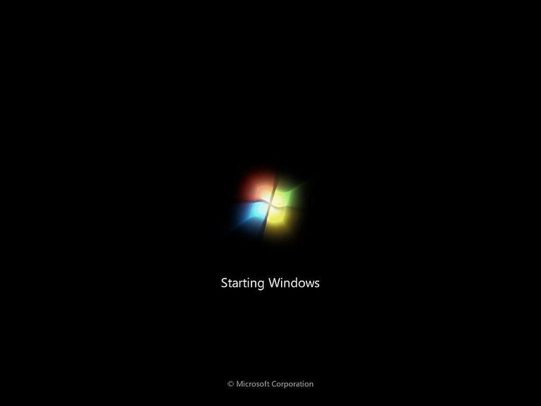

*Windows 7 Clean Install - Step 1 of 34.*

Most of the time, a Windows 7 clean install means to remove an existing operating system (like Windows XP, Linux, Windows 7, Windows 10, Windows 8, ... it doesn't matter) and replace it with a fresh or "clean" installation of Windows 7.

In other words, it's the "erase everything and start from scratch" process for Windows 7, a procedure referred to as a "clean install" or sometimes as a "custom install." It's the ultimate "reinstall Windows 7" process.

A clean install is often the best way to solve very serious Windows 7 problems, like a virus infection you can't get rid of completely or maybe some kind of Windows issues that you can't seem to solve with normal troubleshooting.

Performing a clean install of Windows 7 is usually a better idea than upgrading from an older version of Windows as well. Since a clean install is a true start over from scratch, you don't risk inheriting any buggy situations from your previous installation.

To be 100% clear, this is the right procedure to follow if:

* you want to erase whatever you have have and install Windows 7
* you want to reinstall Windows 7
* you want to install windows 7 on a new hard drive

This guide is broken into a total of 34 steps and will walk you through every part of the Windows 7 clean install process. Let's get started...

**Backup & Locate Your Product Key**

The most important thing to realize before performing a clean install of Windows 7 is that all of the information on the drive that your current operating system is installed on (probably your C: drive) will be destroyed during this process. That means that if there's anything you want to keep you should back it up to a disc or another drive prior to beginning this process.

You should also locate the Windows 7 product key, a 25-digit alphanumeric code unique to your copy of Windows 7. If you can't locate it, there is a fairly easy way to find the Windows 7 product key code from your existing Windows 7 installation, but this must be done before you reinstall Windows 7.

**Note:** If Windows originally came preinstalled on your computer (i.e. you did not install it yourself), your product key is probably located on a sticker attached to the side, back, or bottom of your computer's [case](https://www.lifewire.com/what-is-a-computer-case-2618149). This is the product key you should use when installing Windows 7.

**Start the Windows 7 Clean Install Process**

When you're absolutely sure sure that everything from your computer that you want to keep is backed up, proceed to the next step. Keep in mind that once you delete all of the information from this drive (as we'll do in a future step), the action is not reversible!

**Note:** The steps and screen shots shown in these 34 steps refer specifically to Windows 7 Ultimate edition but will also serve perfectly well as a guide to reinstalling any Windows 7 edition you may have including Windows 7 Professional or Windows 7 Home Premium.

**Important:** Microsoft has changed the clean install process for every new Windows release. If you're using Windows 10, 8, Vista, etc., see [How Do I Perform a Clean Installation of Windows?](https://www.lifewire.com/how-to-clean-install-windows-2624904) for links to specific instructions for your version of Windows.

### Boot From the Windows 7 DVD or USB Device

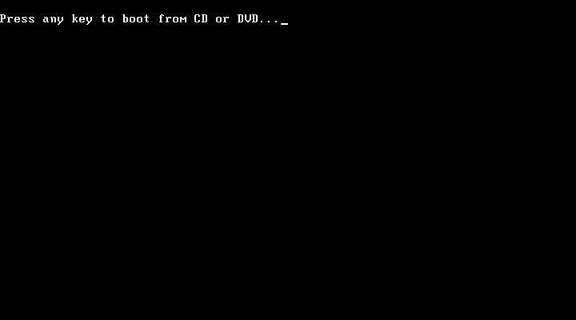

*Windows 7 Clean Install - Step 2 of 34.*

To begin the Windows 7 clean install process, you'll need to boot from the Windows 7 DVD if you're using a Windows 7 DVD, or boot from a USB device if your Windows 7 installation files are located on a flash drive or other external USB drive.

**Tip:** See my Windows Installation FAQif you you have Windows 7 as an ISO image that you need on a  flash drive or disc, or a Windows 7 DVD you need on a flash drive.

1. Restart your computer with the Windows 7 DVD in your optical drive, or with the properly configured Windows 7 USB flash drive plugged in.
2. Watch for a Press any key to boot from CD or DVD... message similar to the one shown in the screenshot above. If you're booting from a flash drive, the message may be phrased differently, like Press any key to boot from external device....
3. **Press a key** to force the computer to [boot](https://www.lifewire.com/what-does-booting-mean-2625799) from the Windows 7 DVD or USB storage device. If you do not press a key, your computer will attempt to boot to the next device in the boot order, which is probably your hard drive. If this happens, chances are your current operating system will boot.

**Note:** If you existing Windows installation begins to boot or you see a "No Operating System Found" or "NTLDR is Missing" error here instead of the screen above, the most probable reason is that your computer is not setup to boot first from the correct source. To correct this problem, you'll need to change the boot order in BIOS to list the CD/DVD/BD drive, or External Device, first.

**Note:** It's perfectly fine if, instead of the screen above, the Windows 7 setup process begins automatically (see the next step). If this happens, consider this step complete and move on!

### Wait for Windows 7 Installation Files to Load

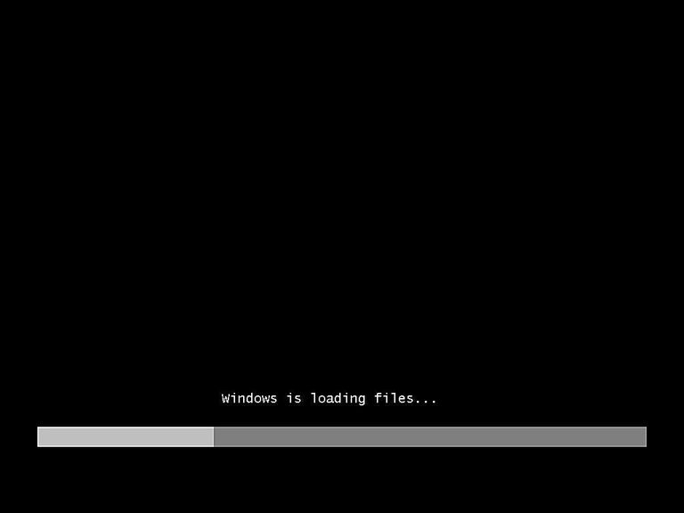

*Windows 7 Clean Install - Step 3 of 34.*

You don't need to do anything at this point but wait for [Windows 7](https://www.lifewire.com/windows-7-2626265) to finishing loading [files](https://www.lifewire.com/what-is-a-file-2625878) in preparation for the setup process.

**Note:** No changes are being made to your computer at this time. Windows 7 is just temporarily "loading files" into [memory](https://www.lifewire.com/what-is-random-access-memory-ram-2618159) for the setup process. You'll be removing everything on your computer as part of the Windows 7 clean install in a future step.

### Wait for Windows 7 Setup to Finish Loading



*Windows 7 Clean Install - Step 4 of 34.*

After the [Windows 7](https://www.lifewire.com/windows-7-2626265) install files are loaded into [memory](https://www.lifewire.com/what-is-random-access-memory-ram-2618159), you'll see the Windows 7 splash screen, indicating that the setup process is about to begin.

You don't need to do anything at this point either.

### Choose Language and Other Preferences

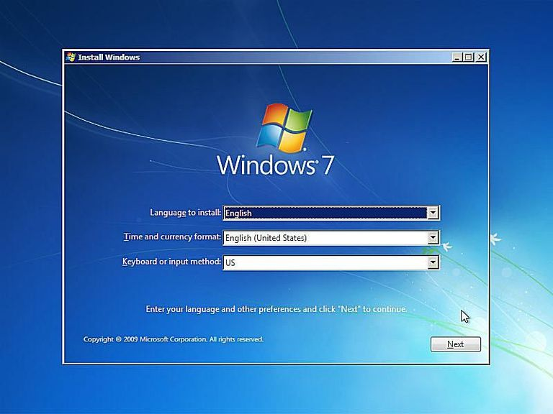

*Windows 7 Clean Install - Step 5 of 34.*

Choose the Language to install, Time and currency format, and Keyboard or input method that you'd like to use in your new Windows 7 installation.

Click **Next.**

Click the Install Now Button

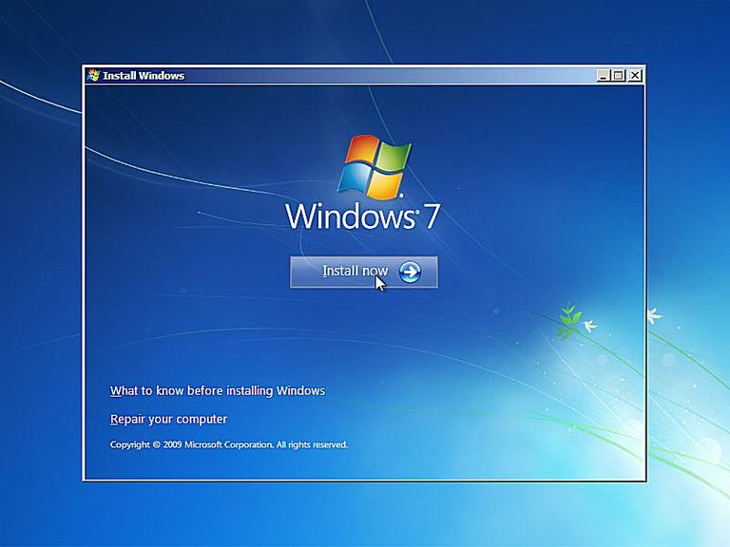

*Windows 7 Clean Install - Step 6 of 34.*

Click on the **Install now** button in the center of the screen, under the [Windows 7](https://www.lifewire.com/windows-7-2626265)logo.

This will officially begin the Windows 7 clean install process.

**Note:** Do not click the Repair your computer link at the bottom of the window even if you're completing this clean install of Windows 7 as part of some larger repair project for your computer.

The Repair your computer link is used to start a Windows 7 Startup Repair or perform another recovery or repair task from System Recovery Options.

**Important:** If you're performing a clean install of Windows 7 as a solution to a major problem but have not yet tried a Startup Repair, do that first. It could save you the trouble of completing this clean install process.

### Wait for Windows 7 Setup to Begin

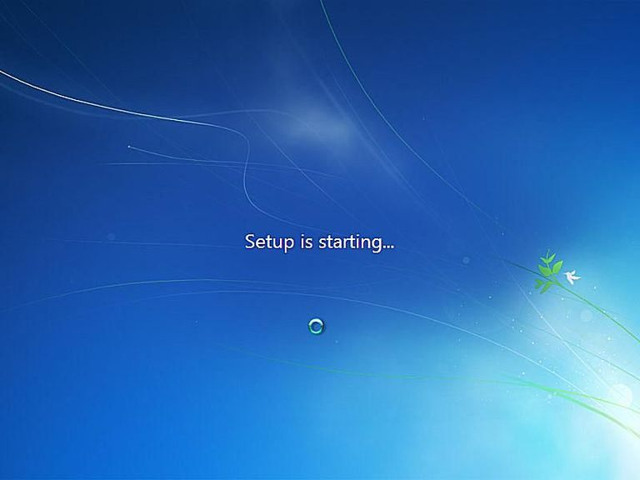

*Windows 7 Clean Install - Step 7 of 34.*

The [Windows 7](https://www.lifewire.com/windows-7-2626265) setup process is now beginning.

No need to press any keys here - everything is automatic.

### Accept the Windows 7 License Terms

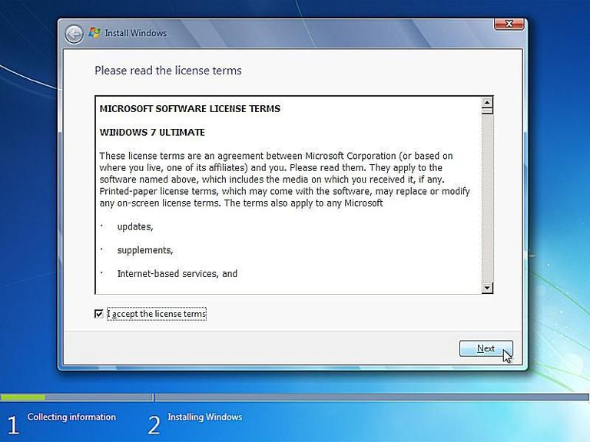

*Windows 7 Clean Install - Step 8 of 34.*

The next screen that appears is a textbox containing the Windows 7 Software License.

Read through the agreement, check the I accept the license terms checkbox under the agreement text and then click **Next** to confirm that you agree with the terms.

**Note:** You should always read "small print" especially when it comes to operating systems and other software. Most programs, Windows 7 included, have legally binding limits on how many computers the application can be installed on, among other limitations.

**Important:** You are not breaking any laws or contracts by reinstalling Windows 7 via this clean install. As long as this particular copy of Windows 7 is only being operated on one computer, you're OK.

### Choose the Type of Windows 7 Installation to Complete

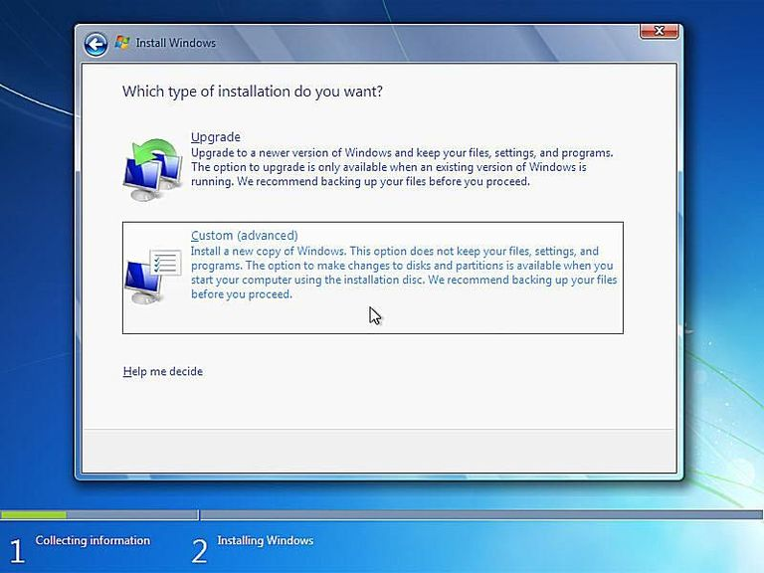

*Windows 7 Clean Install - Step 9 of 34.*

In the Which type of installation do you want? window that appears next, you're offered the choice of **Upgrade** and **Custom (advanced)**.

Click on the **Custom (advanced)** button.

**Important:** Even if you are upgrading from a previous [operating system](https://www.lifewire.com/operating-systems-2625912) to [Windows 7](https://www.lifewire.com/windows-7-2626265), I highly recommend that you do not follow the Upgrade installation. You'll get better performance with less chance of issues if you follow these clean install steps.

### Show the Windows 7 Advanced Drive Options

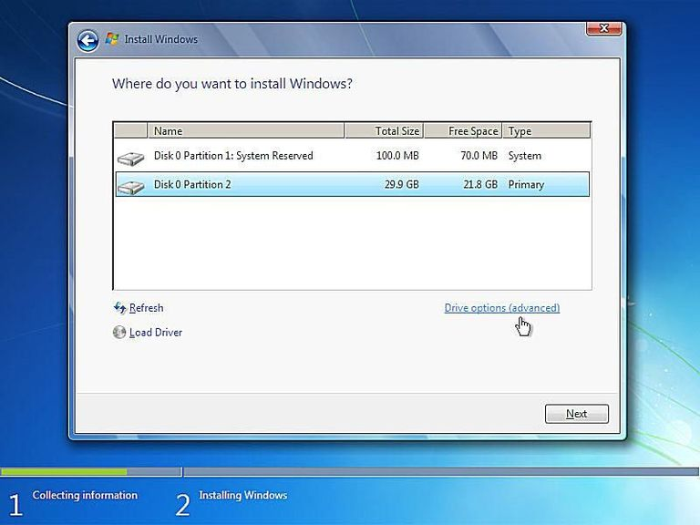

*Windows 7 Clean Install - Step 10 of 34.*

In this screen, you'll see each [partition](https://www.lifewire.com/what-is-a-partition-2625958) that [Windows 7](https://www.lifewire.com/windows-7-2626265) recognizes. Since a clean install involves the removal of all [operating system](https://www.lifewire.com/operating-systems-2625912) related partitions, if they exist, we'll do this now.

**Important:** If, and only if, you're installing Windows 7 on a new hard drive, which of course does not have an operating system on it to remove, you can skip directly to Step 15!

Windows 7 setup considers partition management as an advanced task so you'll need to click the **Drive options (advanced)** link to make those options available.

In the next few steps you'll delete the partitions containing the operating system you're replacing with Windows 7, be it Windows Vista, Windows XP, a previous installation of Windows 7, etc.

### Delete the Partition Windows is Installed On

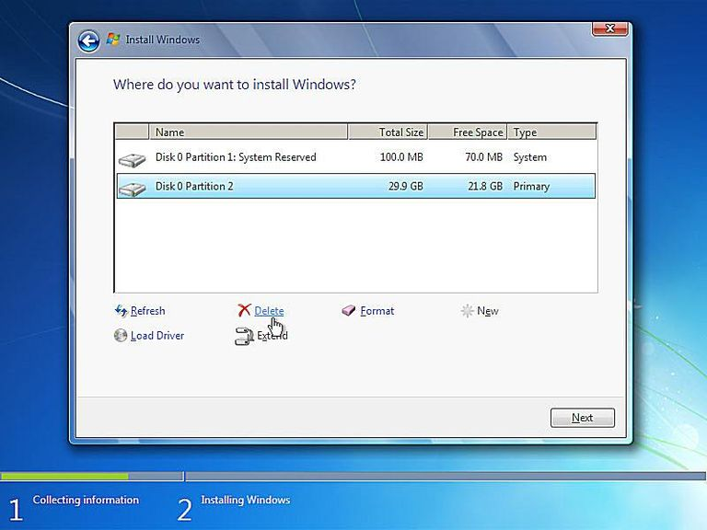

*Windows 7 Clean Install - Step 11 of 34.*

Now that all available drive options are listed, you can delete any [operating system](https://www.lifewire.com/operating-systems-2625912)related [partitions](https://www.lifewire.com/what-is-a-partition-2625958) from your existing [hard drive(s)](https://www.lifewire.com/what-is-a-hard-disk-drive-2618152).

**Important:** Before continuing, please be aware that deleting a partition will permanently erase all data from that drive. By all data I mean the operating system installed, all programs, all data saved by those programs, all music, all video, all documents, etc. that might be on that particular drive.

Highlight the partition you want to delete and then click the **Delete** link.

**Note:** Your list of partitions may differ considerably from mine shown above. On my computer, I am performing a clean install of [Windows 7](https://www.lifewire.com/windows-7-2626265) on a computer with a small 30GB hard drive that has previously had Windows 7 installed.

If you have multiple hard drives and/or multiple partitions on those drive(s), take great care in confirming that you're deleting the correct partition(s). Many people, for example, have second hard drives or partitions that act as backup drives. That's certainly not a drive you want to be deleting.

### Confirm the Partition Deletion

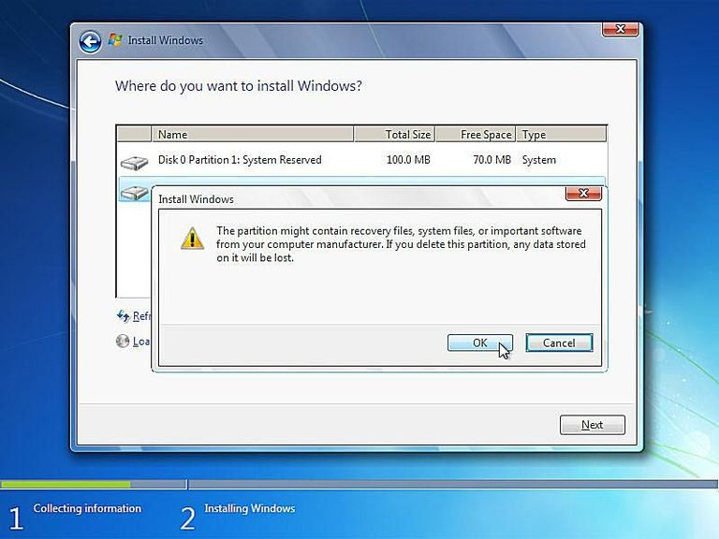

*Windows 7 Clean Install - Step 12 of 34.*

After deleting the [partition](https://www.lifewire.com/what-is-a-partition-2625958), [Windows 7](https://www.lifewire.com/windows-7-2626265) setup will prompt you to confirm the deletion.

The message says "The partition might contain recovery files, system files, or important software from your computer manufacturer. If you delete this partition, any data stored on it will be lost."

Click the **OK** button.

**Important:** As I spelled out in the last step, please be aware that all the data stored on that drive will be lost. If you have not backed up everything you want to keep, click Cancel, end the Windows 7 clean install process, restart your computer to boot back into whatever operating system you have installed, and backup everything you want to keep.

To be clear: **This is the point of no return!** There's no reason to be scared, I just want it to be very clear that you can't undo the deletion of the drive you selected after you click this OK button.

### Delete Other Operating System Related Partitions

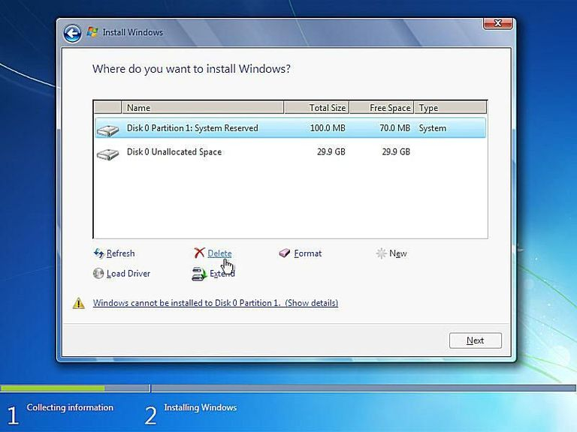

*Windows 7 Clean Install - Step 13 of 34.*

If there are any other [partitions](https://www.lifewire.com/what-is-a-partition-2625958) that need to be deleted, you can do so at this time.

For example, the [Windows 7](https://www.lifewire.com/windows-7-2626265) installation I had on my PC previously created this special 100MB (very small) partition to store system data in. This is most definitely related to the [operating system](https://www.lifewire.com/operating-systems-2625912) that I'm trying to completely remove from my computer so I'll delete this as well.

Highlight the partition and click the **Delete** link.

**Note:** As you can see, the partition we deleted in the last step is gone. It may appear like it's still there but if you look closely, you'll see that that same 29.9GB space is now described as Unallocated Space, not as a partition.

### Confirm Additional Partition Deletions

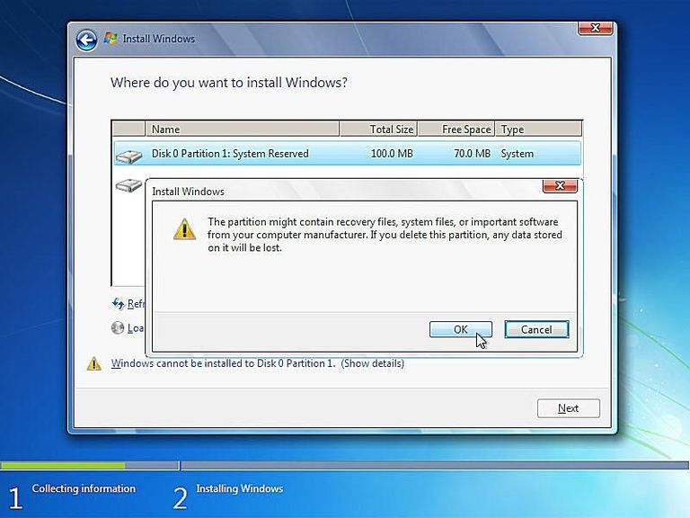

*Windows 7 Clean Install - Step 14 of 34.*

Just as in Step 12, Windows 7 setup will prompt you to confirm the deletion of this [partition](https://www.lifewire.com/what-is-a-partition-2625958).

Click the **OK** button to confirm.

**Important:** Just as before, please be aware that all the data stored on this particular drive will be lost.

**Choose a Physical Location to Install Windows 7 On**

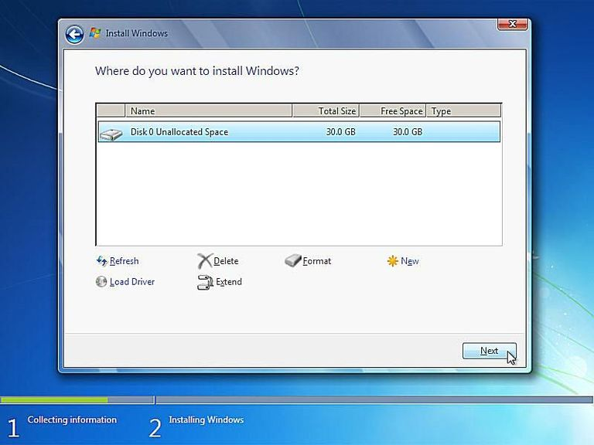

*Windows 7 Clean Install - Step 15 of 34.*

As you can now see, all the space on the installed hard drive is unallocated. No partitions exist on this computer.

**Note:** The number of partitions displayed and whether those partitions are unallocated portions of a hard drive, previously partitioned spaces, or previously formatted and blank partitions will depend on your specific system and which partitions you deleted in the last several steps.

If you're installing Windows 7 on a computer with a single hard drive on which you've just deleted all the partitions from, your screen should look like the one above, aside from your hard drive being a different size.

Choose the appropriate unallocated space to install Windows 7 on and then click **Next**.

**Note:** You do not need to manually create a new partition nor are you required to manually format a new partition. Windows 7 Setup will do this automatically.

**Wait While Windows 7 is Installed**

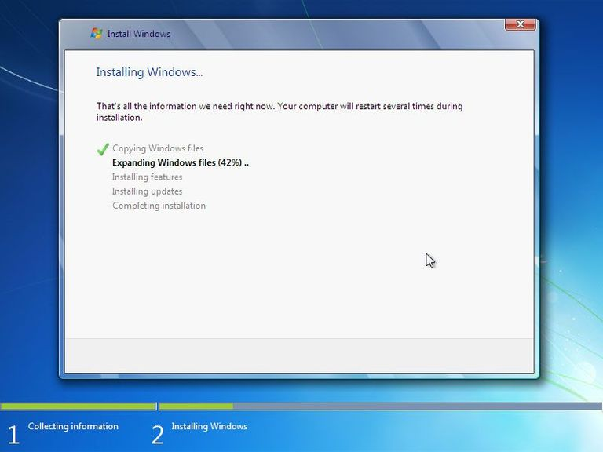

*Clean Install Windows 7 - Step 16 of 34.*

Windows 7 Setup will now install a clean copy of [Windows 7](https://www.lifewire.com/windows-7-2626265) to the location you chose in the previous step. You don't need to do anything here but wait.

This is the most time consuming of any of the 34 steps. Depending on the speed of your computer, this process could take anywhere from 5 to 30 minutes.

### Restart Your Computer

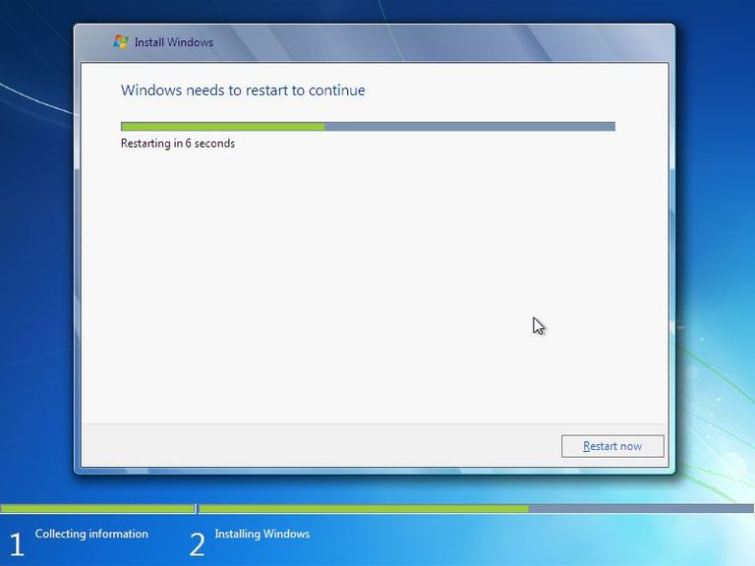

*Windows 7 Clean Install - Step 17 of 34.*

Now that the [Windows 7](https://www.lifewire.com/windows-7-2626265) clean install process is nearly complete, you need to restart your computer.

If you do nothing, your computer will reset automatically after 10 seconds or so. If you'd rather not wait, you can click the **Restart now** button at the bottom of the Windows needs to restart to continue screen.

### Wait for Windows 7 Setup to Begin Again

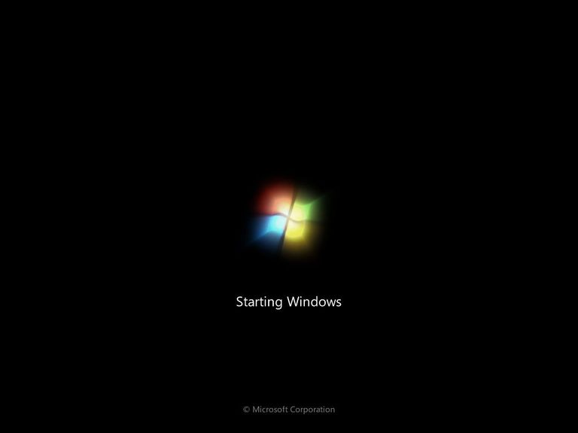

 Windows 7 Clean Install - Step 18 of 34.

The [Windows 7](https://www.lifewire.com/windows-7-2626265) clean install is now continuing.

You don't need to do anything here. There are a few more automatic Windows 7 setup steps to come.

### Wait for Windows 7 Setup to Update Registry Settings

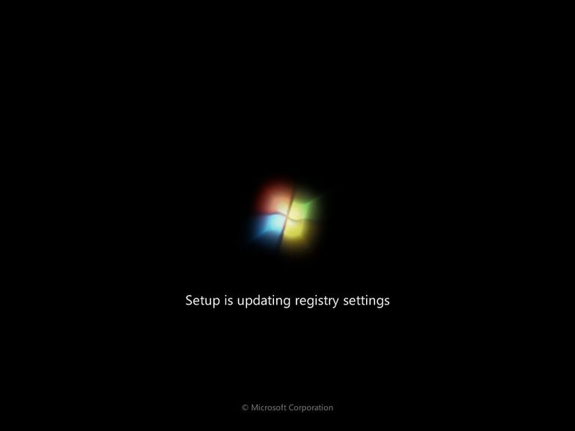

*Windows 7 Clean Install - Step 19 of 34.*

[Windows 7](https://www.lifewire.com/windows-7-2626265) Setup is now updating [registry](https://www.lifewire.com/windows-registry-2625992) settings in preparation for the final stages of the [operating system](https://www.lifewire.com/operating-systems-2625912) clean install.

### Wait for Windows 7 Setup to Start Services

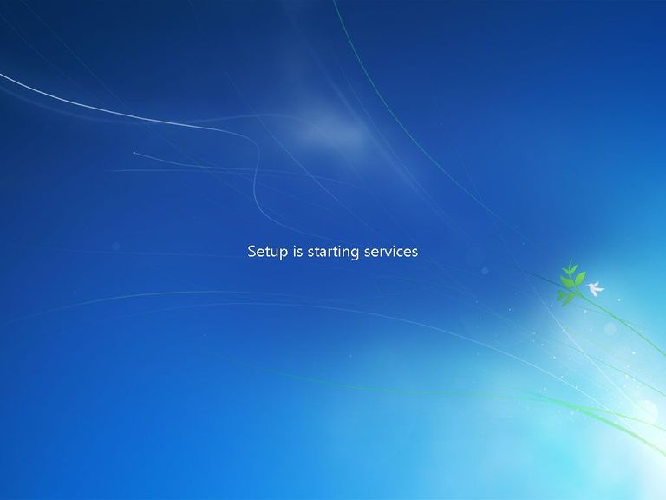

*Windows 7 Clean Install - Step 20 of 34.*

Wait while Windows 7 Setup starts various necessary services.

This starting of services will occur during every Windows 7 boot as well but you won't see it like this again. Services start in the background during a normal Windows 7 startup.

### Wait for Windows 7 Setup to Complete

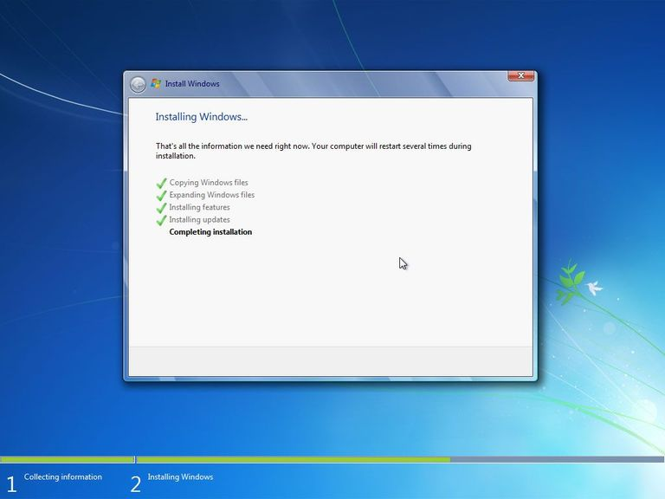

*Windows 7 Clean Install - Step 21 of 34.*

This last [Windows 7](https://www.lifewire.com/windows-7-2626265) Setup screen says "Completing installation" and may take several minutes. All you need to do is wait - everything is automatic.

**If the Windows 7 Setup process is complete, why are we only on step 21 of 34?**

The remainder of the steps in this clean install process include several easy but important configurations that need to take place before you can use Windows 7.

### Wait for Your PC to Automatically Restart

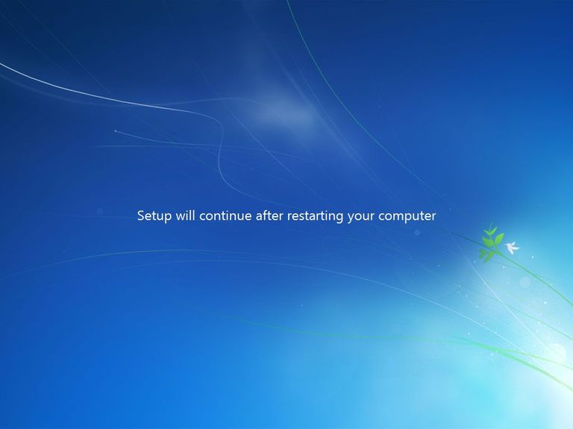

*Windows 7 Clean Install - Step 22 of 34.*

Wait while the Windows 7 setup process automatically restarts your computer.

**Important:** Do not restart your computer manually at this point. Windows 7 Setup will restart your PC for you. If you interrupt the setup process by restarting manually, the clean install process may fail. You may then need to start the Windows 7 setup over again from the beginning.

### Wait for Windows 7 to Start

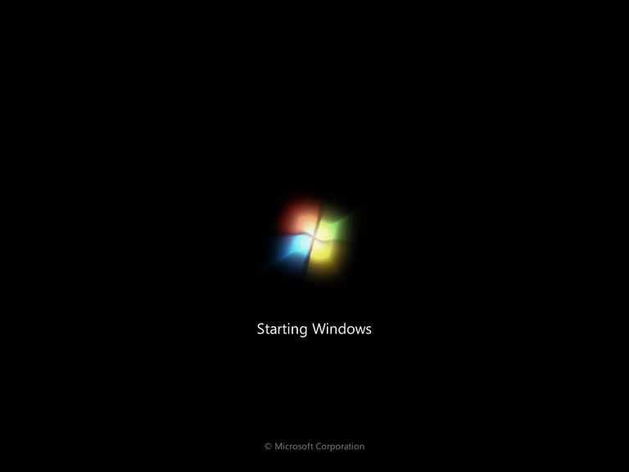

*Windows 7 Clean Install - Step 23 of 34.*

Wait while [Windows 7](https://www.lifewire.com/windows-7-2626265) starts.

No user intervention is required here.

### Wait for Windows 7 to Prepare Your PC for First Use

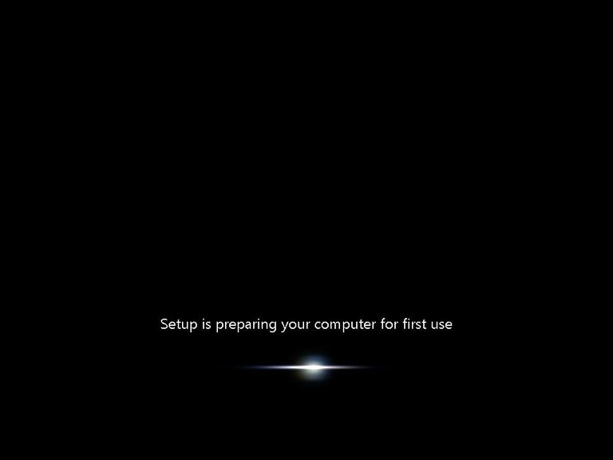

*Windows 7 Clean Install - Step 24 of 34.*

Windows 7 Setup is now preparing your computer for "first use."

Windows 7 is now loading [drivers](https://www.lifewire.com/what-is-a-device-driver-2625796), checking to make sure everything has been setup properly, removing temporary files, etc.

You don't need to do anything here.

**Note:** Remember, this clean install of Windows 7 has completely removed your old operating system. Windows 7 is being installed and configured just as it would on a brand new computer.

### Wait for Windows 7 to Check Your PC's Video Performance

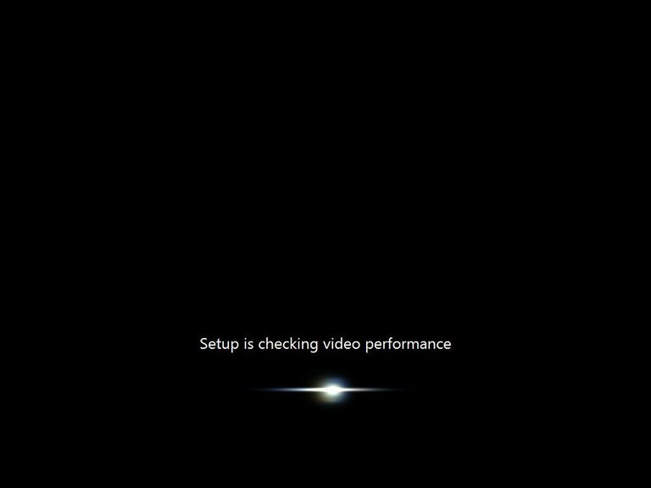

*Windows 7 Clean Install - Step 25 of 34.*

Wait while Windows 7 checks the video performance of your computer.

Windows 7 needs to know how well your video card and related hardware works so it can properly adjust performance options for your computer.

For example, if your video system is too slow, Windows 7 may disable features like Aero Peek, translucent windows, and other graphically intense features of the operating system.

### Choose a User Name and a Computer Name

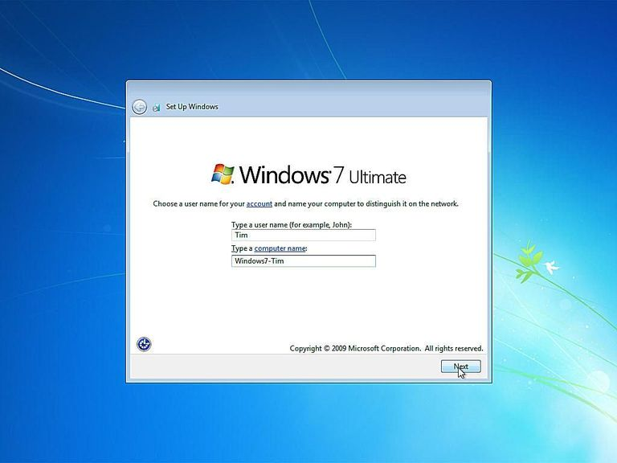

*Windows 7 Clean Install - Step 26 of 34.*

Windows 7 needs to know what use name you'd like to use and how you'd like your computer to be identified on your local network.

In the Type a user name (for example, John): text box, enter your name. You can enter a single name, your first and last name, or any other identifiable text you like. This is the name you'll be identified by in Windows 7.

**Note:** You're more than welcome to use the same user name that you used in your old operating system installation.

In the Type a computer name: text box, enter the name you'd like your computer to have when being viewed by other computers on your network.

**Note:** If it makes sense in your specific situation, I recommend using the same computer name you used in the operating system installation you've deleted as part of this clean install, especially if any other computers on your network connect to resources on your PC.

Otherwise, a good computer name might be Office-PC, Windows-7-Test-PC, Bob-Dell, etc. You get the idea. Anything identifiable that makes sense to you will work.

Click **Next** when you're done entering both the user name and computer name.

**Note:** Planning on having more than one user on your computer? Don't worry - you can set up more users inside Windows 7 later.

### Choose a Password to Access Windows 7

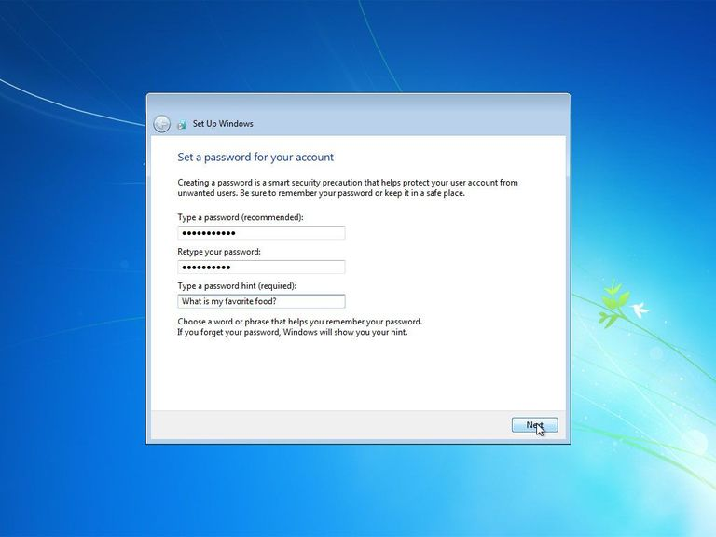

*Windows 7 Clean Install - Step 27 of 34.*

Microsoft recommends that you choose a password that will be required when starting [Windows 7](https://www.lifewire.com/windows-7-2626265) before access to your user account will be allowed.

**Don't treat this as a recommendation - consider it a requirement.**

In the Type a password (recommended): text box, enter a complicated but easy-for-YOU-to-remember password. Retype the same password in the Retype your password: text box.

Type a hint to give yourself in the Type a password hint (required): text box. This hint will display if you enter the wrong password when logging on to Windows 7.

As you can see in the example above, the hint I entered was What is my favorite food?. The password I entered (which you can't see above) was applesauce.

**Note:** Feel free to use the same password as you used in the operating system you've just removed from your computer as part of this Windows 7 clean install. However, this is as good a time as any to choose a stronger password than you might have used before.

### Enter the Windows 7 Product Key

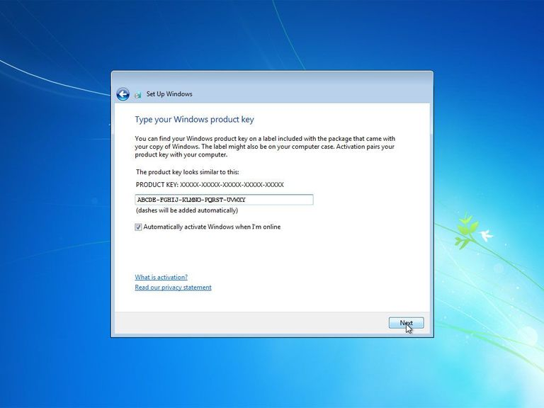

*Windows 7 Clean Install - Step 28 of 34.*

Enter the product key that came with your retail purchase or legal download of Windows 7. If Windows 7 came as part of your complete computer system, enter the product key you were given as part of that purchase.

**Note:** If Windows originally came preinstalled on your computer, your product key is probably located on a sticker attached to the side, back, or bottom of your computer's case.

**Important:** You may be able to avoid entering a product key at this point but you will eventually need to do so in order to continue using Windows 7. I highly advise that you enter your product key here and choose to Automatically activate Windows when I'm online.

### Choose a Windows Update Option

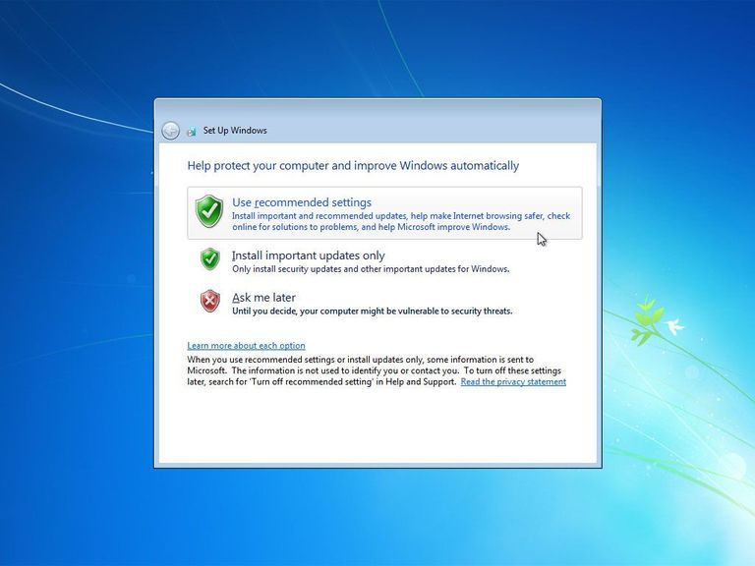

*Windows 7 Clean Install - Step 29 of 34.*

On this Help protect your computer and improve Windows automatically screen, Windows 7 is asking you do choose how you want to automatically install updates from Microsoft's Windows Update service.

I recommend that you choose **Install important updates only**. This option is the safest because it restricts Windows 7 from doing anything with your data or to your computer automatically except when important security and stability updates are available.

You are more than welcome to choose **Use recommended settings** but I do not recommend that you choose **Ask me later**.

**Note:** These settings can easily be changed within Windows 7 after you're done stepping through these configuration questions.

### Choose the Correct Time Zone, Date, and Time

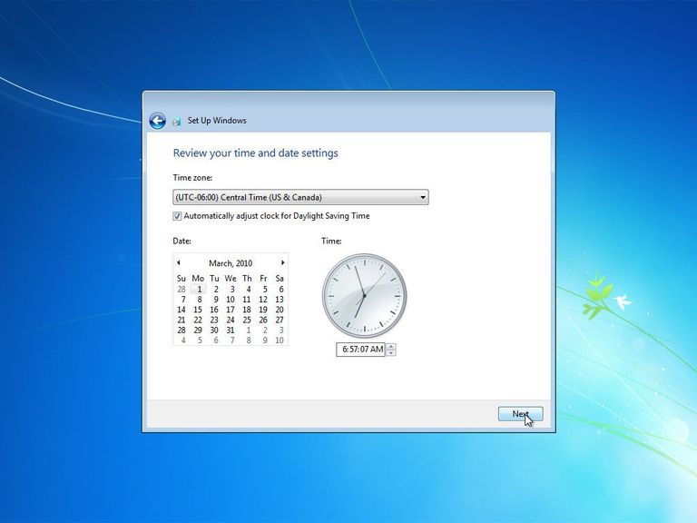

*Windows 7 Clean Install - Step 30 of 34.*

On the Review your time and date settings screen, choose the correct **Time zone**, **Date**, and **Time**.

The time and date is likely already correct but be sure to verify the time zone and change if necessary.

If your area observes Daylight Saving Time be sure to check that box here.

**Note:** If the date and/or time of Daylight Saving Time changes, Microsoft will issue an update via Windows Update to change the automatic time change so don't avoid checking this box assuming that DST changes won't occur correctly.

### Choose a Network Location

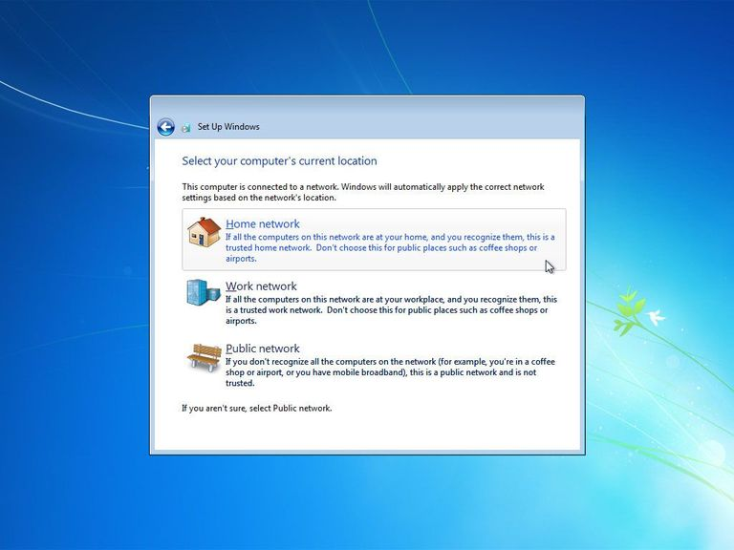

*Windows 7 Clean Install - Step 31 of 34.*

In the Select your computer's current location window you see now, [Windows 7](https://www.lifewire.com/windows-7-2626265) is asking where your computer is located at so it can setup the proper network security - tighter security for public areas and lighter for private ones like home and work.

Choose **Home network** or **Work network** if that applies to you. Most of you reading this will choose Home network.

Choose **Public network** if you use a mobile computer and you connect to the Internet or other computers away from home. Also, be sure to choose Public network if you access the internet via a mobile broadband network - no matter if you're at home or not.

### Wait for Windows 7 to Connect to the Network

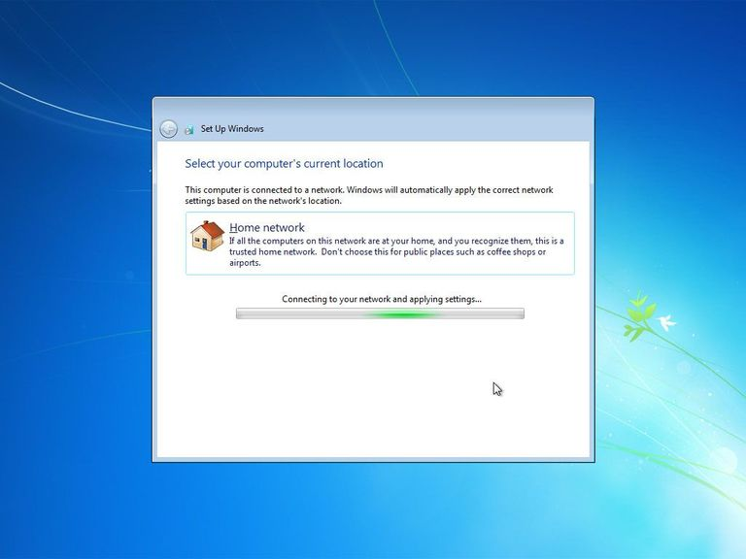

*Windows 7 Clean Install - Step 32 of 34.*

Windows 7 is now connecting your computer to the network.

You don't need to do anything here. Everything is automatic.

**Note:** If Windows 7 detects another computer on your network running Windows 7 that also has a homegroup setup, you will be prompted to choose what kinds of files you'd like to share on that homegroup and for the homegroup password. You can enter this information or **Skip** the setup entirely.

### Wait for Windows 7 to Prepare the Desktop

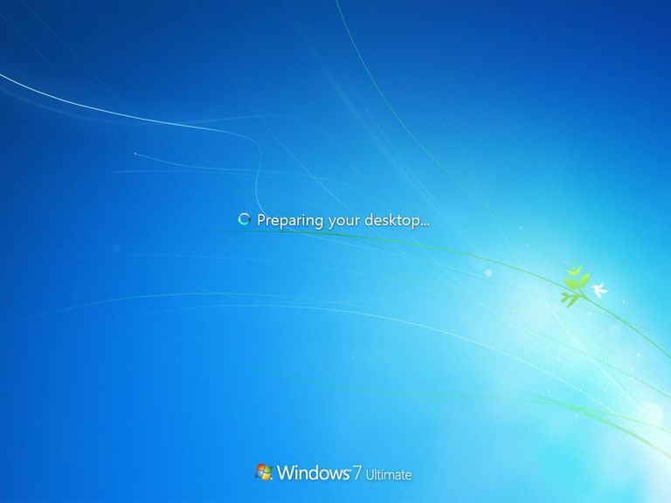

*Windows 7 Clean Install - Step 33 of 34.*

[Windows 7](https://www.lifewire.com/windows-7-2626265) will now put all the "finishing touches" on your clean installation like adding icons to the desktop, prepare the start menu, etc.

You don't need to do anything here. All of these changes are done automatically in the background.

### Your Windows 7 Clean Install is Complete!

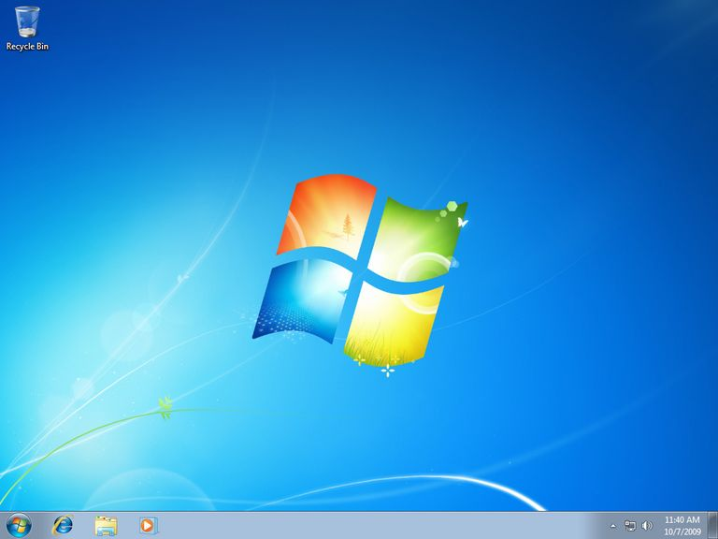

 Windows 7 Clean Install - Step 34 of 34.

This completes the final step of your clean install of [Windows 7](https://www.lifewire.com/windows-7-2626265). Congratulations!

## Practical No.5

## Knowledge about various networking tools.

## HUB

[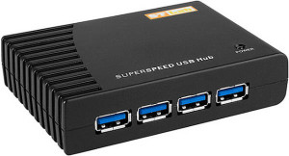](http://www.certiology.com/wp-content/uploads/2014/03/Hub.jpg)

Hub is one of the basic icons of networking devices which works at physical layer and hence connect networking devices physically together. Hubs are fundamentally used in networks that use twisted pair cabling to connect devices. They are designed to transmit the packets to the other appended devices without altering any of the transmitted packets received. They act as pathways to direct electrical signals to travel along. They transmit the information regardless of the fact if data packet is destined for the device connected or not.

***Hub falls in two categories:***

* **Active Hub**: They are smarter than the passive hubs. They not only provide the path for the data signals infact they regenerate, concentrate and strengthen the signals before sending them to their destinations. Active hubs are also termed as ‘repeaters’.
* **Passive Hub:** They are more like point contact for the wires to built in the physical network. They have nothing to do with modifying the signals.

## Ethernet Hubs

## It is a device connecting multiple Ethernet devices together and makes them perform the functions as a single unit.  They vary in speed in terms of data transfer rate. Ether utilizes Carrier Sense Multiple Access with Collision Detect (CSMA/CD) to control Media access. Ethernet hub communicates in half-duplex mode where the chances of data collision are inevitable at most of the times.

[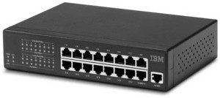](http://www.certiology.com/wp-content/uploads/2014/03/Ethernet-Hubs.jpg)

## Switches

Switches are the linkage points of an Ethernet network. Just as in hub, devices in switches are connected to them through twisted pair cabling. But the difference shows up in the manner both the devices; hub and a switch treat the data they receive. **Hub**works by sending the data to all the ports on the device whereas a **switch** transfers it only to that port which is connected to the destination device.  A switch does so by having an in-built learning of the MAC address of the devices connected to it. Since the transmission of data signals are well defined in a **switch** hence the network performance is consequently enhanced. Switches operate in **full-duplex**mode where devices can send and receive data from the switch at the simultaneously unlike in half-duplex mode. The transmission speed in switches is double than in Ethernet hub transferring a 20Mbps connection into 30Mbps and a 200Mbps connection to become 300Mbps. Performance improvements are observed in networking with the extensive usage of switches in the modern days.

[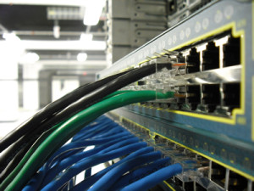](http://www.certiology.com/wp-content/uploads/2014/03/switches.jpg)

The following method will elucidate further how data transmission takes place via switches:

* **Cut-through transmission**: It allows the packets to be forwarded as soon as they are received. The method is prompt and quick but the possibility of error checking gets overlooked in such kind of packet data transmission.
* **Store and forward**: In this switching environment the entire packet are received and ‘checked’ before being forwarded ahead. The errors are thus eliminated before being propagated further. The downside of this process is that error checking takes relatively longer time consequently making it a bit slower in processing and delivering.
* **Fragment Free**: In a fragment free switching environment, a greater part of the packet is examined so that the switch can determine whether the packet has been caught up in a collision. After the collision status is determined, the packet is forwarded.

## Bridges

A bridge is a computer networking device that builds the connection with the other bridge networks which use the same protocol. It works at the Data Link layer of the OSI Model and connects the different networks together and develops communication between them. It connects two local-area networks; two physical LANs into larger logical LAN or two *segments* of the same LAN that use the same protocol.

[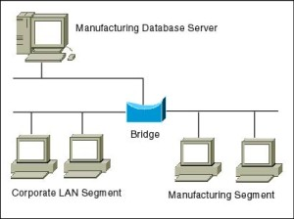](http://www.certiology.com/wp-content/uploads/2014/03/Brige.jpg)

Apart from building up larger networks, bridges are also used to segment larger networks into *smaller* portions. The bridge does so by placing itself between the two portions of two physical networks and controlling the flow of the data between them. Bridges nominate to forward the data after inspecting into the MAC address of the devices connected to every segment. The forwarding of the data is dependent on the acknowledgement of the fact that the destination address resides on some other interface. It has the capacity to block the incoming flow of data as well. Today **Learning bridges** have been introduced that build a list of the MAC addresses on the interface by observing the traffic on the network. This is a leap in the development field of manually recording of MAC addresses.

**Types of Bridges:**

There are mainly three types in which bridges can be characterized:

* **Transparent Bridge:**As the name signifies, it appears to be transparent for the other devices on the network. The other devices are ignorant of its existence. It only blocks or forwards the data as per the MAC address.
* **Source Route Bridge:**It derives its name from the fact that the path which packet takes through the network is implanted within the packet. It is mainly used in Token ring networks.
* **Translational Bridge:**The process of conversion takes place via Translational Bridge. It converts the data format of one networking to another. For instance Token ring to Ethernet and vice versa.
* **Switches superseding Bridges:**Ethernet switches are seen to be gaining trend as compared to bridges. They are succeeding on the account of provision of logical divisions and segments in the networking field. Infact switches are being referred to as **multi-port bridges** because of their advanced functionality

## Routers

Routers are network layer devices and are particularly identified as Layer- 3 devices of the OSI Model. They process *logical* addressing information in the Network header of a packet such as IP Addresses. Router is used to create larger complex networks by complex traffic routing. It has the ability to connect dissimilar LANs on the same protocol. It also has the ability to limit the flow of broadcasts. A router primarily comprises of a hardware device or a system of the computer which has more than one network interface and routing software.

[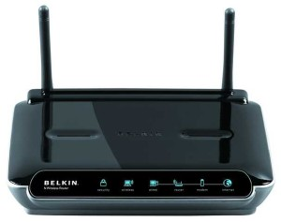](http://www.certiology.com/wp-content/uploads/2014/03/Router.jpg)

**Functionality:**

When a router receives the data, it determines the destination address by reading the header of the packet. Once the address is determined, it searches in its **routing table** to get know how to reach the destination and then forwards the packet to the higher hop on the route. The hop could be the final destination or another router.

**Routing tables**play a very pivotal role in letting the router makes a decision. Thus a routing table is ought to be *updated*and *complete*. The two ways through which a router can receive information are:

* **Static Routing**: In static routing, the routing information is fed into the routing tables manually. It does not only become a time-taking task but gets prone to errors as well. The manual updating is also required in case of statically configured routers when change in the topology of the network or in the layout takes place. Thus static routing is feasible for tinniest environments with minimum of one or two routers.
* **Dynamic Routing**: For larger environment dynamic routing proves to be the practical solution. The process involves use of peculiar routing protocols to hold communication. The purpose of these protocols is to enable the other routers to transfer information about to other routers, so that the other routers can build their own routing tables.

## Brouters

Brouters are the combination of both the bridge and routers. They take up the functionality of the both networking devices serving as a *bridge*when forwarding data between networks, and serving as a*router* when routing data to individual systems. Brouter functions as a filter that allows some data into the local network and redirects unknown data to the other network.

[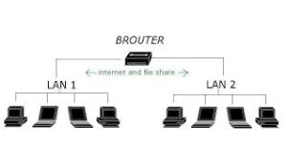](http://www.certiology.com/wp-content/uploads/2014/03/Brouters.jpg)

Brouters are rare and their functionality is embedded into the routers functioned to act as bridge as well.

## Gateways

## Gateway is a device which is used to connect multiple networks and passes packets from one packet to the other network. Acting as the ‘gateway’ between different networking systems or computer programs, a gateway is a device which forms a link between them. It allows the computer programs, either on the same computer or on different computers to share information across the network through protocols. A router is also a gateway, since it interprets data from one network protocol to another.

[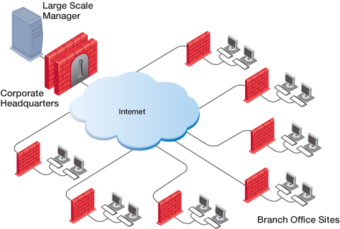](http://www.certiology.com/wp-content/uploads/2014/03/LSM_diagram.gif)

Others such as bridge converts the data into different forms between two networking systems. Then a software application converts the data from one format into another. Gateway is a viable tool to translate the data format, although the data itself remains unchanged. Gateway might be installed in some other device to add its functionality into another.

## Network card

Network cards also known as Network Interface Cards (NICs) are hardware devices that connect a computer with the network. They are installed on the mother board. They are responsible for developing a physical connection between the network and the computer. Computer data is translated into electrical signals send to the network via Network Interface Cards.

[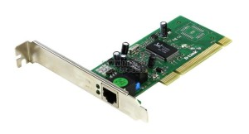](http://www.certiology.com/wp-content/uploads/2014/03/card.jpg)

They can also manage some important data-conversion function.  These days network cards are software configured unlike in olden days when drivers were needed to configure them. Even if the NIC doesn’t come up with the software then the latest drivers or the associated software can be downloaded from the internet as well.

## Network protocols

Network protocols define a language of instructions and conventions for communication between the network devices. It is essential that a networked computer must have one or more protocol drivers. Usually, for two computers to interconnect on a network, they must use identical protocols. At times, a computer is designed to use multiple protocols. Network protocols like HTTP, TCP/IP offer a basis on which much of the Internet stands.

**System requirement:**

* The **bus compatibility** should be verified on installing an NIC into the system. The commonly used bus system is Peripheral Component Interconnect (PCI)
* Memory I/O addresses and IRQ are needed.
* Need of drivers if not already installed.

## ISDN (Integrated Services Digital Network)

ISDN are used to send over graphic or audio data files. It is a WAN technology that can be used in place of a dial up link. The accessibility of ISDN depends upon the provision of the service by the service provider, the quality of the line set up to your area. It surely provides higher speed than a modem and has the capability to pick up the line and drop it considerably at a faster rate.

[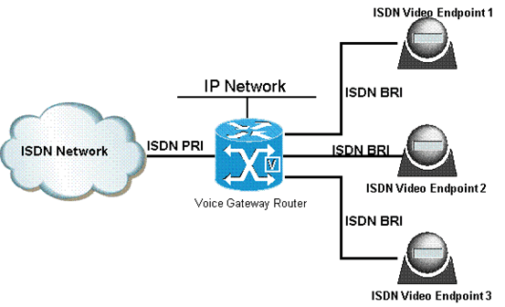](http://www.certiology.com/wp-content/uploads/2014/03/ISDN-Integrated-Services-Digital-Network.gif)

ISDN can create numerous communication routes on a single line. Nowadays, even faster and cheaper technologies that ISDN have found their way in the realm of technology.

## Modems

Modem is a device which converts the computer-generated digital signals of a computer into analog signals to enable their travelling via phone lines. The ‘modulator-demodulator’ or modem can be used as a dial up for LAN or to connect to an ISP. Modems can be both external, as in the device which connects to the USB or the serial port of a computer, or proprietary devices for handheld gadgets and other devices, as well as internal; in the form of add-in expansion cards for computers and PCMCIA cards for laptops.

[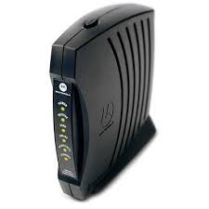](http://www.certiology.com/wp-content/uploads/2014/03/Modems.jpg)

Configuration of a modem differs for both the external and internal modem. For internal modems, IRQ – Interrupt request is used to configure the modem along with I/O, which is a memory address. Typically before the installation of built-in modem, integrated serial interfaces are disabled, simultaneously assigning them the COM2 resources.

For external connection of a modem, the modem assigns and uses the resources itself. This is especially useful for the USB port and laptop users as the non-complex and simpler nature of the process renders it far much more beneficial for daily usage.

Upon installation, the second step to ensure the proper working of a modem is the installation of drivers. The modem working speed and processing is dependent on two factors:

* Speed of UART – Universal Asynchronous Receiver or Transmitter chip (installed in the computer to which the modem connection is made)
* Speed of the modem itself

# Practical No.6

**Network cabling and troubleshooting.**

# What is network cabling?

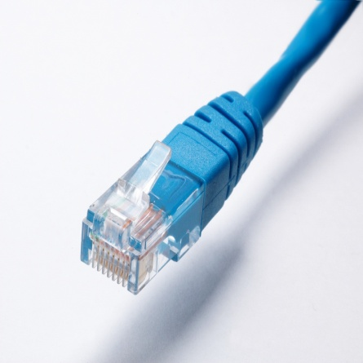

Network cables are used to connect and transfer data and information between computers, routers, switches and storage area networks . Cables are essentially the carrier or media through which data flows.  
  
There are different types of network cable, and the appropriate type to use will depend on the structure and topology of the overall architecture of the system. The most commonly used types of network cables are dominated by what is referred to as “twisted pair cable”. In local area networks, twisted pair cable is by far the moist commonly used type of cable.  
  
Twisted pair cable is used in many ethernet networks. Comprising of four pairs of thin wires or conductors, these wires are contained inside of the insulation or outer sheath of the cable. Each pair is twisted into several additional twists. These twists are to prevent interference from other devices and indeed from other adjacent cables!  
  
Fibre optic cabling is specified where high bandwidth is needed; especially in the data centre environment and where an installation demands high capacity, typically a hospital, airports, banks....Fibre optic is fast becoming the medium of choice for any installation that is sending high volumes of data!  
  
Of cource, there are other types of cables, i.e., coaxial, multipair and of course, other types of media such as wireless.

**TYPES OF NETWORK CABLES:**

### Straight Cable

You usually use straight cable to connect different type of devices. This type of cable will be used most of the time and can be used to:

1) Connect a computer to a switch/hub's normal port.   
2) Connect a computer to a cable/DSL modem's LAN port.   
3) Connect a router's WAN port to a cable/DSL modem's LAN port.   
4) Connect a router's LAN port to a switch/hub's uplink port. (normally used for expanding network)   
5) Connect 2 switches/hubs with one of the switch/hub using an uplink port and the other one using normal port.

If you need to check how straight cable looks like, it's easy. **Both side (side A and side B) of cable have wire arrangement with same color**. Check out different types of straight cablehttp://www.assoc-amazon.com/e/ir?t=homnetwirneta-20&l=ur2&o=1 that are available in the market here.

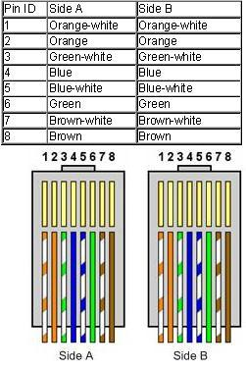

### Crossover Cable

Sometimes you will use crossover cable, it's usually used to connect same type of devices. A crossover cable can be used to:

1) Connect 2 computers directly.   
2) Connect a router's LAN port to a switch/hub's normal port. (normally used for expanding network)   
3) Connect 2 switches/hubs by using normal port in both switches/hubs.

In you need to check how crossover cable looks like, **both side (side A and side B) of cable have wire arrangement with following different color**. Have a look on these crossover cableshttp://www.assoc-amazon.com/e/ir?t=homnetwirneta-20&l=ur2&o=1 if you plan to buy one. You can also find more network cable choices and information from Comtrad Cables.

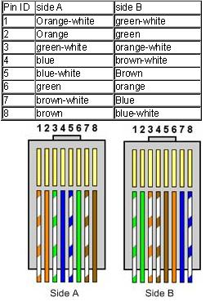

* **FIBER OPTICS**

Instead of insulated metal wires transmitting electrical signals, fiber optic network cables work using strands of glass and pulses of light.

These network cables are bendable despite being made of glass. They have proven especially useful in wide area network (WAN) installations where long distance underground or outdoor cable runs are required and also in office buildings where a high volume of communication traffic is common.

Two primary types of fiber optic cable industry standards are defined – **single-mode**(100BaseBX standard) and **multimode** (100BaseSX standard). Long-distance telecommunications networks more commonly use single-mode for its relatively higher bandwidth capacity, while local networks typically use multimode instead due to its lower cost.

**TROUBLESHOOTING**

The process of solving a problem or determining a problem to an issue.

**Troubleshooting** often involves the process of elimination, where a technician will follow a set of steps to determine the problem or resolve the problem.

**Computer troubleshooting overview:**

Below is a brief overview of the basics of troubleshooting a computer problem. Following these steps can help identify or solve most computer problems.

*PROBLEM: POWER BUTTON WILL NOT START COMPUTER*

**Solution 1**: If your computer **does not start**, begin by checking the power cord to confirm that it is plugged securely into the back of the computer case and the power outlet.

**Solution 2**: If it is plugged into an outlet, make sure it is a **working outlet**. To check your outlet, you can plug in another **electrical device**, such as a lamp**.**

**Solution 3**: If the computer is plugged in to a **surge protector**, verify that it is turned on. You may have to **reset** the surge protector by turning it off and then back on. You can also plug a lamp or other device into the surge protector to verify that it's working correctly.

**Solution 4**: If you are using a **laptop**, the **battery** may not be charged. Plug the **AC adapter** into the wall, then try to turn on the laptop. If it still doesn't start up, you may need to wait a few minutes and try again.

*PROBLEM: AN APPLICATION IS RUNNING SLOWLY*

**Solution 1**: Close and reopen the application.

**Solution 2**: Update the application. To do this, click the **Help** menu and look for an option to check for**Updates**. If you don't find this option, another idea is to run an online search for application updates.

*PROBLEM: AN APPLICATION IS FROZEN*

Sometimes an application may become stuck, or **frozen**. When this happens, you won't be able to close the window or click any buttons within the application.

**Solution 1**: Force quit the application. On a PC, you can press (and hold) **Ctrl+Alt+Delete** (the Control, Alt, and Delete keys) on your keyboard to open the **Task Manager**. On a Mac, press and hold **Command+Option+Esc**. You can then select the unresponsive application and click **End task** (or **Force Quit** on a Mac) to close it.

**Solution 2**: Restart the computer. If you are unable to force quit an application, **restarting** your computer will close all open apps.

*PROBLEM: ALL PROGRAMS ON THE COMPUTER RUN SLOWLY*

**Solution 1**: Run a **virus scanner**. You may have **malware** running in the background that is slowing things down.

**Solution 2**: Your computer may be running out of hard drive space. Try **deleting** any files or programs you don't need.

**Solution 3**: If you're using a **PC**, you can run **Disk Defragmenter**. To learn more about **Disk Defragmenter**, check out our lesson on **Protecting Your Computer**.

*PROBLEM: THE COMPUTER IS FROZEN*

Sometimes your computer may become completely unresponsive, or **frozen**. When this happens, you won't be able to click anywhere on the screen, open or close applications, or access shut-down options.

**Solution 1 (Windows only)**: Restart Windows Explorer. To do this, press and hold **Ctrl+Alt+Delete**on your keyboard to open the **Task Manager**. Next, locate and select **Windows Explorer** from the **Processes** tab and click **Restart**. You may need to click**More Details** at the bottom of the window to see the Processes tab.

**Solution 2 (Mac only):**Restart Finder. To do this, press and hold **Command+Option+Esc**on your keyboard to open the **Force Quit Applications** dialog box. Next, locate and select **Finder**, then click **Relaunch**.

**Solution 3**: Press and hold the Power button. The Power button is usually located on the front or side of the computer, typically indicated by the **power** **symbol**. Press and hold the Power button for **5 to 10 seconds** to force the computer to shut down.

**Solution 4**: If the computer still won't shut down, you can **unplug the power cable** from the electrical outlet. If you're using a laptop, you may be able to remove the battery to force the computer to turn off. **Note**: This solution should be your **last resort** after trying the other suggestions above.

*PROBLEM: THE MOUSE OR KEYBOARD HAS STOPPED WORKING*

**Solution 1**: If you're using a **wired** mouse or keyboard, make sure it's correctly plugged into the computer.

**Solution 2**: If you're using a **wireless** mouse or keyboard, make sure it's turned on and that its batteries are charged.

*PROBLEM: THE SOUND ISN'T WORKING*

**Solution 1**: Check the volume level. Click the audio button in the top-right or bottom-right corner of the screen to make sure the sound is turned on and that the volume is up.

**Solution 2**: Check the audio player controls. Many audio and video players will have their own separate audio controls. Make sure the sound is turned on and that the volume is turned up in the player.

**Solution 3**: Check the cables. Make sure external speakers are plugged in, turned on, and connected to the correct audio port or a USB port. If your computer has **color-coded** ports, the audio output port will usually be **green**.

**Solution 4**: Connect headphones to the computer to find out if you can hear sound through the headphones.

*PROBLEM: THE SCREEN IS BLANK*

**Solution 1**: The computer may be in **Sleep** mode. Click the mouse or press any key on the keyboard to wake it.

**Solution 2**: Make sure the monitor is **plugged in** and **turned on**.

**Solution 3**: Make sure the computer is **plugged in** and **turned on**.

**Solution 4**: If you're using a desktop, make sure the monitor cable is properly connected to the computer tower and the monitor.

**What to do if troubleshooting doesn't help?**

The goal of troubleshooting is to try to isolate the problem by eliminating the possible problems one at a time. If you've gone through all the steps on this page and you're still not sure what the problem is, you should bring the computer to a repair shop and have the issue evaluated by an expert.

**Practical No.7**

**Printer and derives sharing.**

Over the years, Windows has gotten much better about how it handles networked printers. But if you want to share a printer over the network, you may still need to do a little legwork to get it all up and running. Here’s how it all works.

Setting up a printer on your network involves two steps. The first step is getting the printer connected to the network, and there are three ways you can do that:

* **Connect the printer to the network directly**. This is the easiest way to set up a network printer.  It doesn’t require that another PC be turned on to print (like the below methods do), and you don’t have to go through the hassle of setting up sharing. And, since most printers made within the last few years have networking built in, there’s a good chance your printer supports this option.
* **Connect the printer to one of your PCs and share it with the network over Homegroup**. If connecting a printer directly to the network isn’t an option, you can connect it to a PC on the network and share it with Windows Homegroup. It’s easy to set up, and is optimal for networks that are made up of mostly Windows computers. This method, however, requires that the computer its connected to be up and running in order for you to use the printer.
* **Connect the printer to one of your PCs and share it without Homegroup**. This is ideal if your network has other computers running different operating systems, if you want more control over file and printer sharing, or if Homegroup just isn’t working very well. Like the Homegroup method, this requires that the computer its connected to be up and running in order for you to use the printer.

The second step, once you’ve hooked up your printer, will be connecting other PCs to the network printer…which depends a lot on how you hooked it up. Confused yet? Don’t worry. We’re about to go over all of this.

## Step One: Connect Your Printer to the Network

First, let’s talk about getting that printer connected to your network. As we mentioned above, you have three options here. You can connect it directly to the network, you can connect it to a PC and share it through a Homegroup, or you can connect it to a PC and share it without using Homegroup.

### Connect Your Printer Directly to the Network

Most printers these days have networking built in. Some come equipped with Wi-Fi, some with Ethernet, and many have both options available. Unfortunately, we can’t give you precise instructions for getting this done, since how you do it depends on the type of printer you have. If your printer has an LCD display, chances are you can find the network settings somewhere in the Settings or Tools portion of the menus. If your printer has no display, you’ll probably have to rely on some series of physical button presses to tell it whether it should use its Wi-Fi or Ethernet network adapter. Some printers even have a dedicated easy connect button that can set up the Wi-Fi for you.

If you’re having trouble setting up a printer that connects directly to the network, the manufacturer should have instructions for making it happen. Check the manual that came with your printer or the manufacturer’s web site for information on hooking it up.

### Share a Printer Connected to a PC by Using a Homegroup

Sharing a printer with Homegroup is super easy. First, of course, you’ll want to make sure that the printer is connected to one of the PCs on the network and set up properly. If that PC can print to the printer, then you’re good to go.

Start by firing up the Homegroup control panel app. Click Start, type “homegroup,” and then click the selection or hit Enter.

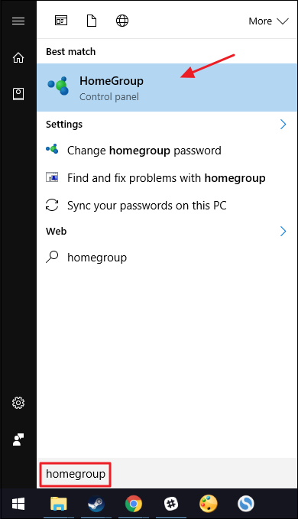

What you do next depends on what you see in the Homegroup window. If the PC you have the printer connected to is already part of a Homegroup, you’ll see something like the following screen. If it shows that you’re already sharing printers, then you’re done. You can skip on to step two, where you connect other PCs on the network. If you’re not already sharing printers, click the “Change what you’re sharing with the homegroup” link.

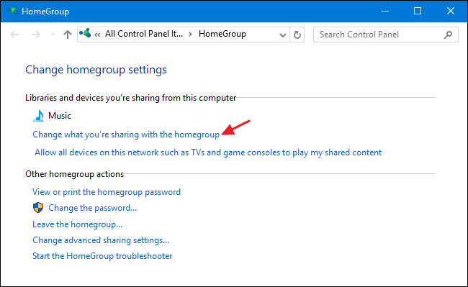

On the “Printers & Devices” drop-down menu, choose the “Shared” option. Click Next and then you can close the Homegroup options and move on to step two.

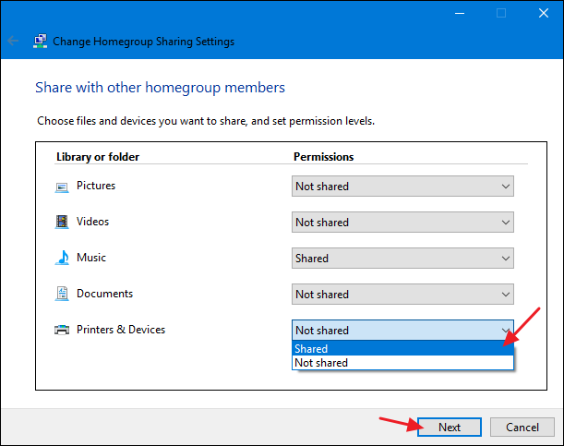

If there is already a Homegroup created for other PCs on the network, but the PC you’ve got your printer connected to isn’t a member, the main screen when you start the Homegroup control panel app will look something like the one below. Click the “Join now” button and then click “Next” on the following screen that just tells you a bit about Homegroups.

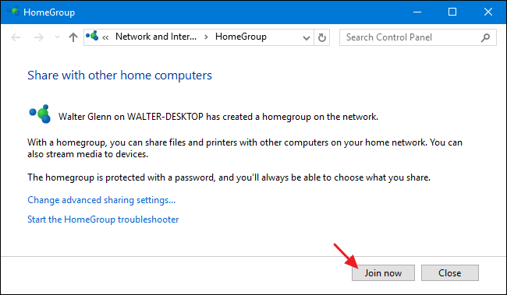

Set your sharing options, making sure that “Printers and devices” is set to “Shared,” and then click “Next.”

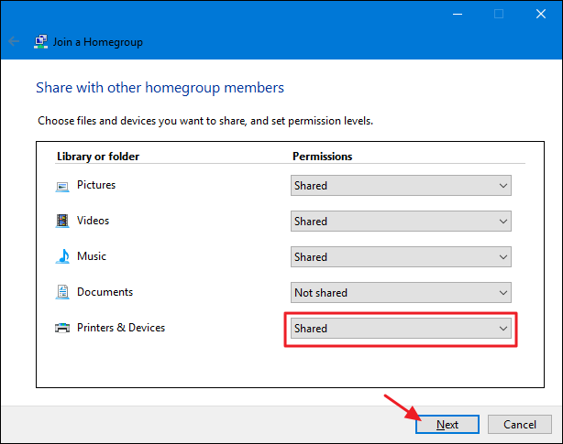

Type the password for the Homegroup and then click “Next.” If you don’t know the password, go to one of the other PCs on the network that is already a member of the Homegroup, launch the Homegroup control panel app, and you can look it up there.

If you’re connecting from another PC that you’ve signed onto using the same Microsoft account as the PC that’s already a member of the Homegroup, Windows 8 and 10 won’t ask for your password. Instead, Windows will authorize you automatically.

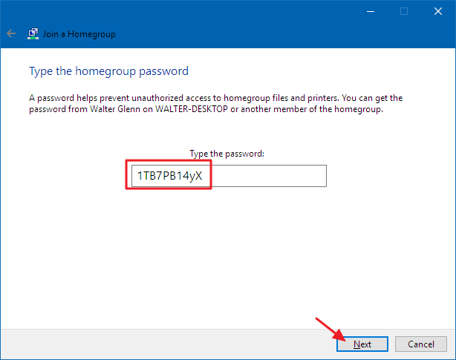

On the final screen, click the “Finish” button and then you can move on to step two and get your other PCs on the network connected to the printer.

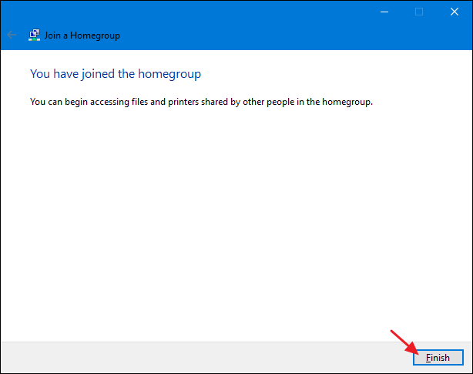

And finally, if there is no Homegroup at all on your network, you’ll see something like the following screen when you open the Homegroup control panel window. To create a new homegroup, click the “Create a homegroup” button.

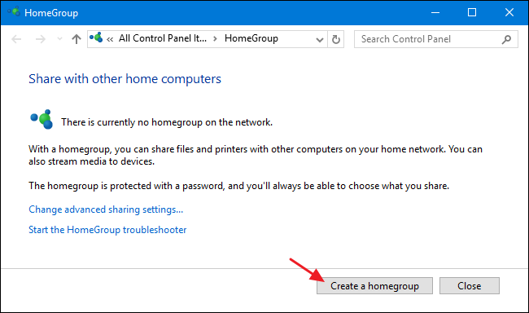

The following screen just tells you a little about Homegroups. Go ahead and click “Next.”

[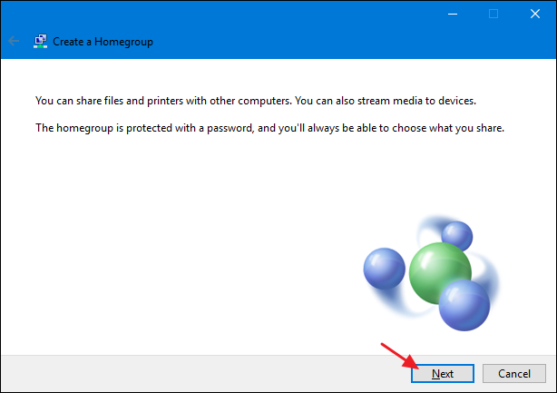](https://www.howtogeek.com/wp-content/uploads/2016/08/inp_b.png)

Choose whatever libraries and folders you want to share with the network from the PC you’re on. Just make sure that you select the “Shared” option for “Printers & Devices.” Click “Next” when you’re done making your selections.

[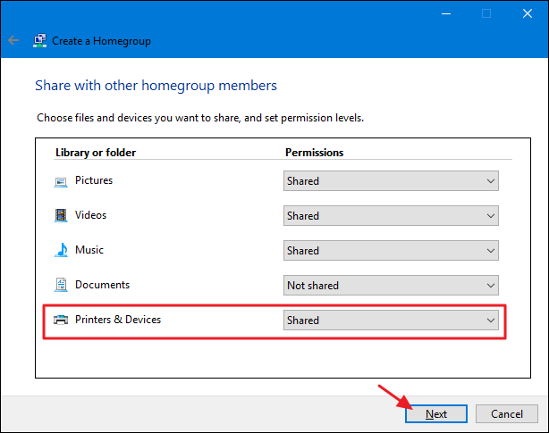](https://www.howtogeek.com/wp-content/uploads/2016/08/inp_c.png)

The final screen shows the password you’ll need for other PCs on your network to connect to the Homegroup. Write it down and then click the “Finish” button.

[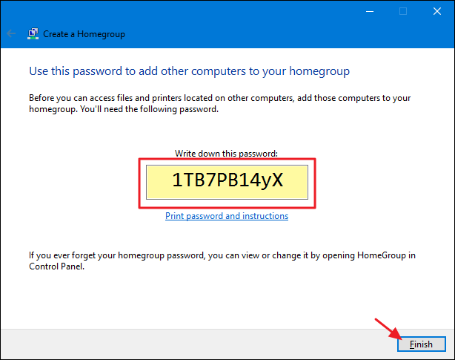](https://www.howtogeek.com/wp-content/uploads/2016/08/inp_d.png)

Now that you’ve got your Homegroup set up and your PC is sharing its printers with it, you can skip down to step two and get those other PCs on the network connected to the printer.

### Share a Printer Connected to a PC Without Using a Homegroup

If you have computers or mobile devices on your network that run an OS other than Windows 7, 8, or 10–or you just don’t want to use Homegroup for some reason–you can always use the sharing tools that have always been a part of Windows to share a printer with the network. Again, your first step is making sure the printer is connected to a PC and that you can print to it.

Click Start, type “devices and printers,” and then hit Enter or click the result.

[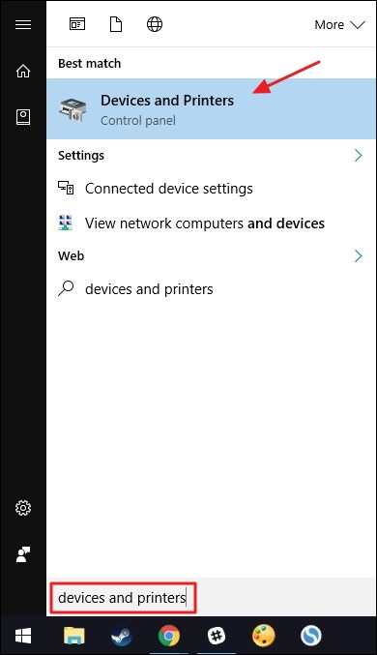](https://www.howtogeek.com/wp-content/uploads/2016/08/inp_1.jpg)

Right-click the printer you want to share with the network and then select “Printer properties”.

[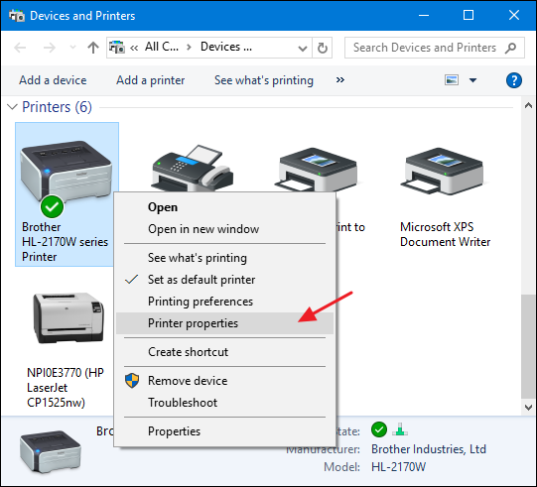](https://www.howtogeek.com/wp-content/uploads/2016/08/inp_m.png)

The “Printer Properties” window shows you all kinds of things you can configure about the printer. For now, click the “Sharing” tab.

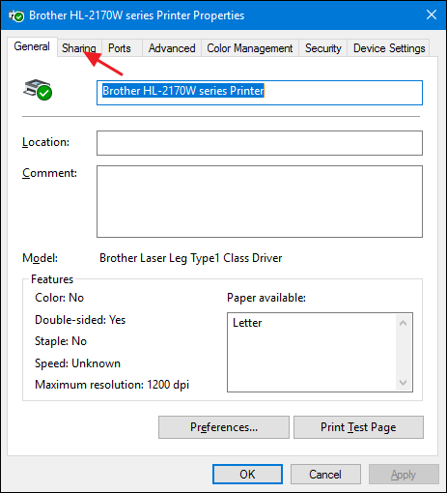

**Customizing Your Network Sharing Settings**

You are informed that the printer will not be available when your computer sleeps or it is shut down. Also, if you are using password protected sharing, you are informed that only users on your network with a username and password for this computer can print to it. Credentials are a one-time thing you’ll have to enter the first time you connect another PC to the shared printer; you won’t have to do it each time you print. If you’d prefer, you can make sharing available to guests so that passwords aren’t necessary, but that setting will also apply to any files you have shared. We suggest you read up on customizing your network sharing settings before making that decision.

To proceed, enable the “Share this printer” option and, if you want, give the printer a friendlier name so that others on the network can more easily identify the printer.

The other option you can set here is whether you would like to render print jobs on client computers. If this setting is enabled, all the documents that will be printed are rendered on the computers where people are doing the printing. When this setting is disabled, the documents are rendered on the computer to which the printer is attached. If it’s a PC that someone uses actively, we recommend enabling this setting so that system performance is not impacted every time something gets printed.

When you’re done setting things up, go ahead and click “OK.”

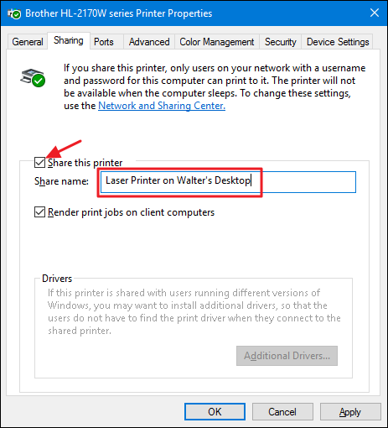

Now that you’ve shared the printer, other PCs on your network should be able to connect to it. So, you’re ready to move on to step two.

## Step Two: Connect to Your Printer from Any PC on the Network

Now that you’ve got your printer connected to the network using one of the above methods, it’s time to turn your attention to the second part of the process: connecting other PCs on the network to that printer. How you do that really just depends on whether you’re using Homegroup or not.

### Connect to a Printer That’s Shared by a PC Using a Homegroup

This is probably the easiest step in this whole tutorial. If you’ve got the printer connected to a PC and that PC is sharing the printer as part of a Homegroup, all you have to do is make sure that other PCs on the network are also joined to the Homegroup. You can use the same process we went over in Step One to get them joined. When PCs are part of the same Homegroup, Windows will automatically connect to any printers shared from other PCs. They’ll just show up in your Devices and Printers window automatically and any PC in the Homegroup can print to them. Super simple.

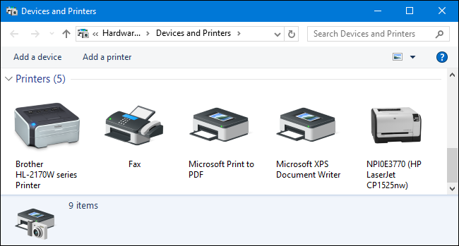

### Connect to a Printer without Using Home group

If your printer is connected directly to a network, or is shared from a PC without using Homegroup, you’ll have to do a little more work to connect to it from other PCs on the network. It’s still pretty straightforward, though. Click Start, type “devices and printers,” and then hit Enter or click the result.

[](https://www.howtogeek.com/wp-content/uploads/2016/08/inp_1.jpg)

The Devices and Printers window shows a collection of devices on your PC. Click the “Add a printer” link to get started adding your network printer.

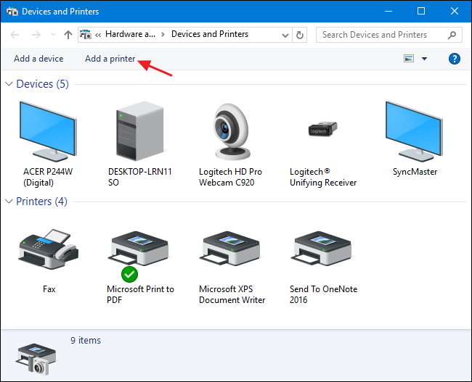

Windows will perform a quick scan of your network for discoverable devices that are not yet installed on your PC and display them in the “Add a device” window. Chances are high that you’ll see your printer on the list, whether it’s directly connected to the network or shared from another PC. If you see the printer you’re looking for, then your job just got super easy. Click the printer you want to install. Windows will handle the installation, download drivers if needed, and ask you to provide a name for the printer. That’s all you have to do.

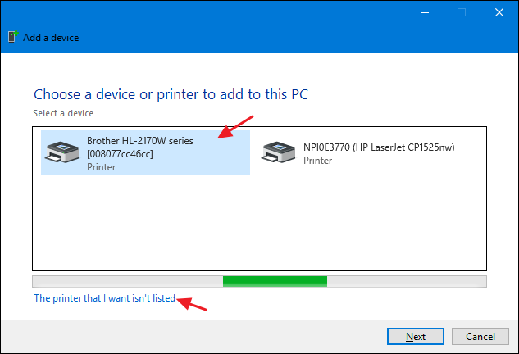

If you don’t see the printer you want to install–and you’re sure you’ve got it properly connected to the network–click the “The printer that I want isn’t listed” link. The next window will present you with several options for helping you find it:

* **My printer is a little older**. If you select this option, Windows will perform a more thorough scan of your network looking for the printer. In our experience, though, it rarely finds anything that it didn’t already find during its initial scan. It’s an easy enough option to try, but it may take a few minutes.
* **Select a shared printer by name**. If the network computer is shared from another PC, this is the best option for finding it. If you know the exact network name of the computer and printer, you can type it here. Or you can click the “Browse” button to look through the PCs on your network that have sharing enabled and see if you can find the printer that way.
* **Add a printer using a TCP/IP address or hostname**. If your printer is attached directly to the network and you know its IP address, this is probably the simplest and surest option. Most network printers have a function that lets you determine their IP address. If your printer has an LCD display, you may be able to find the IP address by scrolling through the printer settings. For printers without a display, you can usually perform some sequence of button presses that will print the settings for you. If all else fails, you can always use an IP scanning app like [Wireless Network Watcher](http://www.nirsoft.net/utils/wireless_network_watcher.html) to locate devices on your network. Check out [the last section of this guide](https://www.howtogeek.com/204057/how-to-see-who%E2%80%99s-connected-to-your-wi-fi-network/)for more information on how to do that.
* **Add a Bluetooth, wireless, or network discoverable printer**. If you choose this option, Windows will scan for those types of devices. Again, we’ve rarely seen it pick up a device that it didn’t find during the initial scan. But, it still may be worth a try.
* **Add a local printer or network printer with manual settings**. This option may help you get a printer added if nothing else works. It’s mostly for configuring a local printer by specifying exact port information, but there is one setting in particular that can help with network printers if you know the model. When asked to specify a port, you can choose a Windows Self Discovery option, which is listed toward the bottom of the available ports as “WSD” followed by a string of numbers and letters. When you choose that, Windows will ask you to specify a model so that it can install drivers. When you’re done, Windows will then monitor the network for that printer. It’s a longshot, but it’s worth a try if all else fails.

You’ll find all these options are pretty straightforward and feature short wizards for walking you through the process. Since TCP/IP is the surest way to get a printer added, we’re going to continue with that as our example.  Select “Add a printer using a TCP/IP address or hostname” and then click “Next.”

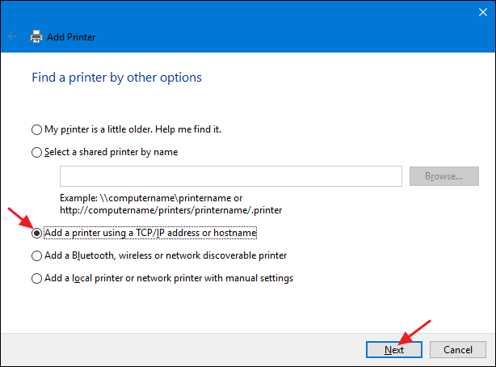

Type the IP address for the printer into the “Hostname or IP address” box. Make sure the “Query the printer and automatically select the driver to use” check box is selected and then click “Next.”

[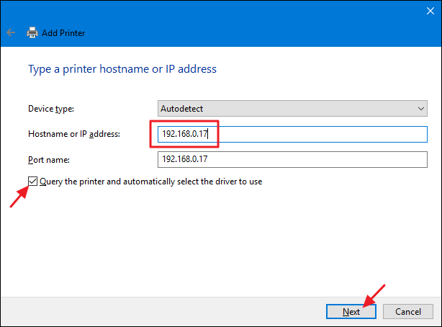](https://www.howtogeek.com/wp-content/uploads/2016/08/inp_5.png)

Type a new name for printer if the default name doesn’t suit you and then click “Next.”

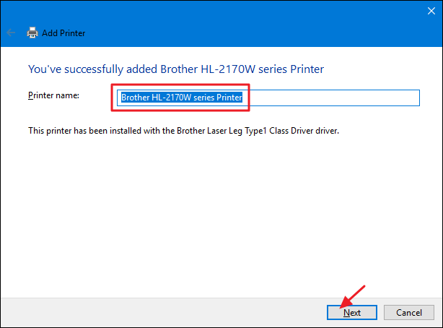

Choose whether to set the new printer as the default, print a test page if you want to make sure everything’s working, and then click “Finish” when you’re done.

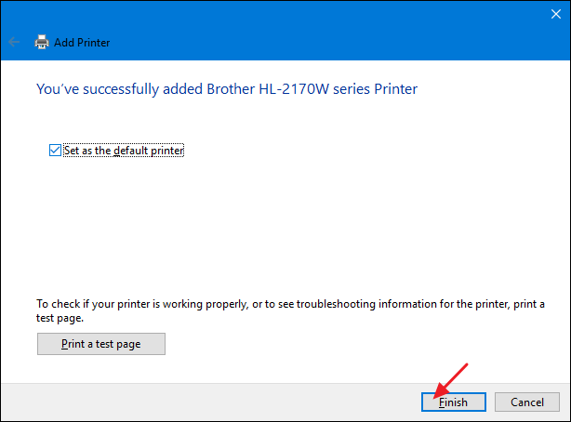

Hopefully, you never need to bother with most of this stuff. If your network printer is properly connected to the network, the chances are high that Windows will pick it up and install it for you right off the bat. And if your network is mostly Windows machines and you use Homegroup for sharing files and printers, things should also happen mostly automatically. If it doesn’t–or if you have a more complicated setup–at least you know you have some options.

**TOPIC-1**

**ARE INDIAN VILLAGES OUR STRENGTH OR OUR WEAKNESS?**

Villages are definitely an important part of our economy with more than 70% of the population living in villages. They are responsible for the production of food, milk and milk products without which our country will not be able to survive. The presence of industries in villages adds to the fact that they are they are the centers of economic activity. Such important villages have to be our strengths for our country to develop rapidly. But many hurdles have stopped this from happening. Some main reasons include poverty, absence of basic health facilities, lack of technology and infrastructure.Though the government has taken many steps to improve the condition, a lot has to be improved. The migration of villagers to cities has also been a potential problem. The government has to take sufficient steps to prevent this and motivate people to engage in agriculture. Only then can our villages be preserved and only then Facts related to the topic:

* Almost 70% of the population live in villages and more than 60% of the population depend on agriculture for their living.
* Today, agriculture contributes only about 23% to GDP while during independence, it contributed more than 60%.
* The Services sector contributes more than 50% to GDP nowadays.
* The nominal growth rate in agriculture is only about 2% on a year on year basis.
* Almost one in three persons in India is struggling to earn a square meal a day. About 33% of the population is below the poverty line.
* The MGNREGA scheme has reduced the unemployment rate to a historical low of below 4% can they become our true strengths.

**TOPIC-2**

**DIGITAL EQUALITY IN INDIA IS NOT EQUAL FOR ALL**

Digital equality means provision of internet access to all citizens. It is being promoted by Facebook in order to promote its Free Basics which was previously introduced as internet.org. Free Basics is against net neutrality which means everyone getting the same speed access to all websites and services and no content should be blocked by Internet Service Providers (ISP). So complete digital equality compromises on net neutrality. So there should be some mid-way solution. Also, digital equality can be achieved with the help of Digital India initiative. Will it not require some kind of government intervention? And if government intervenes, it calls for a policy or law which is not in favour of any one particular web gaint and ensures net neutrality.

Facts related to the Topic:

* Digital equality is a promotion by Facebook to promote Free Basics.Digital Equality means universal access of internet by making it accessible to everyone irrespective of one's status in society be it economical ( rich or poor ), political ( country or abroad ) or religious etc.
* To achieve Digital equality, all the 600,000 villages and 250,000 gram panchayats have to be connected with an optical fibre network.
* Digital equality compromises on net neutrality and hence digital equality and net neutrality contradict with each other.
* Internet penetration in India is 15%, USA is 84%, Australia is 81%,which is not in favour of any one particular web giant and ensures net neutrality.

**TOPIC-3**

**RELIANCE INDIAN 4G CHANGING THE INDIAN TELECOM SECTOR**

Launched in 2016, Reliance Jio started offering free services for customer acquisition. This has definitely been a move to capture maximum market in India and increase competition.However, telecom players like Idea, Vodafone, Airtel etc. feel that this has given them an unfair advantage and has disrupted the market completely. Prices have declined tremendously, which can spoil the profits and the market. However, another school of thought promotes that increase in competition would help improve services, benefit the customers and eventually help increase telecom penetration in India.

Facts related to the Discussion :

* Reliance Jio was launched in September 2016 by Mukesh Ambani.
* Shahrukh Khan is the brand ambassador of Jio.
* Jio has close to 100 million subscribers across India, and till 31st March it would offer free services.
* Telecom players like Idea, Vodafone, Airtel have called this an unfair advantage as Jio is offering free services.
* There has been a tremendous revision of prices across the telecom sector, which is bound to reduce profits for telecom players.
* Reliance Jio first to launch 4G VoLTE and are also introducing new phones also.
* Jio has several apps for TV, chat, messenger, music etc.

**TOPIC-4**

**DEMONITISATION OF 500 AND 1000 RUPEES NOTES BY THE**

**GOVERNMENT OF INDIA**

Demonetization of the 500 and 1000 rupees notes has been a massive exercise by theRBI and Modi government. This was truly an attempt to fight fake currency, blackmoney and also the first step to fight corruption. The banks did there job well by working overtime to ensure old notes are replaced by new 2000 rupee notes and other denominations. However, poor people,villagers who had limited access to banks,ATMs etc had to struggle and are still facing the issue. In the short run this is a problematic issue, but demonetization can be extremely beneficial in the long run.

Facts related to the topic:

* Demonetization was announced by the PM of India, Narendra Modi on 8th November, 2016.
* From 9th November 2016, Rs500 and Rs1000 notes were not legal tenders.
* Positive support:People supported demonetization as they felt it could help fightblack money, fake currency, corruption, human trafficking etc.
* Criticism: Economists have felt that it could have serious ramifications in the growth of the Indian economy. Cash shortage, deaths, stock market crash have created a negative vibe.
* More than 86% people in India use cash for transactions. India is primarily a cash economy.
* Only 4% use debit cards, credit cards etc, 6% used net banking and 2% use cheques etc.
* Till 30 December 2016, Rs15 lakh crore deposited in banks in old notes.

**TOPIC-5**

**BLACK MONEY IN INDIA**

Black money in India is a serious issues hampering the country’s growth. The best way forward is to have strict checks in place. Events like demonetization has been helpful but better laws, better processes, more digitalization, more power to the income tax department etc are the best way to go forward. Government should raid secure havens like Swiss banks and strict punishment should be given to those avoiding taxes.

Facts related to the Discussion:

* Black money is the money unaccounted for i.e. money on which tax is not paid.
* Black money is used for illegal activities, extremist activities which leads to corruption, bribery etc.
* India has approximately USD $2 billion black money in Swiss banks.
* After the demonetization exercise, more than Rs65,000 crore black money was declared in India.
* Means to curb black money: more cashless transactions, digitalization of banks, more peer to the income tax department, changing existing practices in sectors like real estate, education etc. Educating citizens about ill-effects of blackmoney, strict punishment to defaulters.